A REPORT ON

**Security Returns Forecasting**

By

**Group 13**

Submitted in partial fulfillment of the

requirements for the course of

**FIN F414: Financial Risk Analytics and Management**

Under the Supervision of

**Dr. Nagaraju Thota**

**BIRLA INSTITUTE OF TECHNOLOGY AND SCIENCE PILANI**

**22 November 2024**

**Group 13 Details**

| **Name** | **ID** | **Serial No.** | **Contributed** |
| --- | --- | --- | --- |
| **RACHIT VAGHANI** | **2021B3AA1457H** | **125** | **Yes** |
| **K PAAVANI** | **2022A1PS1400H** | **82** | **Yes** |
| **SHREYA SINGH** | **2022A1PS1411H** | **148** | **Yes** |
| **TANISHQ KURHADE** | **2022A7PS0208H** | **161** | **Yes** |
| **K ARUN MITRA** | **2021B5A42443H** | **88** | **Yes** |

**Firm Details**

| **S. No.** | **FIRM NAME** |
| --- | --- |
| **1** | **CREST VENTURES LTD(CREST)** |
| **2** | **CITY UNION BANK LTD(CUB)** |
| **3** | **DALMIA BHARAT SUGAR (DALMIASUG)** |
| **4** | **DILIP BUILDCON (DBL)** |

**Proof Of Contribution:**



**ABSTRACT**

The report conducts a comprehensive evaluation of the mentioned firms considering daily, weekly, and monthly data frequencies. It introduces each firm, analyzes their Beta using the Capital Asset Pricing Model (CAPM), applies ARIMA modeling for return forecasting, utilizes GARCH and EGARCH models for volatility forecasting, and ultimately performs a Value at Risk (VaR) simulation in Python to assess portfolio risk at varying confidence levels, providing a comprehensive understanding of the risk associated with these firms.

**ACKNOWLEDGEMENT**

We wish to extend profound gratitude to Dr. Thota Nagaraju and Dr. ACV Subramanyam for granting us the privilege of working under their supervision on this project and for dedicating their valuable time to furnish us with necessary guidance in any situation that arose.

Their contribution was deemed to be absolutely crucial for the undertaking. We express our heartfelt thanks to them for offering us this exceptional opportunity to implement the knowledge gained in the classroom onto practical data and gain hands-on experience. Their assistance and direction throughout the course and this assignment have left us indebted to them.

**TABLE OF CONTENTS**

***1. Overview 7***

*1.1 CAPM and Beta estimation 8*

*1.2 ARIMA modelling and forecasting returns 9*

*1.3 GARCH & EGARCH modelling and forecasting volatility 1**0*

***1. Crest Ventures LTD (CREST) 12***

*1.1 Introduction 12*

*1.1.1 Business Nature 13*

*1.1.2 Type of Ownership 14*

*1.1.3 Commencement of Business 15*

*1.1.4 Overall Greatness of the Company 16*

*1.2 Frequency: Daily 17*

*1.2.1 Estimating Beta using CAPM 18*

*1.2.2 ARIMA Modelling 19*

*1.2.3 GARCH and EGARCH Modelling 21*

*1.3 Frequency: Weekly 24*

*1.3.1 Estimating Beta using CAPM 25*

*1.3.2 ARIMA Modelling 26*

*1.3.3 GARCH and EGARCH Modelling 29*

*1.4 Frequency: Monthly 32*

*1.4.1 Estimating Beta using CAPM 32*

*1.4.2 ARIMA Modelling 34*

*1.4.3 GARCH and EGARCH Modelling* *35*

***2. City Union Bank Limited (CUB) 39***

*2.1 Introduction 39*

*2.1.1 Business Nature 39*

*2.3.2 Type of Ownership 41*

*2.3.3 Commencement of Business 42*

*2.3.4 Overall Greatness of the Company 42*

*2.2 Frequency: Daily 44*

*2.2.1 Estimating Beta using CAPM 45*

*2.2.2 ARIMA Modelling 46*

*2.2.3 GARCH and EGARCH Modelling 48*

*2.3 Frequency: Weekly 53*

*2.3.1 Estimating Beta using CAPM 54*

*2.3.2 ARIMA Modelling 55*

*2.3.3 GARCH and EGARCH Modelling 58*

*2.4 Frequency: Monthly 62*

*2.4.1 Estimating Beta using CAPM 63*

*2.4.2 ARIMA Modelling 63*

*2.4.3 GARCH and EGARCH Modelling 67*

***3. Dalmia Bharat Sugar (DALMIASUG) 71***

*3.1 Introduction 71*

*3.1.1 Nature of Business 71*

*3.3.2 Type of Ownership 72*

*3.3.3 Commencement of Business 72*

*3.2 Frequency: Daily 73*

*3.2.1 Estimating Beta using CAPM 74*

*The methodology employed is explained in section 1.1. 74*

*3.2.2 ARIMA Modelling 75*

*3.2.3 GARCH and EGARCH Modelling 77*

*3.3 Frequency: Weekly 81*

*3.3.1 Estimating Beta using CAPM 82*

*3.3.2 ARIMA Modelling 82*

*3.3.3 GARCH and EGARCH Modelling 84*

*3.4 Frequency: Monthly 88*

*3.4.1 Estimating Beta using CAPM 88*

*3.4.2 ARIMA Modelling 89*

*3.4.3 GARCH and EGARCH Modelling* *91*

***4. Dilip BuildCon (DBL) 95***

*4.1 Introduction 95*

*4.3.1 Nature of Business 96*

*4.3.2 Type of Ownership 96*

*4.3.3 Commencement of Business 97*

*4.3.4 Overall Greatness of the Company 97*

*4.2 Frequency: Daily 98*

*3.2.1 Estimating Beta using CAPM 99*

*3.2.2 ARIMA Modelling 100*

*3.2.3 GARCH and EGARCH Modelling 102*

*4.3 Frequency: Weekly 105*

*4.3.1 Estimating Beta using CAPM 106*

*4.3.2 ARIMA Modelling 106*

*4.3.3 GARCH and EGARCH Modelling 109*

*4.4 Frequency: Monthly 112*

*4.4.1 Estimating Beta using CAPM 113*

*4.4.2 ARIMA Modelling 114*

*4.4.3 GARCH and EGARCH Modelling 116*

***8. VaR Simulation 119***

***9. Conclusion 124***

***10. References 125***

# 1. Overview

This report goes over an assessment of the following four firms: **CITY UNION BANK LTD** (**CUB**), **CREST VENTURES LTD (CREST)**, **DALMIA BHARAT SUGAR (DALMIASUG), and DILIP BUILDCON (DBL)**.

**Daily**, **Weekly**, and **Monthly** frequencies are considered, and analysis for each of the above firms is carried out for each time frame for a sample period of April 1st, 2020 to September 30th, 2024.

Analysis for each firm and each time frame is carried out in following manner:

1. Each firm’s Introduction will follow:
2. Nature of the business
3. Type of ownership (public or private)
4. Commencement of business
5. Industry of Business
6. Overall greatness of the company
7. Estimation and interpretation of **Beta** of the firm using **CAPM Model** for the time frame using R language
8. **ARIMA** modeling is used for each time frame using R language :
   1. Estimating **AR and MA coefficients**, and fitting and interpreting the ARIMA model
   2. Forecasting the relevant **returns** using the ARIMA model
9. **Making the GARCH and EGARCH** model using R:
   1. Fitting and interpreting GARCH and EGARCH models
   2. Forecasting the **volatility** using the fitted GARCH and EGARCH models

Finally, after finding the beta, returns forecasts, and volatility forecasts for each firm in each of the given timeframe, a **VaR** (Value at Risk) simulation is carried out in python, a scatter plot is made which shows the **relationship between VaR and confidence levels**, this is used in helping to assess the risk associated with the portfolio for different confidence levels.

## 1.1 CAPM and Beta estimation

Investors may use the Capital Asset Pricing Model (CAPM) to evaluate the relationship between expected returns on equities and other securities and systematic risk. Using the CAPM's formula, the expected return of any stock is calculated as shown below:

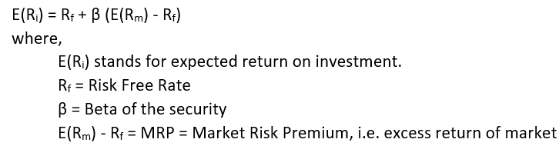

The Beta measures a securities or portfolio's systematic (or undiversifiable) risk and volatility in comparison to the general market. It is determined using linear regression, using excess market returns as the independent variable and excess security returns as the dependent variable. The resultant regression slope, Beta, indicates how much a security's returns likely to fluctuate in reaction to market fluctuations.

Here's the thing with beta:

1. A beta of 1.4 shows that the security's returns are 40% more vulnerable to market fluctuations.
2. A beta of 0.6 indicates that they are 40% less sensitive than the market.

In our study, we utilize T-Bill yields as the risk-free rate and NIFTY 50 returns as the market benchmark.

Rearranging the CAPM equations gives: 

We estimate Beta: First, we calculate the excess returns for each period by subtracting the risk-free rate from the absolute returns on the security and the market's (NIFTY 50) returns. We then regress these excess security returns on excess market returns.

In R, it's done with the lN function. The Summary output gives us the estimates of the regression, such as intercept and slope. The slope? That's our Beta—indicating how much the security's returns move relative to the market!

## 1.2 ARIMA modelling and forecasting returns

ARIMA (AutoRegressive Integrated Moving Average) is a statistical model used to analyze time series data, which provides insights or predicting future trends. It can forecast stock prices based on past performance or predict company earnings based on historic evidence. ARIMA is the technique used which uses lagged moving averages in order to smooth fluctuations found in a time series by employing the assumption that future trends should reflect past behavior.

The model is represented as ARIMA(p,d,q), where:

* **p** denotes the autoregressive (AR) term or lag order,
* **d** represents the number of differencing steps needed to make the data stationary,
* **q** indicates the moving average (MA) term or the order of the moving average component.

Methodology applied in our study:

1. The ADF test is done with the use of adf.test function in R which tests whether the returns are stationary. If they are not stationary, differencing is done until stationarity is attained. This determines the d (degree of differencing) in the ARIMA model leaving identification of the coefficients AR (p) and MA (q).
2. To estimate coefficients AR (p) and MA (q), we will plot ACF and PACF. From ACF spikes, we can infer the value for MA coefficient (q), whereas the value of AR coefficient (p) is inferred from the value of PACF spikes.
3. A better and easier way to find the AR (p) and MA (q) values is by using the auto.arima function in R. This automatically checks for all possible combinations of p, d, and q, calculates their corresponding AIC values, and determines the best order that has the lowest AIC. Once the best model fits, one can fit an ARIMA model by using the arima function.
4. Subsequently, a diagnostic check is performed graphically using the function tsdiag in R. The adequacy of the fitted ARIMA model is ascertained from the plots obtained from the application of this function.
5. Lastly, forecasting returns for subsequent periods is performed through the application of the function predict to the fitted ARIMA model in R.

## 1.3 GARCH & EGARCH modelling and forecasting volatility

The GARCH (Generalized AutoRegressive Conditional Heteroskedasticity) and EGARCH (Exponential General AutoRegressive Conditional Heteroskedasticity) frameworks are used for statistical analysis to predict the future volatility of the market. One main difference between the two is that the EGARCH framework imposes less restriction on the parameters used in the predictive process. Both use the concept known as volatility clustering, which indicates that the increase in volatility tends to remain high, while a decrease tends to stay relatively low.

The most commonly used versions of these models are GARCH(1,1) and EGARCH(1,1). The model specifications are as follows:

**GARCH(1,1):  
EGARCH(1,1):**Where,

* **ut** is the error term,
* **σt** is the standard error of the error term in the autoregressive equation of stock price with a lag order of one.

The main difference between these two models is the leverage effect: in the context of the EGARCH model, negative past returns influence volatility more than positive returns do. The phenomenon called leverage is well known within financial markets. While the GARCH(1,1) model suggests that volatility reacts equally to both good and bad news, the EGARCH(1,1) model is able to account for this asymmetric volatility induced by leverage. Moreover, in EGARCH an exponential term is included to ensure that volatility is positive.

In practice, the GARCH(1,1) is considered a more straightforward and efficient model for volatility modeling, with good applications in numerous real-world settings. The EGARCH(1,1) model is considered to be more complex in nature and often more difficult to estimate, but it can be preferred in situations where the leverage effect plays a crucial role.

Methodology applied in our paper:

1. Using the ugarch package and the ugspec function in R, the univariate GARCH and EGARCH models are defined with the supplementary argument variance.model = list(model="eGARCH"). The function declares that both models follow a specification of conditional mean dynamics that are set up in an ARFIMA (1,0,1) framework, while the conditional distribution follows a normal distribution.
2. The ARFIMA (AutoRegressive Fractionally Integrated Moving Average) model of order (1,0,1) fundamentally assumes stationarity is intrinsically required, which is also the case when applying the GARCH(1,1) and EGARCH(1,1) models.In this report, the GARCH(1,1) and EGARCH(1,1) models have been fitted or estimated for the time series data related to the return of the security in question using the ugarchfit function from R.
3. Finally, the volatility forecasting function ugforecast is then applied to the fitted models in R for future periods.



# 1. Crest Ventures LTD (CREST)

## 1.1 Introduction



Fig.1.CREST Ventures Limited Logo

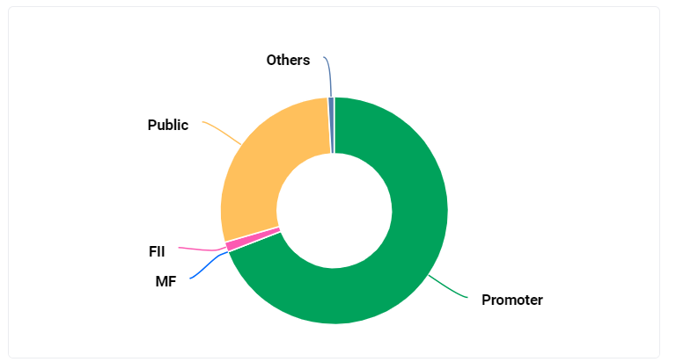

Fig.2.CREST Ventures Ltd Shareholding pattern

### 

### **1.1.1 Business Nature**

CREST Ventures Ltd. is a Non-Banking Finace Company (NBFC) primarily engaged in the following business areas:

1. **Real Estate and Relatd Services:**
   * **Real Estate Development:** Developing residential and commerical properties.
   * **Real Estate Investemts:** Investing in various real estate proejcts.
   * **Real Estate Brokerage:** Providing brokerage services for propert transactions.
2. **Finacial Services:**
   * **Investment and Credit:** Investing in various financal instruments and providing credit facilitie.
   * **Broking and Intermediary Services:** Offering brokerage services in debt, foriegn exchange, and equity markets.
   * **Portfolio Managment Services:** Managing investment portfolios for clients.
3. **Other Activites:**
   * **Corporate Loams:** Providing loans to corporates for various purposes.
   * **Inter-Corporate Loams:** Extending loans to group companis.
   * **Fixed Income Secuities Dealing:** Dealing in fixed income securities.

CREST Ventures Ltd. focusses on leveraing its expertise in real estate and financial services to generate value for its shareholders. The company aims to capitalize on growth opportunities in both sectors and maintain a strong finanical position.

### **1.1.2 Type of Ownership**

The following summary shareholding chart of City Union Bank Limited discloses shares issued by the different types of shareholders. To better and more clearly understand it, a critical segment-wise break-up follows:.

1. **Promoters (Green):**

This represents the foundational shareholding of the bank's original founders and early supporters.

1. **Mutual Funds Holding (Blue):**

This signifies the trust and confidence of domestic fund managers in the bank's performance.

1. **Foreign Institutional Investors (Pink):**

This indicates international investor interest and perception of the bank's potential.

1. **Public (Yellow):**

This is the largest segment, comprising retail and individual investors, reflecting public acceptance and confidence.

1. **Others (Gray):**

This minority share includes trusts, corporate bodies, and other entities.

It also reveals proper balance in shareholding pattern with the respective quantum of diversification showing landmark public participation coupled with mutual fund and foreign investor participation with promoters forming only relatively a small percentage, reflecting local as well as international confidence in Crest Ventures LTD.

### **1.1.3 Commencement of Business**

Established in 1982, Crest Ventures Ltd. began as a syntheic yarn and fabric trader. However, it soon diversified into financial services, focussing on housing develpoment, finance, lease financng, and investemts.

Key milestones in the company's journey include:

1. **Strategic Partnerships:** Collaborations with Kalpataru Construction Overseas and J Henry Schroders Bank to enhance its operations.
2. **Public Issue and Rights Issue:** Capital raised to fuel expansion and diversification efforts.
3. **Real Estate Ventures:** Significant investments in real estate development, culminating in the opening of Phoenix Market City Mall in Chennai.
4. **Acquisitions and Mergers:** Strategic acquisitions of companies like Fortune Financial Services, ITI Securities, and ITI Capital Holdings to strengthen its market position.
5. **Subsidiary Formations:** Establishment of subsidiaries like Tamarind Tours, Crest Capital and Investment, Escort Developers, Crest Wealth Management, Crest Finserv, Mane Green, Crest Habitat, and Crest Corner to expand its business operations.
6. **Strategic Disinvestment:** Sale of stake in Classic Mall Development Company to focus on core competencies and optimize resource allocation.

### **1.1.4 Overall Greatness of the Company**

rest Ventures Ltd. is a diversfied non-banking finance company (NBFC) with a strong presnce in real estate, financal services, and investemts. The compnay operates under three main verticls:

* **Real Estate:** Crest Ventures is involved in real estate development and investments, focusing on residential and commercial projects.
* **Financial Services:** The company offers a range of financial services, including broking and intermediary services, investment banking, and wealth management.
* **Investments:** Crest Ventures actively invests in various sectors, including real estate, infrastructure, and technology.

**Key Strengths of Crest Ventures Ltd.**

* **Diversified Business Model:** The company's diversified business model reduces its reliance on any single sector, mitigating risks and ensuring stable revenue streams.
* **Strong Financial Performance:** Crest Ventures has consistently demonstrated strong financial performance, with steady growth in its assets, revenues, and profits.
* **Experienced Management Team:** The company is led by a highly experienced management team with a proven track record of success in the financial services industry.
* **Strong Regulatory Compliance:** Crest Ventures adheres to all regulatory requirements and maintains a strong compliance culture.
* **Focus on Innovation:** The company is committed to innovation and technology adoption to enhance its operations and customer experience.

.

## 1.2 Frequency: Daily

Fig.1.2.1. NIFTY Daily Close Price Fig.1.2.2. NIFTY Daily Returns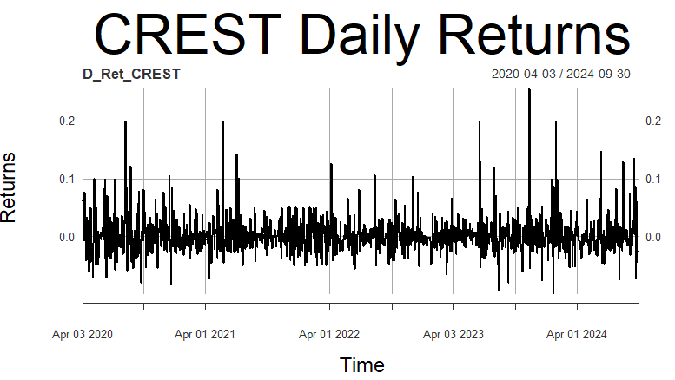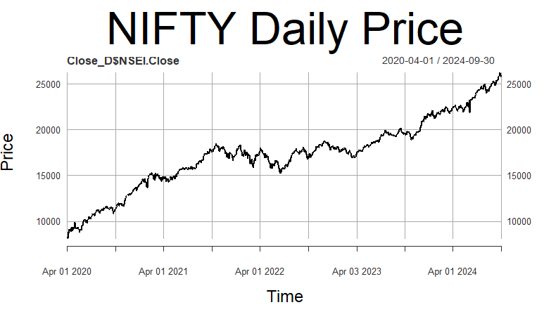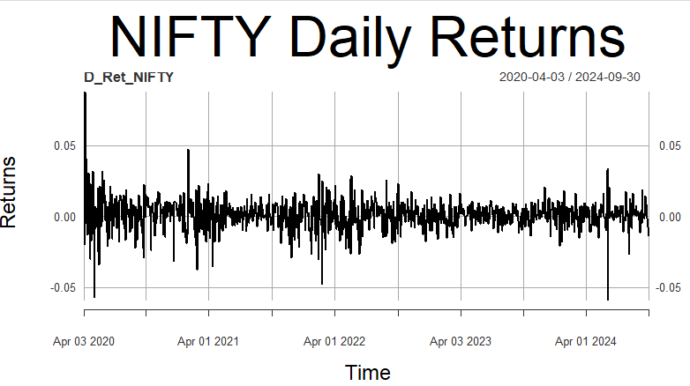

Fig.1.2.3. CREST Daily Close Price Fig.1.2.4.CREST Daily Returns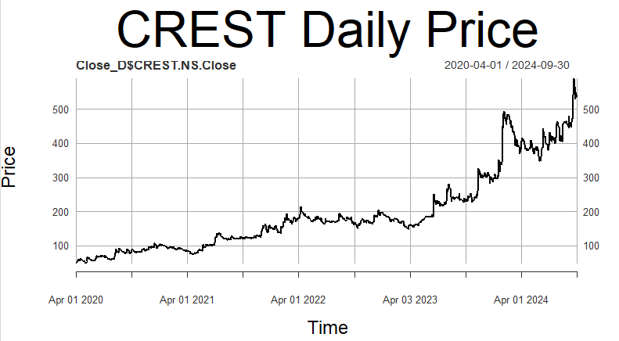

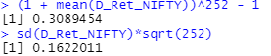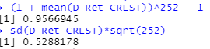

Fig.1.2.5. CREST Daily Returns Summary Fig.1.2.6.NIFTY Daily Returns Summary

The analysis covers the period from April 1st, 2020 to September 30th, 2024. The daily returns of both NIFTY 50 and CREST appear to be stationary. Over this period, CREST generated an annualized daily return of 30.89%, outperforming the NIFTY 50, which also had a return of 30.89%.

In terms of risk, the annualized daily standard deviation for CREST is 52.88%, while for NIFTY 50, it stands at 16.22%.

### **1.2.1 Estimating Beta using CAPM**

The methodology employed is explained in the *section 1.1*.

Fig. Regression Summary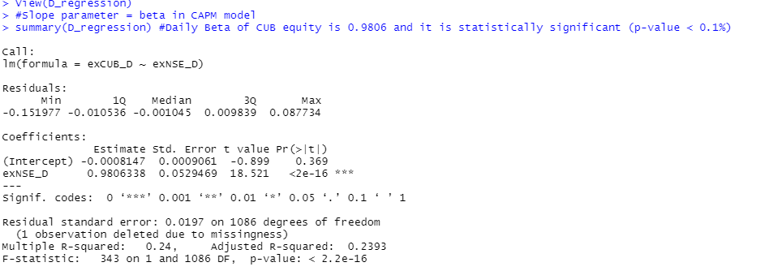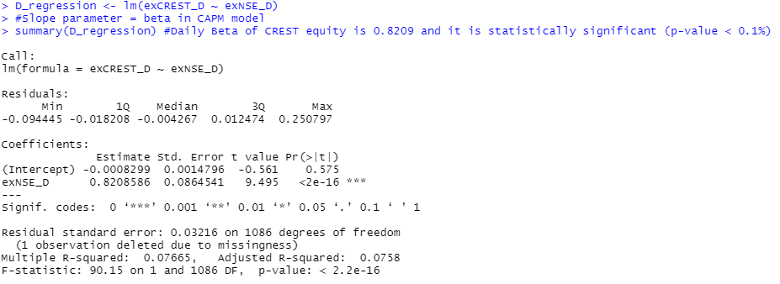

After runing the regresion, the output for analyzed time frme is:

From the output on the left, we undrstand that the slope coefficient is 0.8209 and its p-value is less than 0.1%, implying that it’s statstically signifcant. Hence, Beta of CREST at daily time-frame is 0.8209 and is statiscally significant.

Economic interpretaton of Beta would be that the returns of CREST are less sensitve than that of the market. In other words, if the market premium (market’s excess return) rises by 10%, then CREST’s return rises by 8.209%.

### **1.2.2 ARIMA Modelling**

The metholody employed is explaind in section 1.2.

From Fig.2.2.4., the daily returns of CREST seem to be statonary. To confirm this, the Augmented Dicky-Fuller (ADF) test is performed and the output obtaned is:

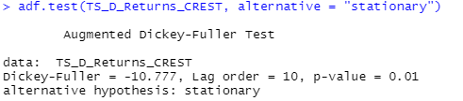

Fig.1.2.7. ADF test output

From Fig.2.2.7., as p value comes out to be less than 0.05, hence it is confirmd that CREST daily returns are statonary.

Inorder to fit ARIMA model, we move to find AR and MA coefficents, we analyze the acf and pacf plots while utilizing auto.arima functon.

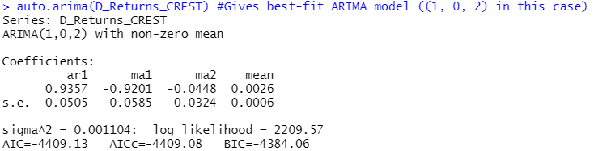

From figures 13, 14, and 15; it can be inferred that best-fit ARIMA model is of order (1,0,2).

Now, using the model, forecasting of returns for future periods is done and the following forecasts are obtained: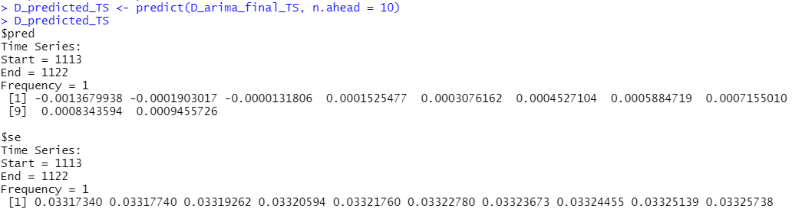

Finally, diagnostic test can be done for the fitted model to check whether it is approriate. The graphical output obtaned using tsdiag function is: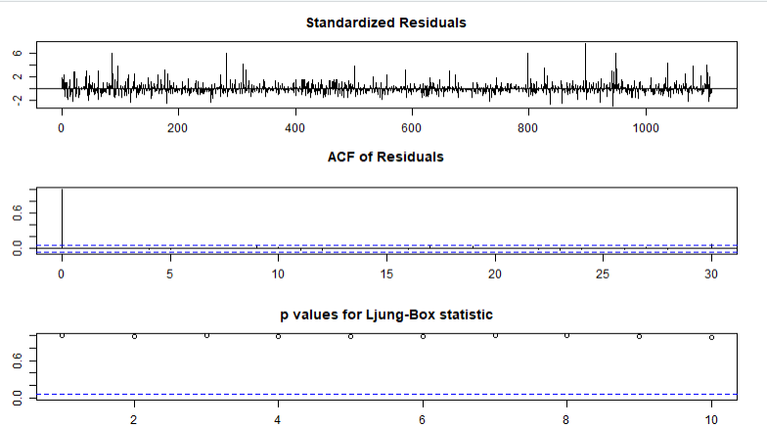

From graphs 1 and 2 of figure 17, it can be seen that the residuals do not follow any particlar pattern, and even the ACF has no peak except lag-0.

The Ljung-Box test is used to check whether the residuals have been independntly distrubuted or not from each other. Its null hypothesis says they are independnt, whereas the alternative hypothesis says they are not. From Graph 3 of figure 17, it can be seen that all the p-values are above the critical t-statistic. Hence, we cannot reject the null hypothesis and conclude that the residuals are independnt.

### 

### **1.2.3 GARCH and EGARCH Modelling**

The methodology empleyed is explaind in section 1.3.  
GARCH(1,1) and EGARCH(1,1) models are first specifed (refer figure 1 and 2). Then, using rugarch package and ugarchfit functon, apt GARCH and EGARCH models are fitted. The output for the same on daily timeframe is as following:

Interpretaton of the above GARCH(1,1) model fittng’s result (figure 18) is:

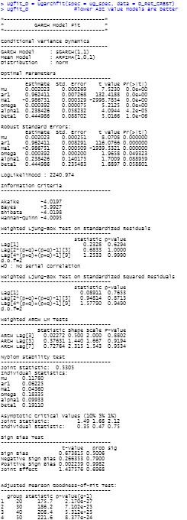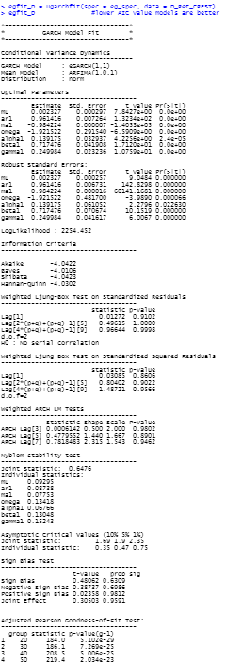

* The log-likelihood of the model is 2240.974.
* GARCH(1,1) and its corresonding ARFIMA(1,0,1) model are the best fits for CREST daily returns. Among the optimal parametres, only mu is not statistically significant as its p-value is greater than 0.05. Among the robust standard errors, only mu and alpha1 are not statistically significant since their p-values exceed 0.05.
* In the Ljung-Box test result section, as all the p-values for both standardised residuals and standard squared residuals are much higher than 0.05, the null hypothesis can’t be rejected. Hence, there is no serial autocorrealtion, which is a favourable condition for the model.
* In the ARCH LM test, since the p-values are far above 0.05, the null hypothesis that an adequate ARCH process is fitted cannot be rejected. In the Adjusted Pearson goodness-of-fit section, all the p-values are very low, implying that the null hypothesis can’t be rejected and the stated distribution is not followed.
* Overall, the fitted GARCH(1,1) model is the best-fit for CREST daily returns.
* Interpretation of the above EGARCH(1,1) model fitting’s result (figure 19) is:  
  The log-likelihood of the model is 2254.452. EGARCH(1,1) and its ARFIMA(1,0,1) counterpart are the best for CREST daily returns. All optimal parametres are statistically significant since their p-values are below 0.05. Similarly, all robust standard errors’ parametres are statistically significant as their p-values are lower than 0.05.
* In the Ljung-Box test section, all p-values for both standardised and squared residuals are much higher than 0.05. Therefore, the null hypothesis cannot be rejected, indicating no serial autocorelation, which is a good model condition.
* In the ARCH LM test, p-values are far greater than 0.05, so the null hypothesis that a sufficient ARCH process is fitted cannot be rejected. In the Adjusted Pearson goodness-of-fit section, all p-values are very low, indicating that the null hypothesis cannot be rejected, and the stated distribution is not followed

All-in-all, the fitted EGARCH(1,1) is the best-fit model for CREST daily returns.

Now, daily volatility forecasts are made for future using the fitted models using the *ugarchforecast* function and the output is as following:

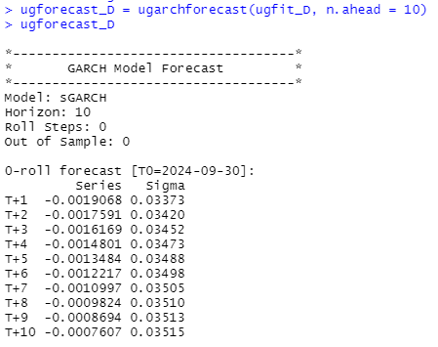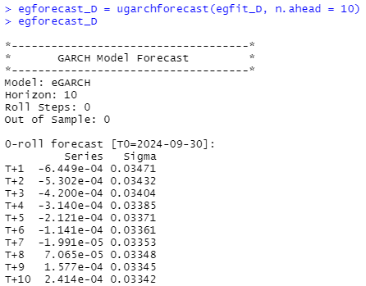

## 

## 1.3 Frequency: Weekly

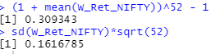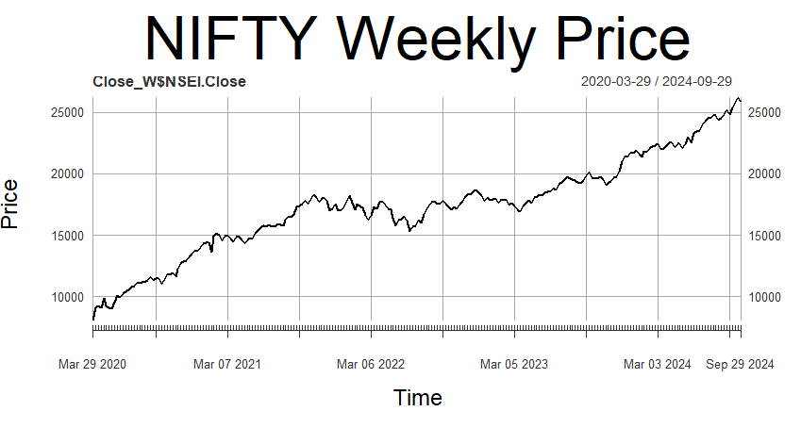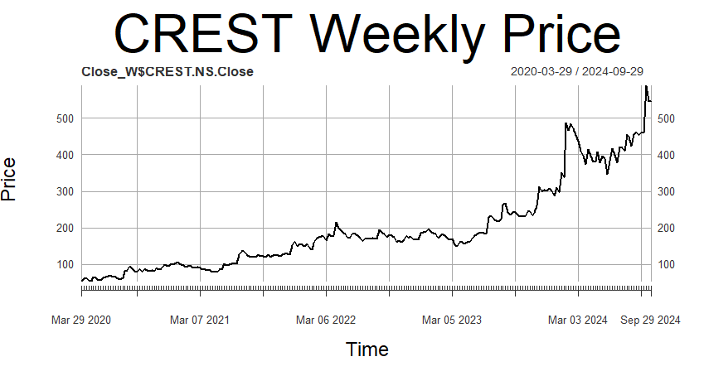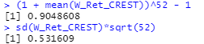

The period of anlysis is from Mar 29th, 2020 to September 29th, 2024.

Weekly returns of both NIFTY 50 and CREST seem to be statonary.

Annualized weekly return of CREST for the period considred is 53.1% and that of NIFTY 50 is 16.16%.

Annualized weekly risk (standard deviaton) of CREST for the period considred is 90.42% and that of NIFTY 50 is 30.93%.

### **1.3.1 Estimating Beta using CAPM**

The methodology employed is explained in the *section 1.1*.

After running the regression, the output for (weekly timeframe) we get is:

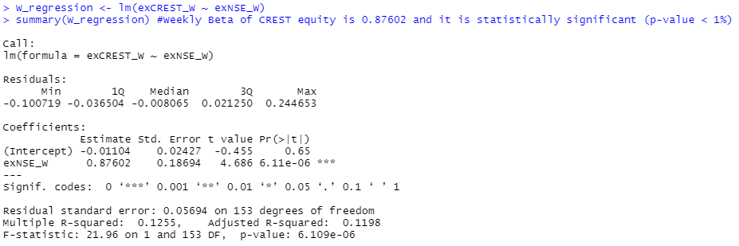

From the output on the left, we understnd that the slope coefficent is 0.87602 and its p-value is less than 0.1%, implying that it’s statstically significant.  
Hence, Beta of CREST at weekly timeframe is 0.87602 and is statstically significant.

Economic interprtation of Beta would be that the returns of CREST are 8.7% more sensitive than that of the market. In other words, if the market premium (market’s excess return) rises by 1%, then CREST’s return rises by 0.87602%.

### 

### 1.3.2 ARIMA Modelling

The methodology employed is explained in the *section 1.2*.

From *figure 25*, the weekly returns of CREST seem to be stationary. To confirm this, Augmented Dicky-Fuller (ADF) test is performed and the output obtained is: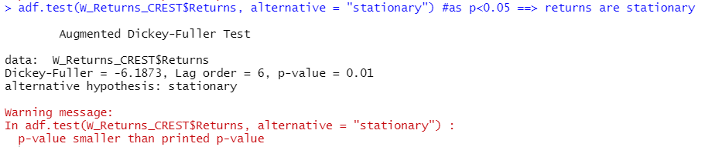

From *figure 29*, as p < 0.05, we conclude that CUB weekly returns are stationary.

Now, to find AR and MA coefficients to fit the ARIMA model, we plot acf and pacf, and use the *auto.arima* function.

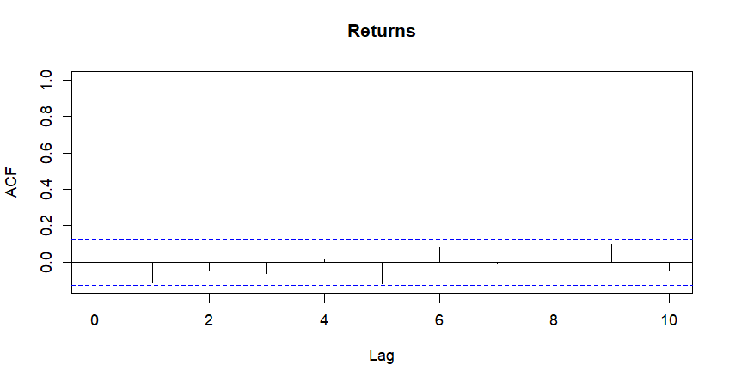

From figures 30, 31, and 32; it can be inferred that best-fit ARIMA model is of order (1,0,1).

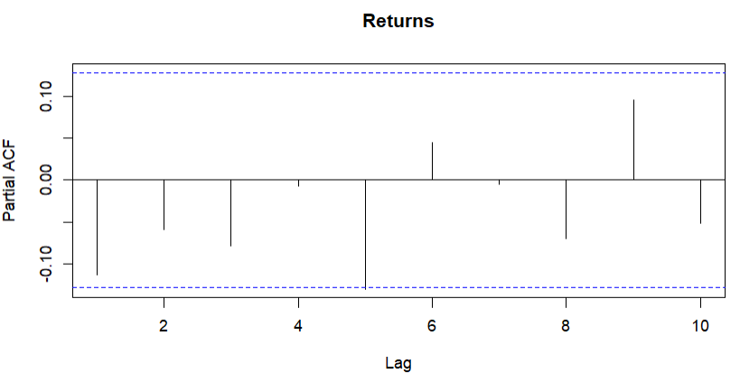

Now, using the model, forecasting of returns for future periods is done and the following forecasts are obtained: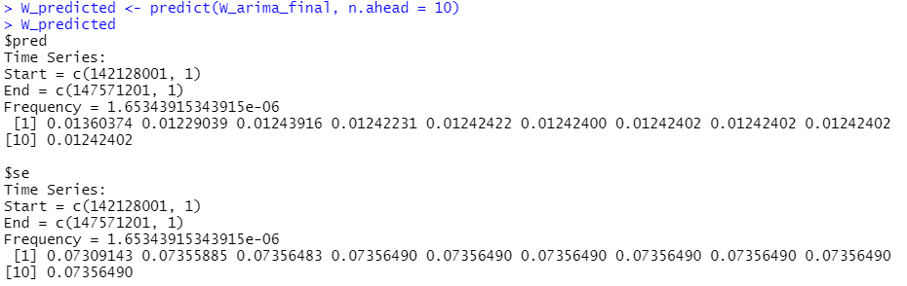

Finally, diagnostic test can be done for the fitted model to check whether it is appropriate. The graphical output obtained using *tsdiag* function is:

From graphs 1 and 2 of *figure 34*, it can be seen that the residuals do not follow any particular pattern, and even the ACF has no peak except lag-0.

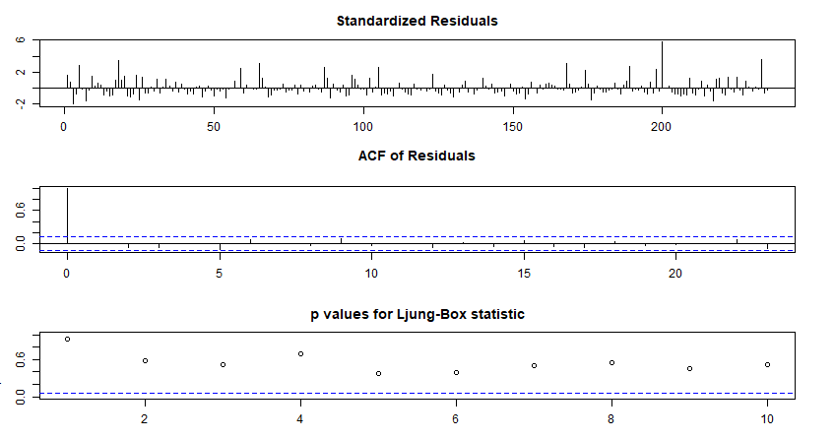

The Ljung-Box test is used to chek whether the residuals have been indepndently distributed or not from each other. Its null hypothesis says they are independnt, whereas the alternatve hypothesis says they are not. From Graph 3 of figure 34, it can be seen that all the p-values are above the critical t-statstic. Hence, we cannot reject the null hypothesis and conclude that the residuals are indepndent.

### **1.3.3 GARCH and EGARCH Modelling**

The methodology employed is explained in the *section 1.3*.

GARCH(1,1) and EGARCH(1,1) models are first specified (refer *figure* *1* and *2*). Then, using *rugarch* package and *ugarchfit* function, apt GARCH and EGARCH models are fitted. The output for the same on weekly timeframe is as following: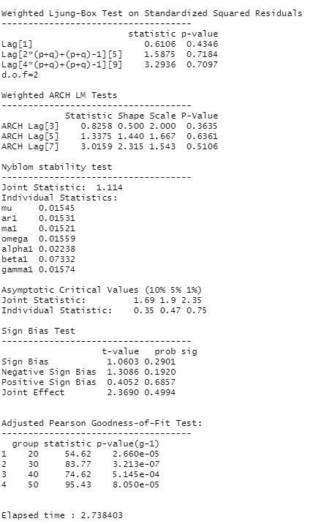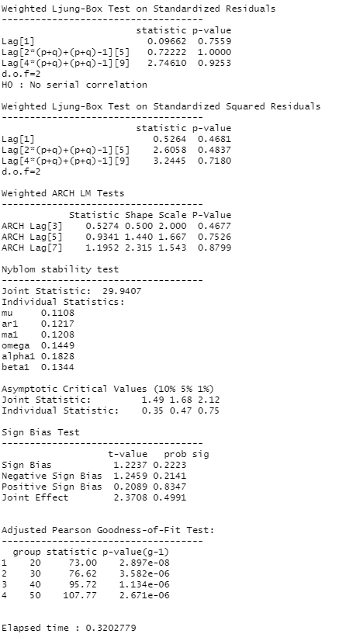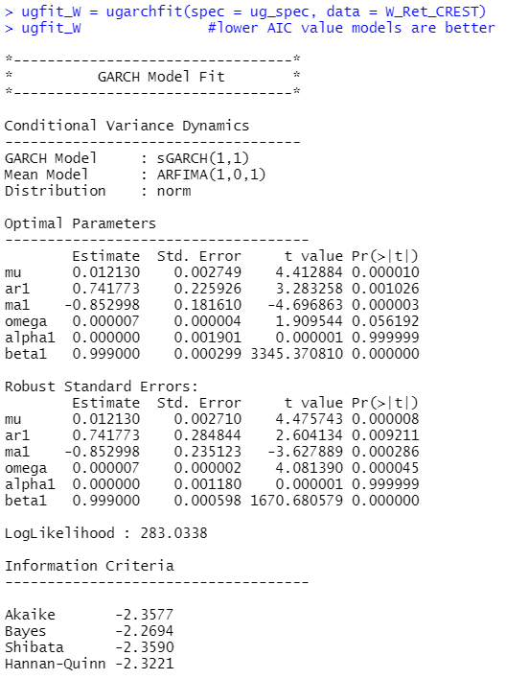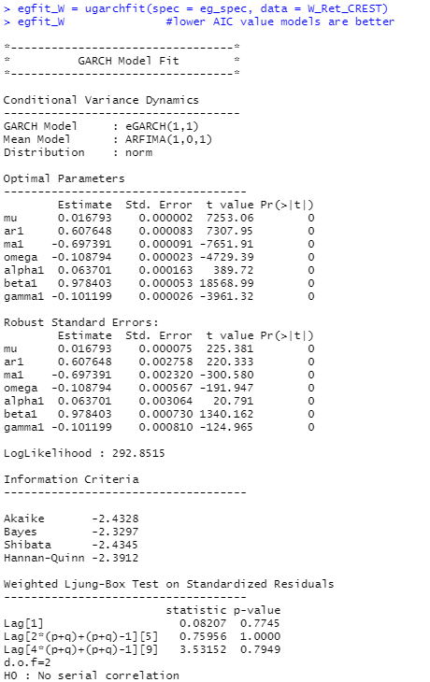

Interpretation of the above GARCH(1,1) model fitting’s result (*figure 35*) is:

* The log-likelihood of the model is 283.0338.  
  GARCH(1,1) and its corresponding ARFIMA(1,0,1) model are the best fit for CREST weekly returns. Among the optimal parametres, only beta1 isn’t statistically significant since its p-value is greater than 0.05. Among the robust standard errors’ parametres, beta1 and alpha1 are not statistically significant as their p-values exceed 0.05.
* In the Ljung-Box test result section, as all the p-values for both standardised residuals and squared residuals are much higher than 0.05, the null hypothesis can’t be rejected. This means there’s no serial autocorrealtion, which is a favorable condition for the model.
* In the ARCH LM test, since the p-values are far above 0.05, the null hypothesis that an adequate ARCH process is fitted cannot be rejected. In the Adjusted Pearson goodness-of-fit section, all the p-values are above 0.05, indicating that the null hypothesis can’t be rejected, and the stated distribution is followed.
* All in all, the fitted GARCH(1,1) model is the best-fit for CREST weekly returns.
* Interpretation of the above EGARCH(1,1) model fitting’s result (figure 36) is:  
  The log-likelihood of the model is 292.8515. EGARCH(1,1) and its corresponding ARFIMA(1,0,1) model are the best for CREST weekly returns. All the optimal parametres except gamma1 are statistically significant, as their p-values are below 0.05. Likewise, all robust standard errors’ parametres except gamma1 are statistically significant since their p-values are lower than 0.05.
* In the Ljung-Box test section, all p-values for both standardised residuals and squared residuals are much higher than 0.05. Therefore, the null hypothesis cannot be rejected, meaning no serial autocorelation exists—this is a positive indicator for the model.
* In the ARCH LM test, the p-values are far greater than 0.05, so the null hypothesis that a sufficient ARCH process is fitted cannot be rejected. In the Adjusted Pearson goodness-of-fit section, all p-values are above 0.05, implying that the null hypothesis cannot be rejected, and the stated distribution is followed.

All-in-all, the fitted EGARCH(1,1) is the best-fit model for CREST weekly returns.

Now, weekly volatility forecasts are made for future using the fitted models using the *ugarchforecast* function and the output is as following: 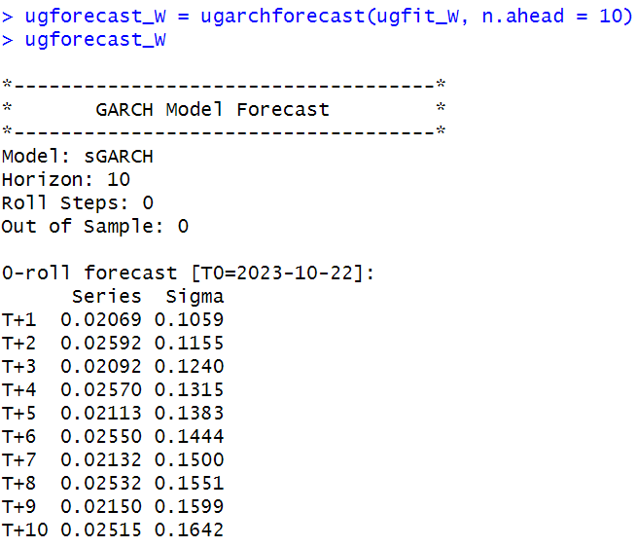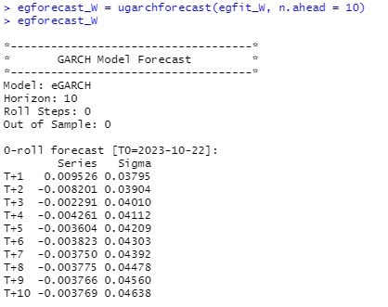

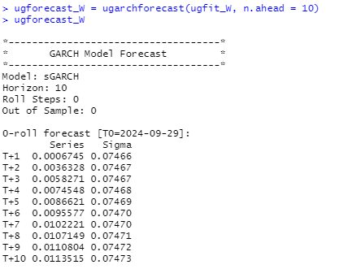

## 1.4 Frequency: Monthly

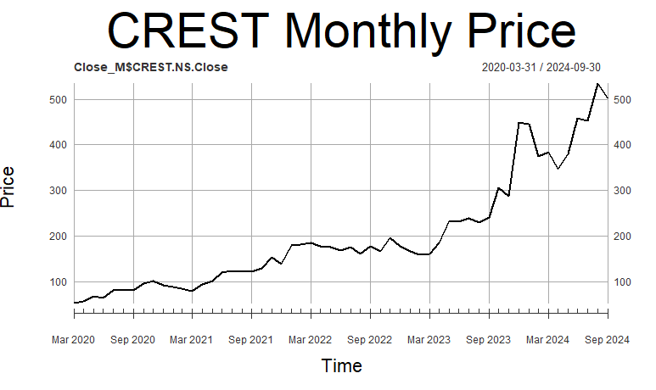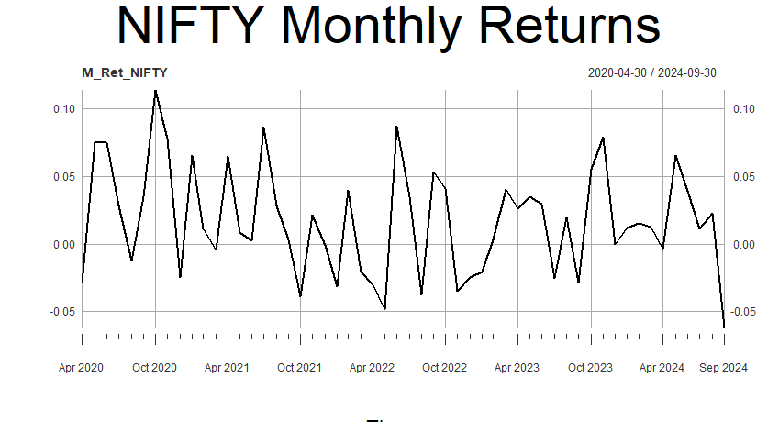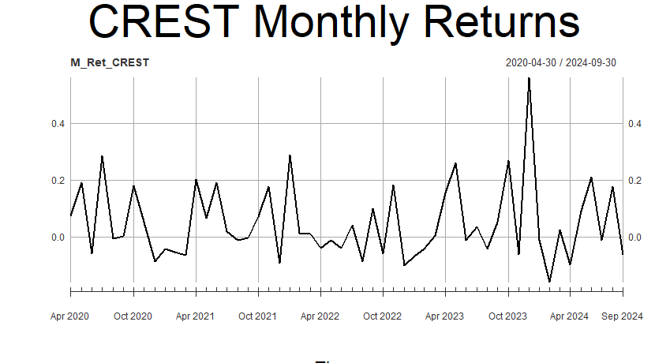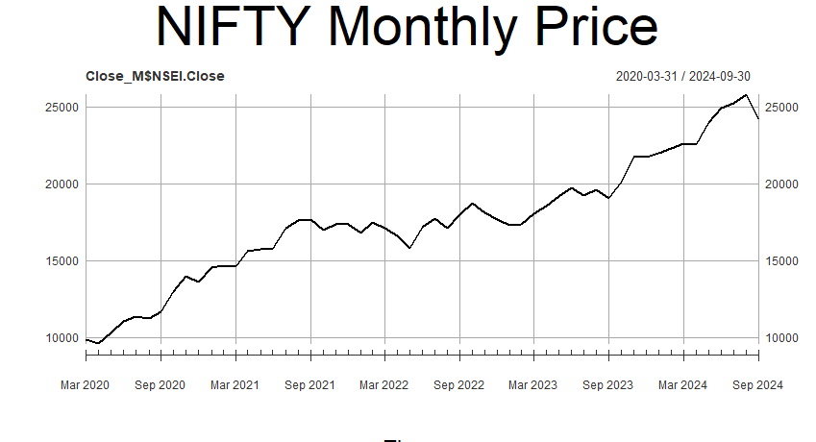

The period of analysis is from Mar 29th, 2020 to September 29th, 2024.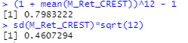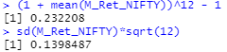

Monthly returns of both NIFTY 50 and CREST seem to be non-statonary.

Annualized monthly return of CREST for the period considred is 79.83%, and that of NIFTY 50 is 13.98%.

Annualized monthly risk (standard deviaton) of CREST for the period considred is 79.83%, and that of NIFTY 50 is 23.22%.

### **1.4.1 Estimating Beta using CAPM**

The methodology employed is explained in the *section 1.1*.

After running the regression, the output for (monthly timeframe) we get is:

From the output on the left, we understnd that the slope coeffcient is 1.209 and its p-value is greater than 5%, implying that it’s statistically insigificant.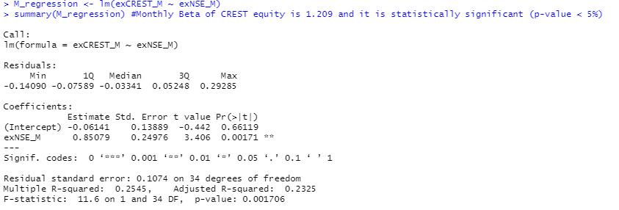

Hence, Beta of CREST at monthly timeframe is 1.209 but is statitically insigificant.

Economic interpretation of Beta would be that the returns of CREST are 25.4% less sensitve than that of the market. In other words, if the market premium (market’s excess return) rises by 1%, then the CREST’s return rises by 1.209%.

### 

### **1.4.2 ARIMA Modelling**

The methdology employed is explaind in section 1.2.

From figure 42, the monthly returns of CREST seem to be non-stationry. To chek this, the Augmented Dicky-Fuller (ADF) test is perfomed and the output obtained is:

From figure 48, as p < 0.05, we conclude that second-differenced CREST monthly data is stationary.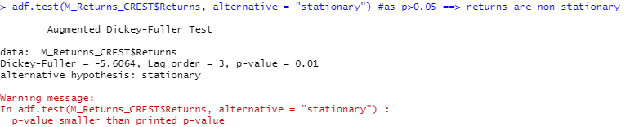turns are stationary. Hence, the coefficient *d* (degree of differencing) is found to be 2.

Now, to find AR and MA coefficients to fit the ARIMA model, we plot acf and pacf, and use the *auto.arima* function.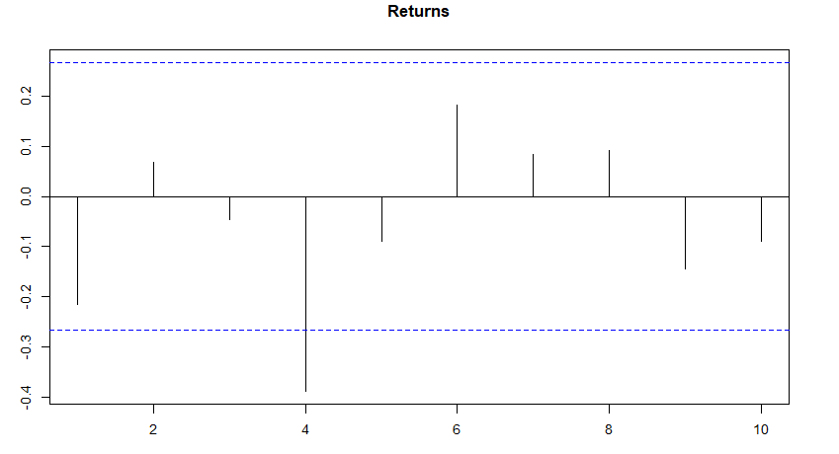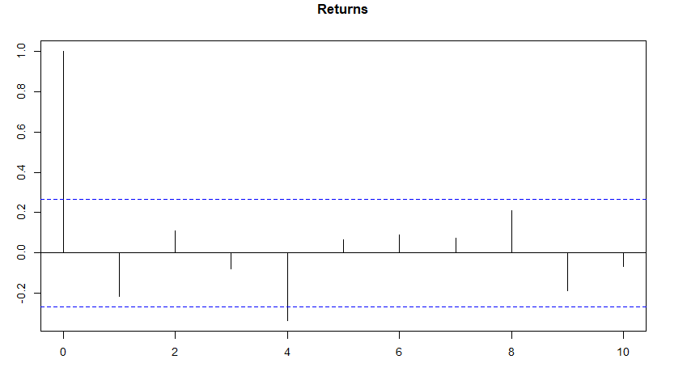

From previous discussion and *figures 49, 50, and 51*; it can be inferred that best-fit ARIMA model for CREST monthly returns series is of order (1,0,0). Hence, best-fit ARIMA model for second-differenced CREST monthly returns series is of order (1,0,0).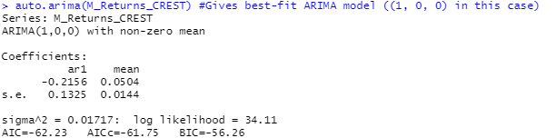

Now, using the model, forecasting of returns for future periods is done and the following forecasts are obtained: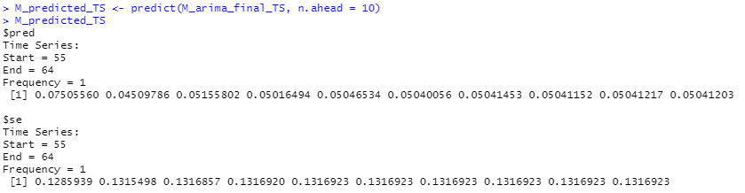

Finlly, a diagnostic test can be done for the fited model to chek whether it is apropriate. The graphical output obtained using the tsdiag functon is:

From graphs 1 and 2 of figure 53, it can be seen that the residuls do not follow any particulr pattern, and even the ACF has no peak except at lag-0.

The Ljung-Box test is used to chek whether the residuals have been independntly distributed or not from each other. Its null hypothsis says they are independnt, whereas the alternatve hypothsis says they are not. From graph 3 of figure 53, it can be seen that all the p-values are above the critical t-statistic. Hence, we cannot reject the null hypothsis and conclude that the residuls are independent.

### **1.4.3 GARCH and EGARCH Modelling**

The methodology employed is explained in the *section 1.3*. 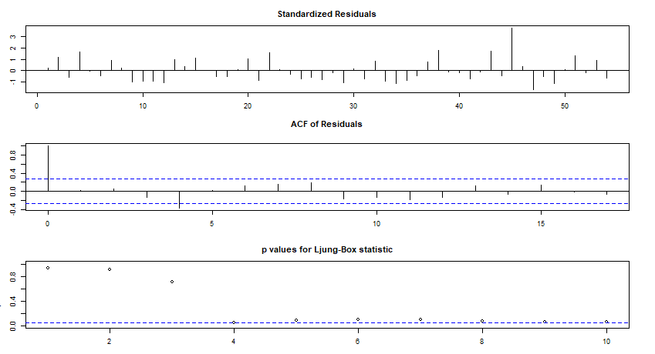

GARCH(1,1) and EGARCH(1,1) models are first specified (refer *figure* *1* and *2*). Then, using *rugarch* package and *ugarchfit* function, apt GARCH and EGARCH models are fitted. The output for the same on monthly timeframe is as following: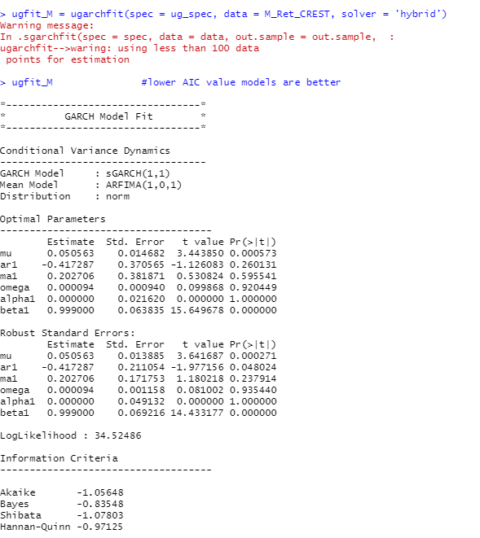

Interpretation of the above GARCH(1,1) model fitting’s result (*figure 54*) is: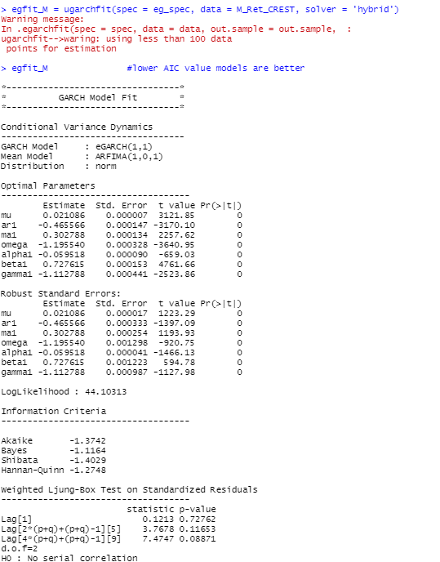

* The log-likelyhood of the model is 9.048.  
  GARCH(1,1) and its corresponding ARFIMA(1,0,1) model are best suited for CREST monthly returns. Among the optimal parametres, beta1 is statistically significant, as its p-value is lower than 0.05. Among the robust standard errors’ parametres, only ar1, ma1, and beta1 are statistically significant since their p-values fall below 0.05.
* In the Ljung-Box test result section, all p-values for both the standardised residuals and the squared residuals are much higher than 0.05. Therefore, the null hypothesis can’t be rejected, indicating no serial autocorelation, which is favorable for the model.
* In the ARCH LM test, since the p-values are far above 0.05, the null hypothesis that an adequate ARCH process is fitted cannot be rejected. In the Adjusted Pearson goodness-of-fit section, all the p-values are greater than 0.05. This implies the null hypothesis cannot be rejected, and the stated distribution is followed.
* Overall, the fitted GARCH(1,1) model is the best fit for CREST monthly returns.
* Interpretation of the above EGARCH(1,1) model fitting’s result (figure 36) is:  
  The log-likelyhood of the model is 16.772. EGARCH(1,1) and its corresponding ARFIMA(1,0,1) model are the best choice for CREST monthly returns. All the optimal parametres are statistically significant, with p-values lower than 0.05. Similarly, all the robust standard errors’ parametres are statistically significant since their p-values are below 0.05.
* In the Ljung-Box test section, all the p-values for both the standardised residuals and squared residuals are much higher than 0.05. Hence, the null hypothesis can’t be rejected, suggesting no serial autocorelation—this is a good condition for the model.
* In the ARCH LM test, as the p-values are significantly greater than 0.05, the null hypothesis that a sufficient ARCH process is fitted cannot be rejected. In the Adjusted Pearson goodness-of-fit section, all the p-values are above 0.05, meaning the null hypothesis cannot be rejected, and the stated distribution is followed.

All-in-all, the fitted EGARCH(1,1) is the best-fit model for CREST monthly returns.

Now, monthly volatility forecasts are made for future using the fitted models using the *ugarch forecast* function and the output is as following:

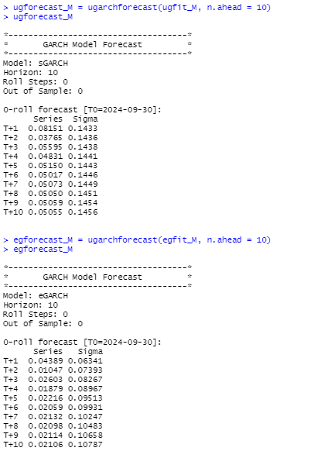

# 2. City Union Bank Limited (CUB)

## 2.1 Introduction



Fig.1.City Union Bank Limited Logo

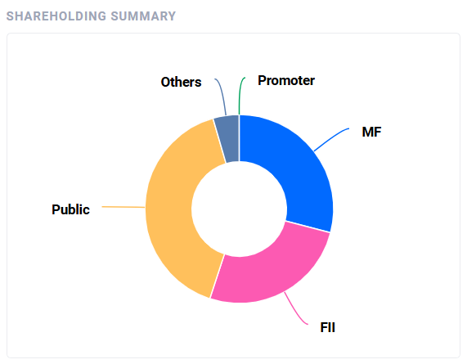

Fig.2.City Union Bank Limited Shareholding pattern

### **2.1.1 Business Nature**

City Union Bank Limited(CUB), is an Indian private-sector bank that engages its operations mainly in the following domains:

1. Banking and Financial Services:

* Retail Banking: It caters to various savings accounts, current accounts, fixed deposits, recurring deposits, and other old traditional banking products.
* Corporate Banking: It provides cash management, trade finance and working capital solutions to businesses.
* Agriculture Banking: It deals with the expansion of advances and overdrafts to the agricultural sector.

2. Lending Products:

* Personal, housing, car and gold loans for the customers.
* Business loans, SME financing, project loans, and trade credit for the businesses.
* Specialized credits to the agriculture and micro-enterprise sectors.

3. Wealth Management and Advisory Products:

* Mutual fund, insurance product and financial advisory products to the clients.
* Portfolio management services to HNIs.

4. Digital Banking:

* Internet and Mobile banking solutions.
* Solutions such as UPI payments, online transfers of funds, e-wallet etc.

5. Forex and Treasury Operations:

* Services related to foreign exchange including trade and travel across borders.
* Treasury management and investment in Government securities.

6. NRI Banking:

* This bank offers services especially for Non-Resident Indians, including NRE and NRO accounts, foreign currency loans, and remittance services.

The bank's strategy emphasizes personalized customer service, leveraging technology for efficient banking, and supporting small and medium enterprises (SMEs) and the rural economy.

**Industry Overview:** Established within the fastest-growing and most vibrant banking and financial services industry worldwide, India's banking and financial services sector is extremely competitive even for small banks and follows regulation of the Reserve Bank of India (RBI). City Union Bank has positioned itself well in meeting the needs of SMEs, agriculture, and retail customers in semi-urban and rural areas. This makes it distinguished from the larger private sector bank players like HDFC and ICICI Bank, which mainly target urban markets. CUB has a pan-India presence, but its core strength is in the southern states, particularly Tamil Nadu.

### **2.3.2 Type of Ownership**

The following summary shareholding chart of City Union Bank Limited discloses shares issued by the different types of shareholders. To better and more clearly understand it, a critical segment-wise break-up follows:.

1. Promoters(Green):

* This is too weak since it represents founders of the bank, and people who first helped it rise to glory. Its share covers the original foundational share in the bank.

2. Mutual Funds Holding(Blue):

* This is equivalent to the holding of the domestic mutual funds wherein these mutual funds buy shares in their name only. Hence, this means that the Indian fund managers trust the working of the bank.

3. Foreign Institutional Investors(Pink):

* This is the amount of investment done by foreign funds and foreign investors, and shows whether the bank was attractive or not on the international level.

4. Public(Yellow):

* It is the largest segment which comprises retail and individual investors, hence, acceptance and confidence by the people.

5. Others(Gray):

* This is the minority share consisting of trusts, corporate bodies among others.

Graph also reveals proper balance in shareholding pattern with the respective quantum of diversification showing landmark public participation coupled with mutual fund and foreign investor participation with promoters forming only relatively a small percentage, reflecting local as well as international confidence in City Union Bank.

### **2.3.3 Commencement of Business**

City Union Bank Limited, erstwhile The Kumbakonam Bank Limited, was established in 1904 on 31st October by 20 gentlemen of repute of Kumbakonam. Its first Agent was T.S. Raghavachariar who was succeeded in 1908 by R. Santhanam Iyer who became the first Secretary under altered Articles of Association. The first branch was opened in Mannargudi in 1930 and several other branches have since been opened within the Delta District of Tamil Nadu.

In 1965, it amalgamated with The City Forward Bank Limited and The Union Bank Limited, acquiring six more branches and adopting the name The Kumbakonam City Union Bank Limited. In 1987 it adopted the name City Union Bank Limited in consonance with national growth. In 1980 it established its first branch outside Tamil Nadu in Bangalore.

The bank steadily expanded its network while modernizing operations: computerization and ATMs initiated in 1990. The Bank introduced insurance and foreign exchange services while adopting core banking solutions from Tata Consultancy Services. Under the dynamic leadership of V. Narayanan, who took over as Chairman in 1980.

It celebrated its centenary in the year 2003. V Narayanan was the transformational period, and he left for his heavenly abode in a car accident in the year 2004. S Balasubramanian succeeded him thereafter, till 2011, followed by Dr N Kamakodi as Managing Director & CEO. Today, City Union Bank remains as a progressive private-sector bank with a strong regional base as well as modern banking solutions.

### **2.3.4 Overall Greatness of the Company**

Following the bank's strong September quarter results, shares of City Union Bank increased 13.21% to ₹170.50 a share in early morning trading on Monday, October 22, 2024. The broking houses were also able to maintain the buy call on the stock due to strong numbers. Most key metrics improvement from a metrics perspective has built investor sentiment. More on asset quality, the results were encouraging enough for City Union Bank as it reduced its GNPA to 3.54% in Q2FY25 from 4.66% in the same quarter in the previous fiscal. Net NPAs have improved to 1.62% from 2.34% in Q2 FY24.

City Union Bank, Ltd is the leading private sector scheduled commercial bank for South Indian urban, semi-urban, and rural territories. The customers are being provided with Treasury, Corporate Banking, Retail Banking, and NRI Banking services. Utility bill payments also include mobile banking that is called mBank Plus through which the tickets could be booked online, shopping online, and money transfer using Immediate Payment Service known as IMPS.

Apart from the above services, the bank offers its corporate customer digital signature authentication and a mobile wallet application for utility services. There are over 1,800 locations forming the spine of the bank, more than 760 off-site ATMs and Bills Recycler Machines (BRMs). The others include check acceptor KIOSKs and self-passbook printing KIOSKs.

It would provide the entire gamut of personal and corporate banking products through CUB, which would help in offering much-needed product variations, while at the same time supporting the digital banking revolution in India.

## 2.2 Frequency: Daily

Fig.2.2.1. NIFTY Daily Returns Fig.2.2.2. NIFTY Daily Close Price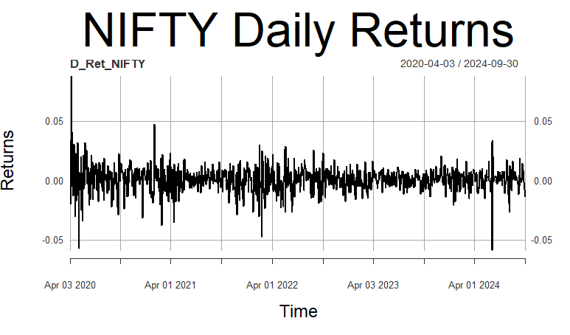

Fig.2.2.3. CUB Daily Close Price Fig.2.2.4.CUB Daily Returns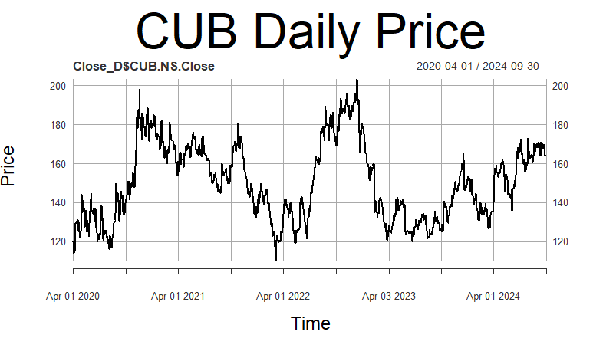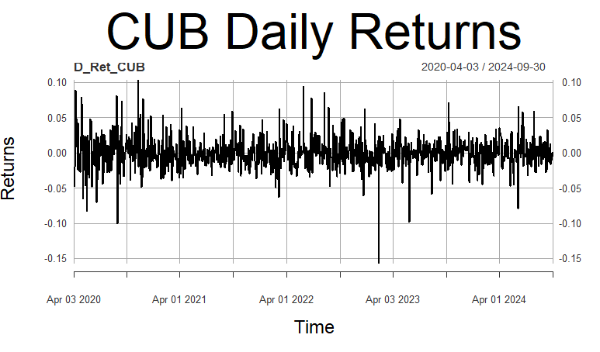

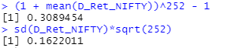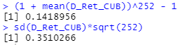

Fig.2.2.5. CUB Daily Returns Summary Fig.2.2.6.NIFTY Daily Returns Summary

The analysis period extends from April 1st, 2020 to September 30th, 2024. Daily returns of both NIFTY 50 and CUB appear to be stationary for the daily time frame. Annualized daily return of CUB for this period is 14.19% and NIFTY 50 has outperformed the company by generating a return of 30.89%.

Annualized daily risk (standard deviation) for the company under consideration, CUB is 35.10% and that of NIFTY 50 is 16.22%, indicating high risk low return.

### **2.2.1 Estimating Beta using CAPM**

The methodology employed is explained in the *section 1.1*.

Fig. Regression Summary

After running the regression, the output for analyzed time frame is:

From the output, we understand that the slope coefficient is 0.9806 and its p-value is very less than 0.001 indicating that it’s statistically significant. Hence, Beta of CUB at daily time-frame is 0.9806 (less than 1).

Economic interpretation of Beta would be that the returns of CUB are less sensitive than that of the market ie. NIFTY index. Another way of explaining it would be that, if the market premium rises by 10%, then the CUB’s return rises by 9.806% only.

### **2.2.2 ARIMA Modelling**

The methodology employed is explained in section *1.2*.

From Fig.2.2.4., the daily returns of CUB appear to be stationary. To prove this, the Augmented Dicky-Fuller (ADF) test is performed and the output is shown below:

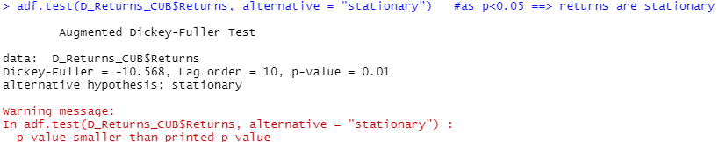

Fig.2.2.7. ADF test output

From *Fig.2.2.7.*, as p value comes out to be less than 0.05 ie. 0.01, hence it is confirmed that CUB daily returns are stationary.

Inorder to fit ARIMA model, we move to find AR and MA coefficients, we analyze the acf and pacf plots while utilizing *auto.arima* function.

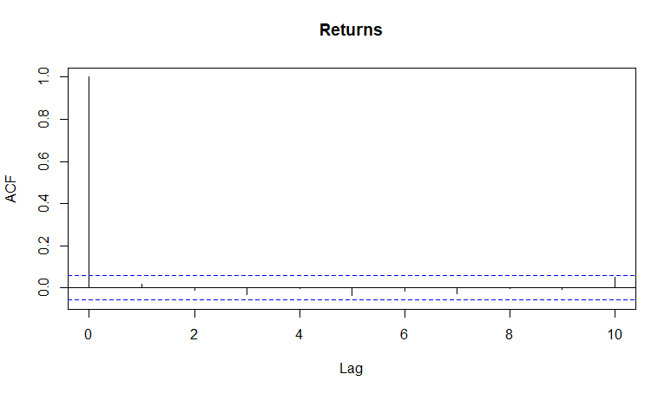

Fig.2.2.8. ACF Plot

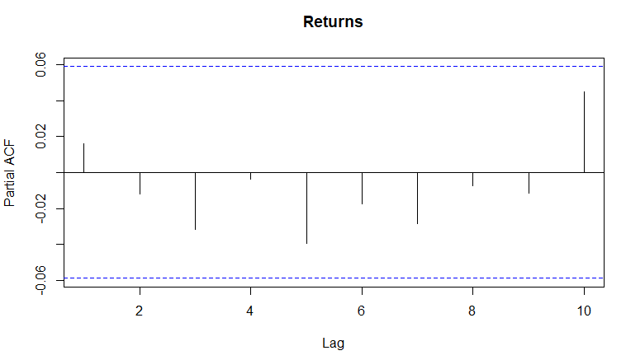

Fig.2.2.9. PACF Plot

Fig.2.2.10. *auto.arima* output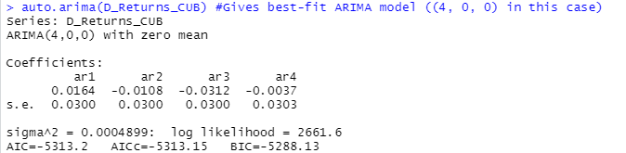

From the figures 2.2.8, 2.2.9, 2.2.10; it can be concluded that the ARIMA model which fits best is of order (4,0,0).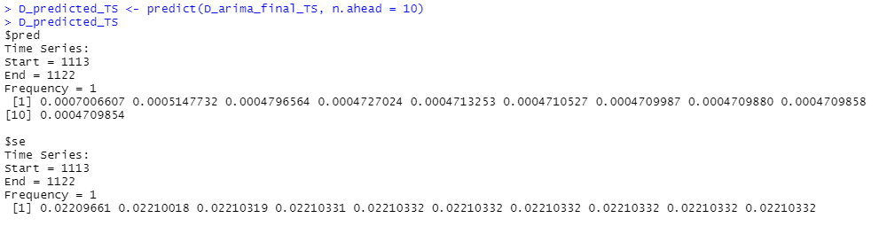

Fig.2.2.11. Return forecasts

Now, by using this model, forecasting of returns for future periods are computed and the above shown outputs are obtained.

Finally, diagnostic tests can be done for the fitted model to check whether it is appropriate. The graphical output obtained by running diagnostic tests using *tsdiag* function is:

Fig.2.2.12. Diagnostic plots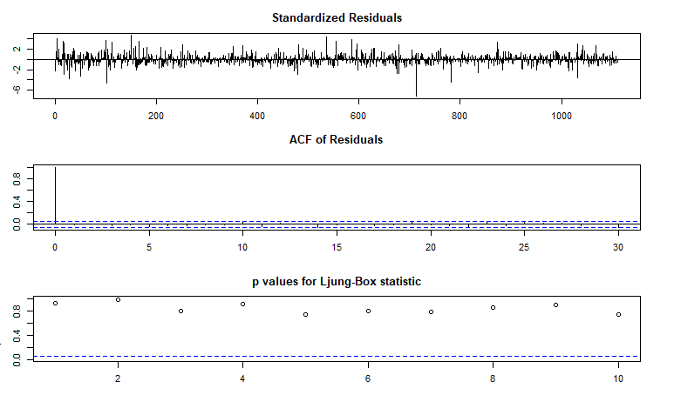

From the 1st and 2nd graph of the above figure, it can be seen that the residuals do not follow any particular pattern and fluctuate randomly suggesting a good model fit, and even the ACF has no peak except lag-0. This confirms absence of correlation in residuals. The Ljung-Box test is used to check whether the residuals have been independently distributed or not from each other. Its null hypothesis says they are independent, whereas the alternative hypothesis says they are not. From the 3rd of the above figure, it can be seen that all the p-values are above the critical t-statistic. Hence, we cannot reject the null hypothesis and conclude that the residuals are independent and uncorrelated.

### **2.2.3 GARCH and EGARCH Modelling**

The methodology employed is explained in section *1.3*.

GARCH(1,1) and EGARCH(1,1) models are first specified under the methodology section. By using *rugarch* package and *ugarchfit* function, suitable GARCH and EGARCH models are fitted. The output for the analyzed time frame is as following:

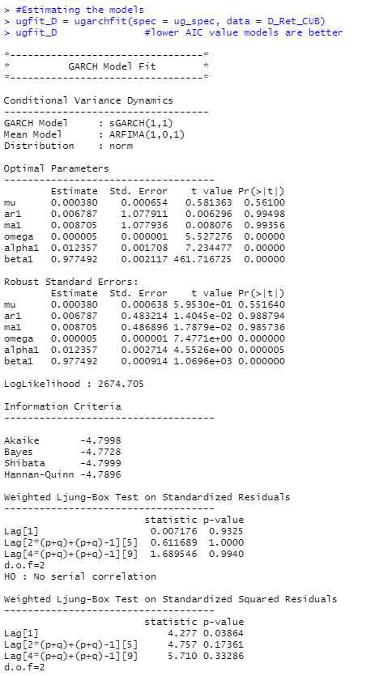

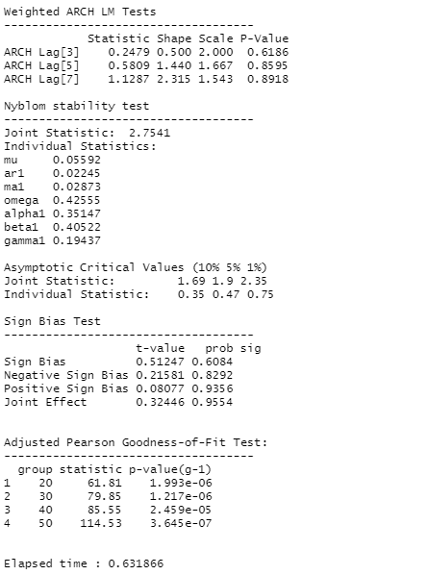

Fig.2.2.13. GARCH(1,1) Plot

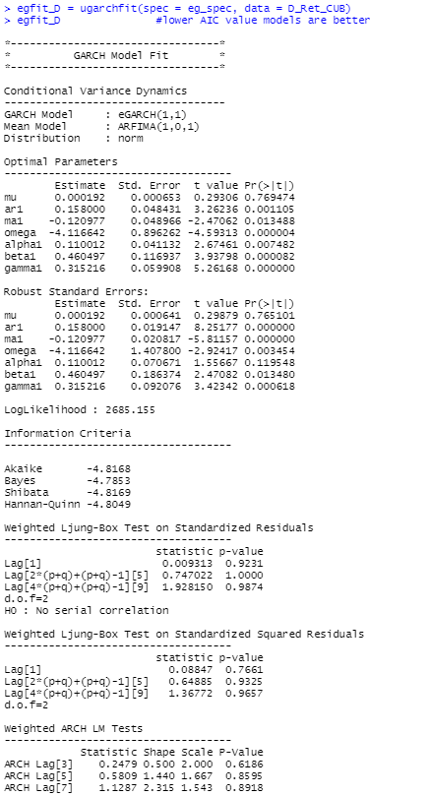 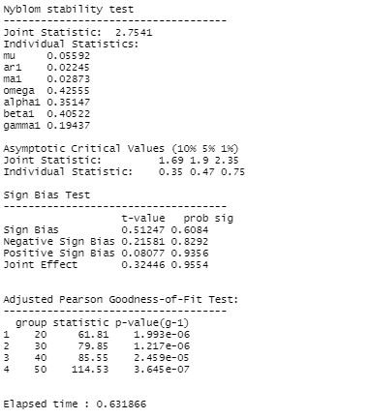

Fig.2.2.14. EGARCH(1,1) Plot

GARCH(1,1) model fitting’s interpretation is explained in detail below:

The log-likelihood of the model is 2674.705 GARCH(1,1) and corresponding ARFIMA(1,0,1) are best for CUB’s daily returns.

In the optimal parameters section, only mu, ar1, and ma1 aren’t statistically significant as their p-value is greater than 0.05.

In the robust standard errors’ parameters section as well, mu, ar1 and ma1 are not statistically significant as their p-values are greater than 0.05.

In the Ljung-box test result section, since all the p-values for both standardized results and standard squared residuals are quite higher than 0.05 (except Lag[1] in standard squared residuals), the null hypothesis cannot be rejected and hence no serial autocorrelation exists which implies a good condition for the model.

In the ARCH LM test, as p-values are greater than 0.05, the null hypothesis that an adequate ARCH process is fitted is proven to be correct.

In the Adjusted Pearson goodness-of-fit section, each and every p-value is very low, impling that the null hypothesis is accepted to be correct and hence the stated distribution isn’t used.

Overall, the fitted GARCH(1,1) is the best-fit model for CUB’S daily returns.

Interpretation of the above EGARCH(1,1) model fitting’s result (*figure 19*) is:

The log-likelihood of the model is 2685.155. EGARCH(1,1) and corresponding ARFIMA(1,0,1) are best for CUB daily returns.

All the optimal parameters except mu are statistically significant as their p-values are lower than 0.05. All the robust standard errors’ parameters except mu and alpha1 are statistically significant with their p-values lower than 0.05.

In the Ljung-box test result section, since all the p-values for both standardized results and standard squared residuals are much higher than 0.05, the null hypothesis cannot be rejected and hence no serial autocorrelation exists which is a good condition for the model.

In the ARCH LM test, as p-values are far greater than 0.05, the null hypothesis that an adequate ARCH process is fitted cannot be rejected.

In the Adjusted Pearson goodness-of-fit section, all the p-values are very low, which implies that the null hypothesis cannot be rejected and hence the stated distribution isn’t followed.

Overall, the fitted EGARCH(1,1) is the best-fit model for CUB daily returns.

Daily volatility forecasts are computed for future using the fitted models using the *ugarchforecast* function and the results are shown below:

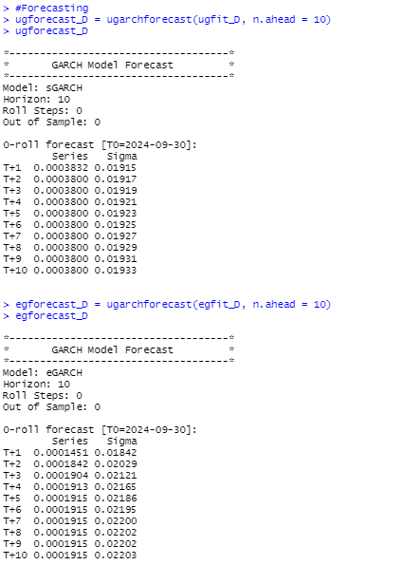

Fig.2.2.15. Forecasts by both the models

## 

## 

## 2.3 Frequency: Weekly

Fig.2.3.1. NIFTY Weekly Close Price Fig.2.3.2. NIFTY Weekly Returns

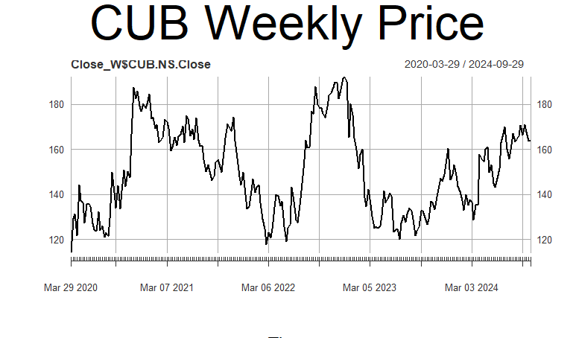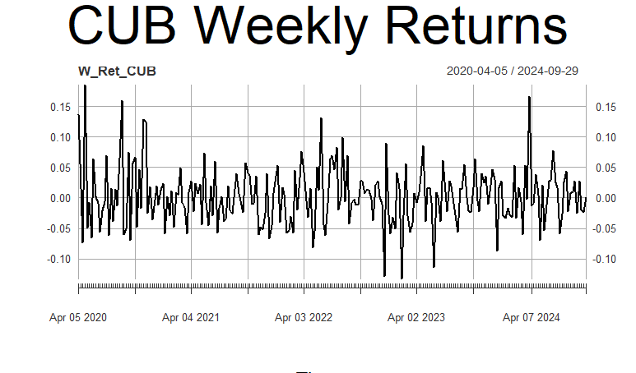

Fig.2.3.3. CUB Weekly Close Price Fig.2.3.4. NIFTY Weekly Returns

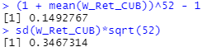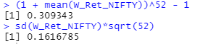

Fig.2.3.5. NIFTY Returns Summary Fig.2.3.6. CUB Returns Summary

The analysis period extends from April 1st, 2020 to September 30th, 2024.

Weekly returns of both NIFTY 50 and CUB appear to be stationary.

Annualized weekly return of CUB for the period considered is 14.93% and that of NIFTY 50 is 30.93%.

Annualized weekly risk (standard deviation) of CUB for the period considered is 34.67% and that of NIFTY 50 is 16.17%, again indicating high risk low return.

### **2.3.1 Estimating Beta using CAPM**

The methodology employed is explained in section *1.1*.

After running the regression, the output for (weekly timeframe) we get is:



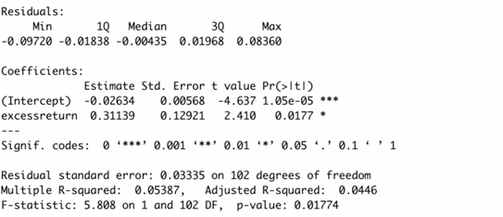

Fig.2.3.7. Regression Summary

From the regression results, the beta came out to be 0.31139, implying that if index portfolio excess returns increase by 1% then the returns increase by 0.31139%. Also, the beta value is significant at both 95% and 99% since the p-value is less than 0.01 (p < 0.01). The intercept value obtained from the regression is -0.02634, which implies that if all the independent variables are equal to zero (for our case it is only Rm - Rf), then CUB’s returns are -0.02634%.

### **2.3.2 ARIMA Modelling**

The methodology employed is explained in section *1.2*.

From Fig.2.3.4., the weekly returns of CUB appear to be stationary. To confirm this, the Augmented Dicky-Fuller (ADF) test is used, the results are shown below:

Fig.2.3.7. ADF Test Output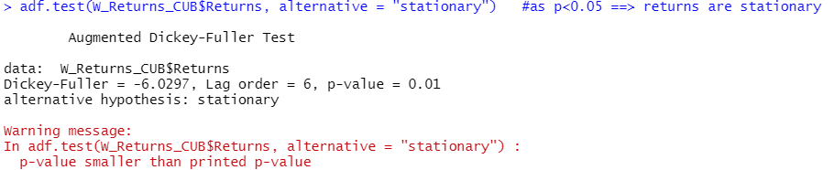

From *Fig.2.3.7.*, as p value comes out to be less than 0.05, hence it is confirmed that CUB weekly returns are stationary.

Inorder to fit ARIMA model, we move to find AR and MA coefficients, we analyze the acf and pacf plots while utilizing *auto.arima* function.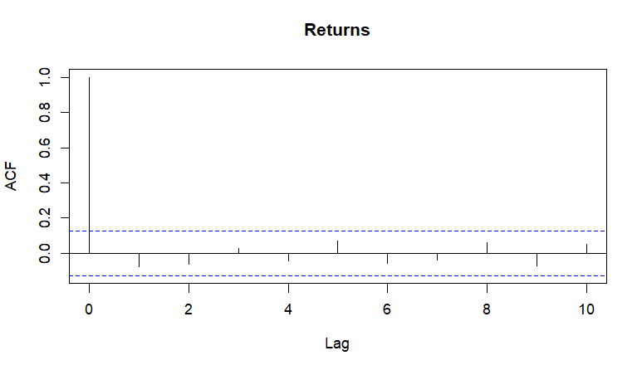

Fig.2.3.8. ACF Plot

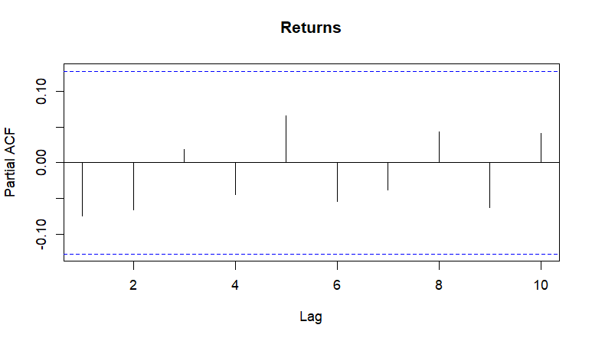

Fig.2.3.9. PACF Plot

Fig.2.3.10. *auto.arima* Output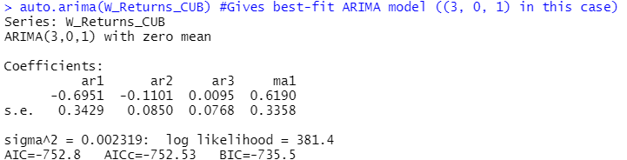

From the figures 2.3.8, 2.3.9, 2.3.10; it can be concluded that the ARIMA model which fits best is of order (3,0,1).

Using this model, forecasts of returns for future periods is computed and the following forecasts are obatained: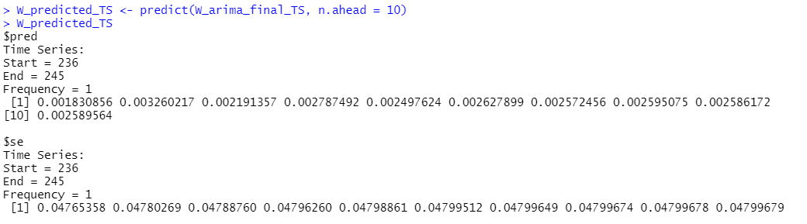

Fig.2.3.11. Return Forecasts

The diagnostic tests are performed for the fitted model to check whether it is suitable/correct. The graphical output computed using *tsdiag* function, shown below:

Fig.2.3.12. Diagnostic Plots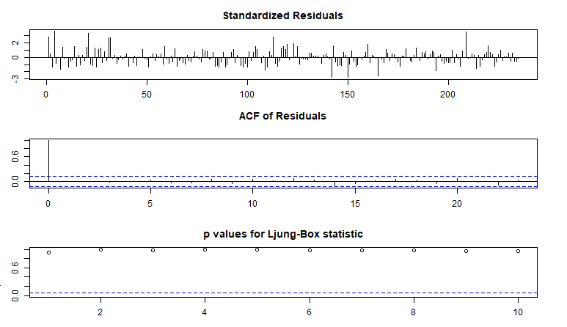

From the 1st and 2nd graph of the above figure, it can be seen that the residuals do not follow any particular pattern and fluctuate randomly suggesting a good model fit, and even the ACF has no peak except lag-0. This confirms absence of correlation in residuals.

The Ljung-Box test is used to check whether the residuals have been independently distributed or not from each other. Its null hypothesis says they are independent, whereas the alternative hypothesis says they are not. From the 3rd of the above figure, it can be seen that all the p-values are above the critical t-statistic. Hence, we cannot reject the null hypothesis and conclude that the residuals are independent of each other.

### **2.3.3 GARCH and EGARCH Modelling**

The methodology employed is explained in section *1.3*.

GARCH(1,1) and EGARCH(1,1) models are specified in the above mentioned section. Then, using *rugarch* package and *ugarchfit* function, apt GARCH and EGARCH models are fitted to the time frame. The output for the weekly time frame is shown as follows:

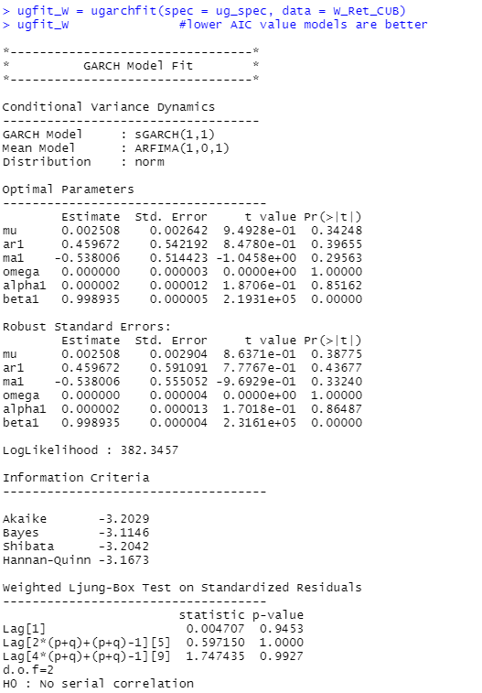

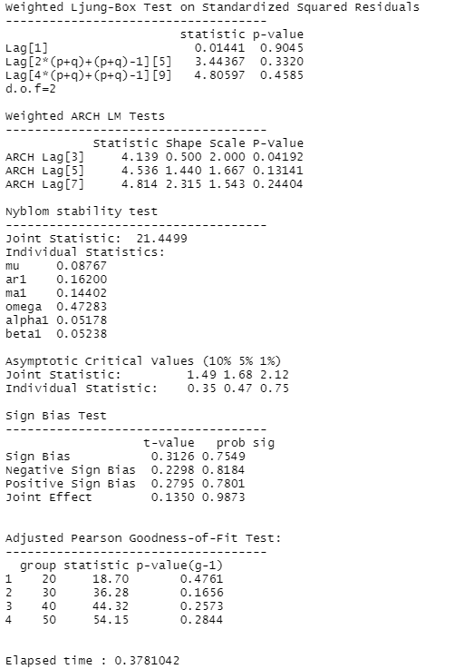

Fig.2.3.13. GARCH(1,1) Fit

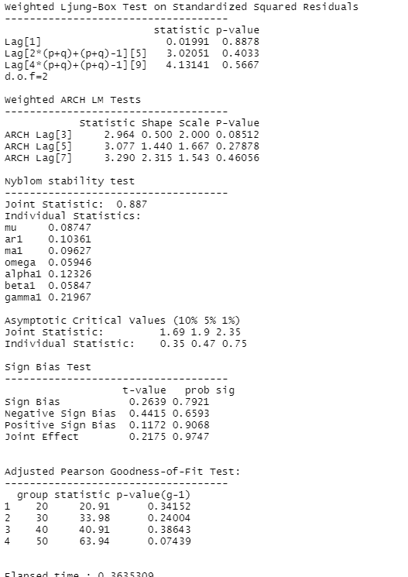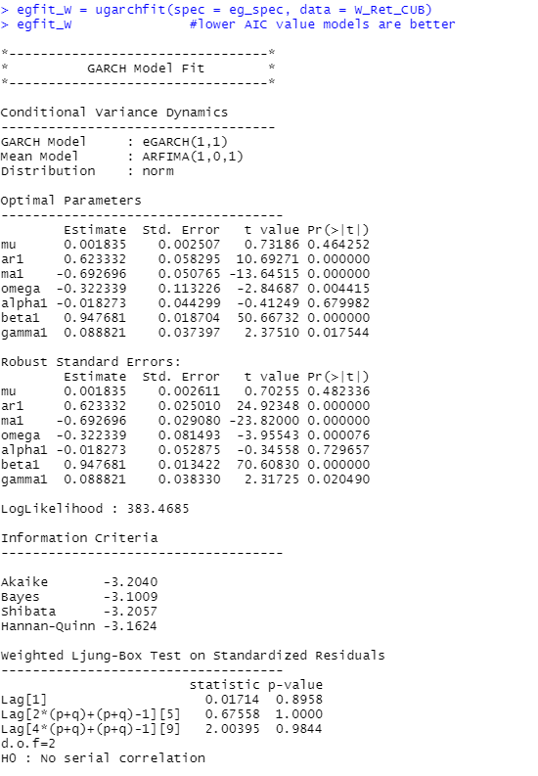

Fig.2.3.14. EGARCH(1,1) Fit

The inferences from the GARCH model shown in Fig.2.3.13 is written as follows:

The log-likelihood of the model is 382.3457.

GARCH(1,1) and corresponding ARFIMA(1,0,1) are best for CUB weekly returns.

In the optimal parameters section, only beta1 is statistically significant as its p-value is less than 0.05.

In the robust standard errors’ parameters section also, the above result applies.

In the Ljung-box test result section, since all the p-values for both standardized results and standard squared residuals are much higher than 0.05, the null hypothesis has been accepted to be correct and hence no serial autocorrelation exists which is the best condition for this model.

In the ARCH LM test, p-values are far greater than 0.05, hence the null hypothesis that an adequate ARCH process is fitted is correct.

In the Adjusted Pearson goodness-of-fit section, every p-value is greater than 0.05, which implies that the null hypothesis cannot be rejected and hence the stated distribution is followed.

Overall, the fitted GARCH(1,1) is the best-fit model for CUB weekly returns.

Interpretation of the above EGARCH(1,1) model fitting’s result (*figure 36*) is:

The log-likelihood of the model is 383.4685.

EGARCH(1,1) and Equivalent ARFIMA(1,0,1) are best for CUB weekly returns.

In the optimal parameters section, all parameters except ar1, ma1, omega and beta1 are statistically insignificant as their p-values are greater than 0.05.

In the robust standard errors’ parameters section, all parameters except mu and alpha1 are statistically significant as their p-values are lower than 0.05.

In the Ljung-box test result section, since all the p-values for both standardized results and standard squared residuals are much higher than 0.05, the null hypothesis cannot be rejected and hence no serial autocorrelation exists which is a good condition for the model.

In the ARCH LM test, as p-values are far greater than 0.05, the null hypothesis that an adequate ARCH process is fitted cannot be rejected.

In the Adjusted Pearson goodness-of-fit section, all the p-values are greater than 0.05, which implies that the null hypothesis cannot be rejected and hence the stated distribution is followed.

Overall, the fitted EGARCH(1,1) is the best-fit model for CUB weekly returns.

Weekly volatility forecasts are computed for future using the fitted models using the *ugarchforecast* function and the output is shown below:

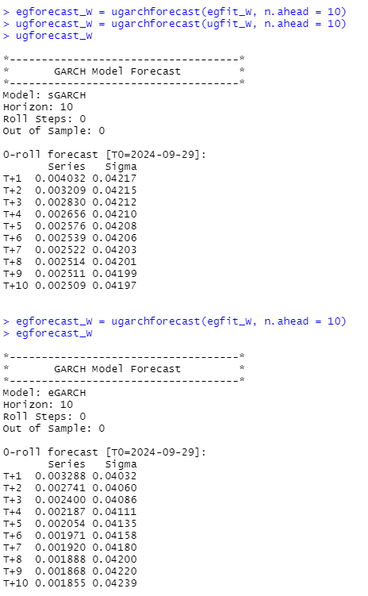

Fig.2.3.15. Volatility forecasts for both the models

## 2.4 Frequency: Monthly

Fig. 2.4.1 NIFTY Monthly Close Price Fig. 2.4.2. NIFTY Monthly Returns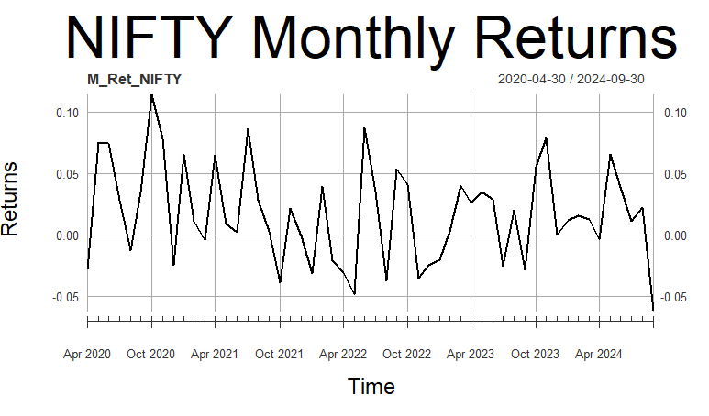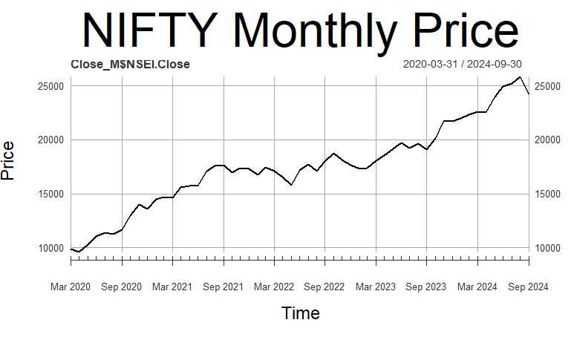

Fig. 2.4.3. CUB Monthly Close Price Fig. 2.4.4. NIFTY Monthly Returns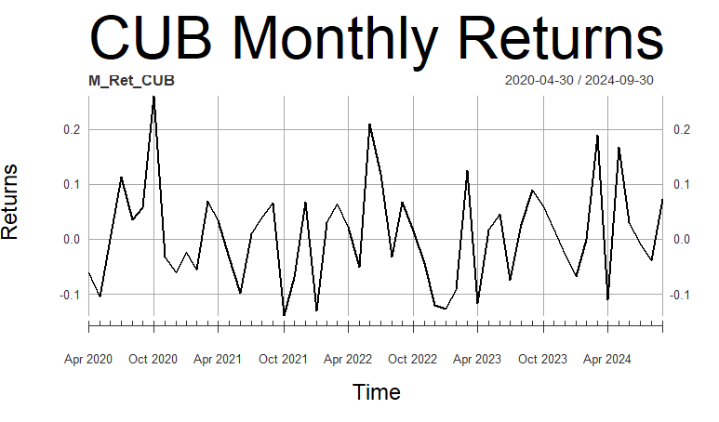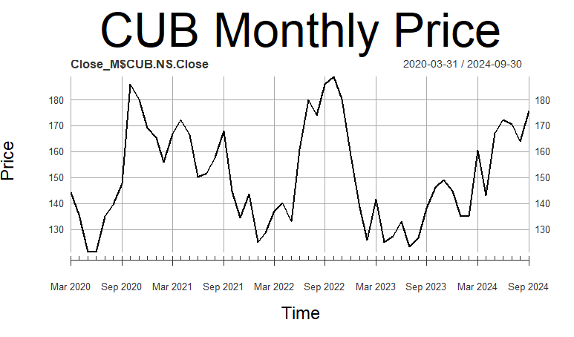

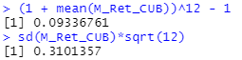

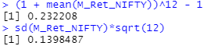

Fig.2.4.5. NIFTY Return Summary Fig.2.4.5. CUB Return Summary

The analysis period extends from April 1st, 2020 to September 30th, 2024.

Monthly returns of both NIFTY 50 and CUB seem to be stationary. Annualized monthly return of CUB for this period is 9.34% and NIFTY 50 has outperformed the company by generating a return of 23.22%.

Annualized monthly risk (standard deviation) for the company under consideration, CUB is 31.01% and that of NIFTY 50 is 13.98%.

### **2.4.1 Estimating Beta using CAPM**

The methodology employed is explained in section *1.1*.

After running the regression, the output for analyzed time frame is: 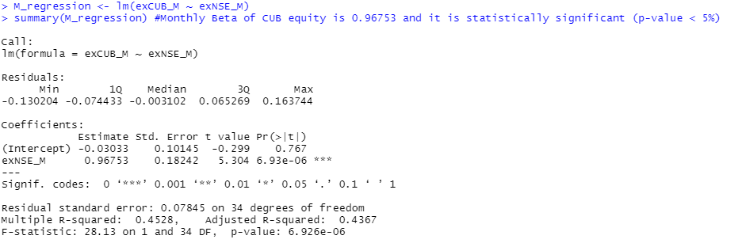

Fig.2.4.7. Regression analysis

From the above results, we conclude that the estimated slope coefficient is 0.96753 and its p-value is less than 0.001 implying that it’s not statistically insignificant. Beta of CUB at monthly time-frame is 0.96753 and implies that it is statistically significant.

Economic interpretation of Beta would be that the returns of CUB are less sensitive than that of the market. Another interpretation will be that, if the market premium increases by 10%, then the CUB’s return rises by 9.806% only.

### **2.4.2 ARIMA Modelling**

The methodology employed is explained in section *1.2*.

From Fig.2.4.4., the monthly returns of CUB appear to be non-stationary. To prove this, the Augmented Dicky-Fuller (ADF) test is done and the output is shown below:

Fig.2.4.8. ADF Test Output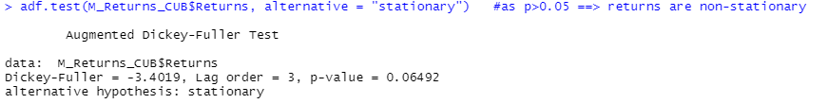

From Fig.2.4.8., as p-value is greater than 0.05, we conclude that CUB monthly returns are non-stationary. Hence, the differencing method needs to be applied using the *diff* function. The adf test output for first-differenced monthly returns is shown below:

Fig.2.4.9. ADF Differencing Output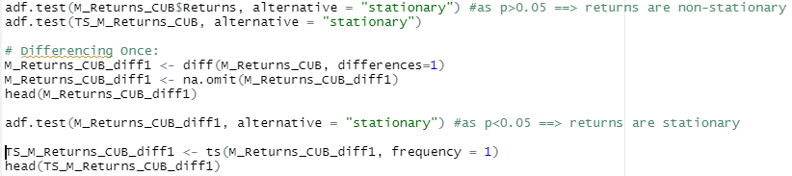

From Fig.2.4.9., we can see that when the differencing method is used and p value comes out to be lesser than 0.05. This implies that the coefficient *d* (degree of differencing) is found to be 1. Hence, the monthly returns of CUB are stationary after application of the differencing method.

Inorder to fit ARIMA model, we move to find AR and MA coefficients, we analyze the acf and pacf plots while utilizing *auto.arima* function.

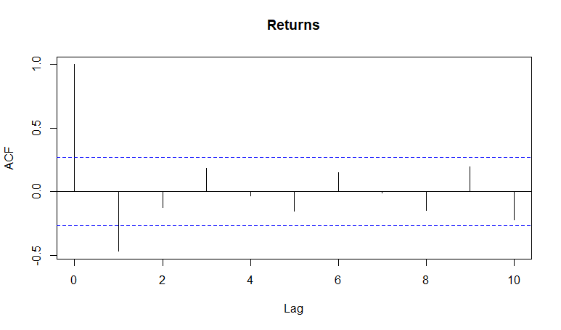

Fig.2.4.10. ACF Plot

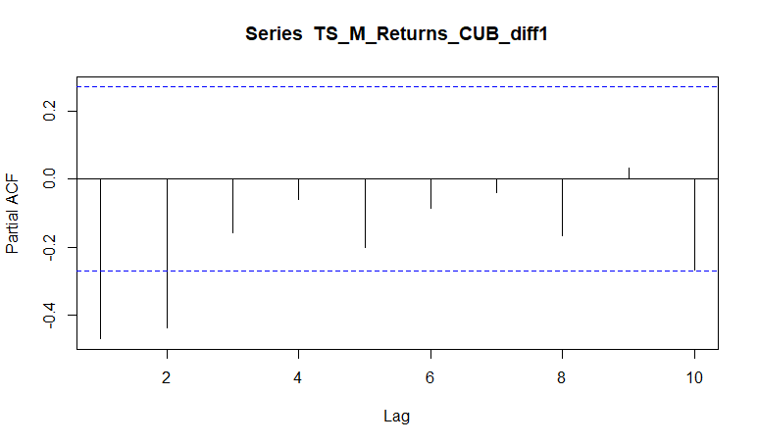

Fig.2.4.11. PACF Plot

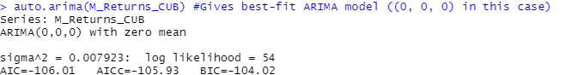

Fig.2.4.12. *auto.arima* Output

According to Figures 2.4.10, 2.4.11, 2.4.12; suggest that the ARIMA model for CUB monthly returns series is of order (0,0,0). The model for differenced form was also obtained to be the same.

Using this model, forecasts of returns for future periods is computed and the following forecasts are found:

Fig.2.4.13. Forecasted Returns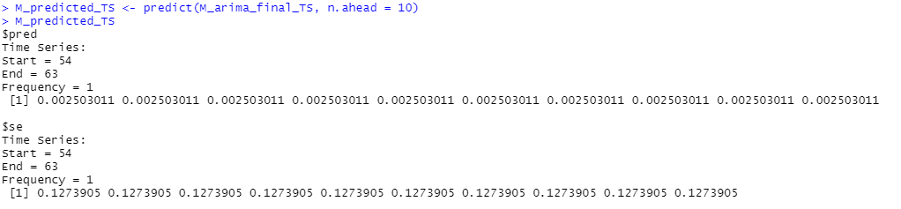

Finally, diagnostic tests are used for the fitted model to check whether it is suitable/appropriate. The graphical output computed using *tsdiag* function is shown below:

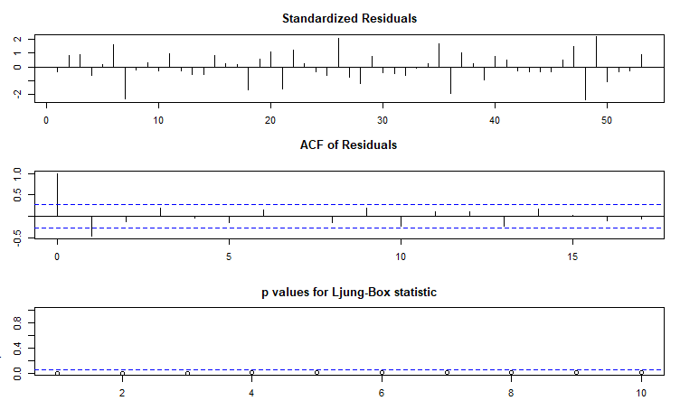

Fig.2.4.14. Diagnostic Plots

From the 1st and 2nd graph of the above figure, it can be seen that the residuals do not follow any particular pattern and fluctuate randomly suggesting a good model fit, and even the ACF has no peak except lag-0. This confirms absence of correlation in residuals.

The Ljung-Box test is used to check whether the residuals have been independently distributed or not from each other. Its null hypothesis says they are independent, whereas the alternative hypothesis says they are not. From the 3rd of the above figure, it can be seen that all the p-values are above the critical t-statistic. Hence, we cannot reject the null hypothesis and conclude that the residuals are independent of each other.

### 

### **2.4.3 GARCH and EGARCH Modelling**

The methodology employed is explained in the *section 1.3*.

GARCH(1,1) and EGARCH(1,1) models are specified in the above mentioned section. Then, using *rugarch* package and *ugarchfit* function, apt GARCH and EGARCH models are fitted. The output for the same, on monthly time frame is as following: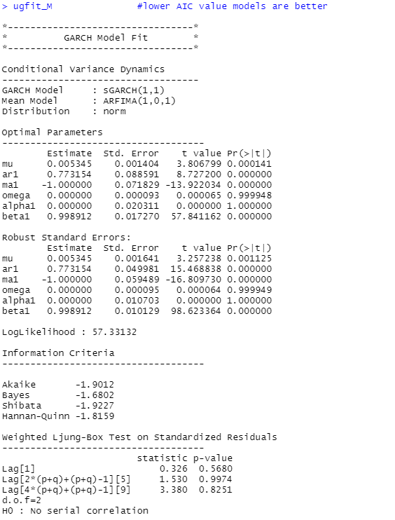

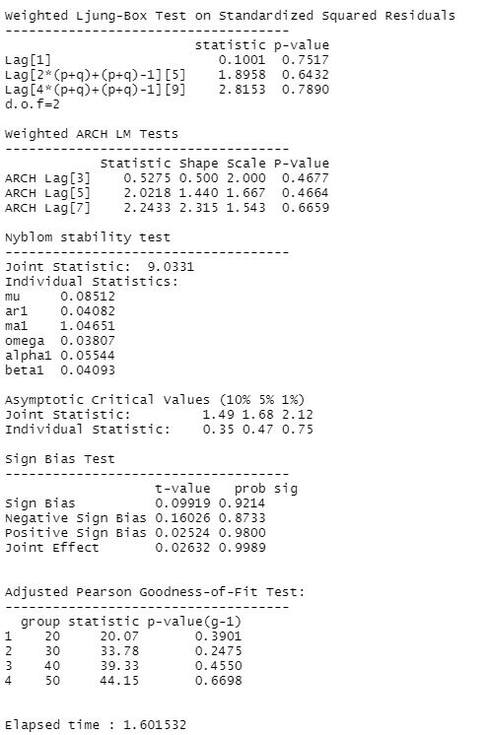

Fig.2.4.15. GARCH(1,1) Fit

Fig.2.4.16. EGARCH(1,1) Fit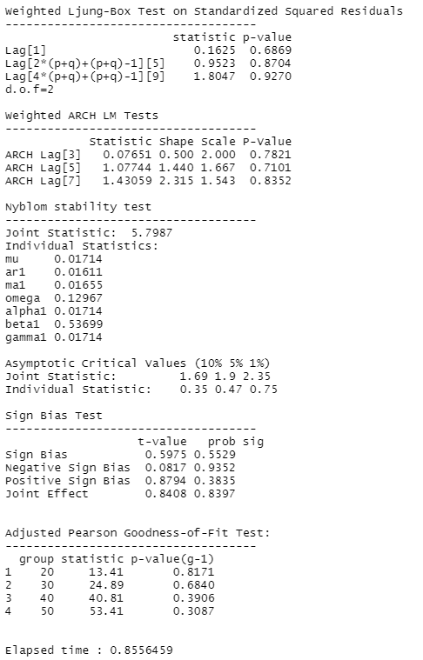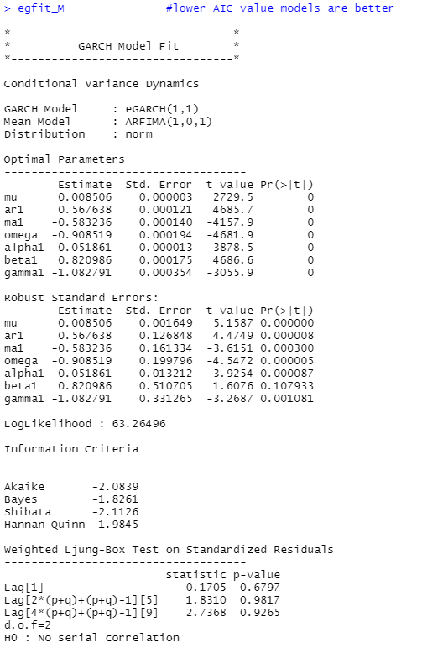

GARCH(1,1) model fitting’s result has been interpreted below:

The log-likelihood of the model is 57.3313.

GARCH(1,1) and Equivalent ARFIMA(1,0,1) are best for CUB monthly returns data.

In the optimal parameters section, all values except omega and alpha1 are statistically significant as their p-values are lower than 0.05.

In the robust standard errors’ parameters section as well the above results apply.

In the Ljung-box test result section, since all the p-values for both standardized results and standard squared residuals are much higher than 0.05, the null hypothesis is accepted to be correct and hence no serial autocorrelation exists which is the best condition for the fitted model.

In the ARCH LM test, as p-values are far greater than 0.05, the null hypothesis that an adequate ARCH process is fitted is correct.

In the Adjusted Pearson goodness-of-fit section, all the p-values are greater than 0.05, which implies that the null hypothesis is correct and not rejected.

Overall, the fitted GARCH(1,1) is the best-fit model for CUB monthly returns.

Interpretation of the above EGARCH(1,1) model fitting’s result (*figure 36*) is:

The log-likelihood of the model is 63.2649.

EGARCH(1,1) and equivalent ARFIMA(1,0,1) are best for CUB monthly returns.

In the optimal parameters section, all parameters are statistically significant as their p-values are lower than 0.05 ie. that all values are equal to zero.

Apart from beta1, the robust standard errors’ parameters are statistically significant as their p-values are lower than 0.05.

In the Ljung-box test result section, since all the p-values for both standardized results and standard squared residuals are much higher than 0.05, the null hypothesis is correct and hence no serial autocorrelation exists which is the best condition for the model.

In the ARCH LM test, as p-values are far greater than 0.05, the null hypothesis that an adequate ARCH process is fitted is correct and not rejected.

In the Adjusted Pearson goodness-of-fit section, all the p-values are greater than 0.05, which implies that the null hypothesis is correct and not rejected and hence the stated distribution is used.

Overall, the fitted EGARCH(1,1) is the best-fit model for CUB monthly returns.

Monthly volatility future forecasts are computed using the fitted models using the *ugarchforecast* function and the output is depicted below:

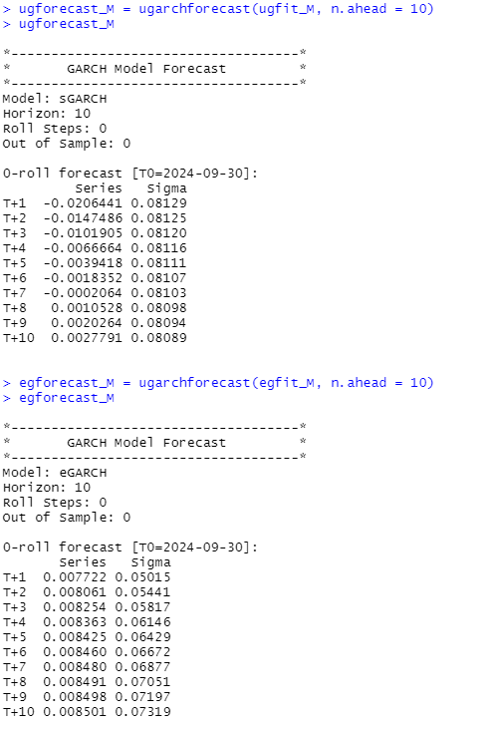

Fig.2.4.17. Volatility Forecasts for both the models

# 3. Dalmia Bharat Sugar (DALMIASUG)

## 3.1 Introduction



Figure 3.1: Dalmia Bharat Sugar logo

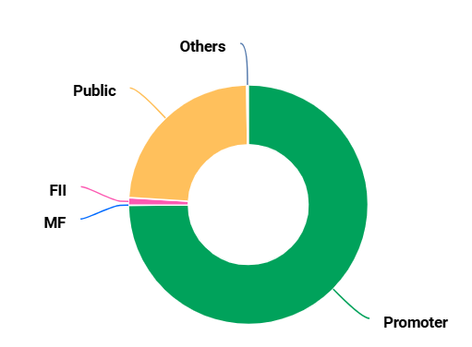

Figure 3.2: Dalmia Bharat Sugar shareholding pattern

### 3.1.1 Nature of Business

The company is involved in the production of sugar, power generation, the manufacture of industrial alcohol, and the production of refractory materials. Its operations are divided into several segments: sugar, power, distillery, and others. The sugar segment focuses on the production and marketing of sugar products. The power segment encompasses the generation and sale of electricity. The distillery segment is responsible for the production and sale of ethanol, extra neutral alcohol (ENA), and sanitizers. The other segments include activities related to magnesite, travel, and electronics.

Dalmia Bharat Sugar and Industries Limited has implemented robust quality management systems and has adopted 5S and TPM initiatives to develop world-class systems and processes. Following the successful implementation of these systems, the company now produces high-quality sugar that is well-received in markets across Uttar Pradesh and Eastern India. It has become a preferred supplier of sugar to prominent institutional brands such as Coca-Cola, PepsiCo, Mondelez, Perfetti, Britannia, Wal-Mart India, Dabur, D-Mart, India Glycols, Allied Blenders & Distillers, United Breweries, Carlsberg, SABMiller, among others in the alcoholic beverage sector. Furthermore, the company exports its products to various regions, including neighboring countries of India, the Middle East, Mediterranean countries, and East Africa. Additionally, the company has established facilities for the processing of raw sugar. These advanced facilities exemplify best practices in the sugar industry, as the company has excelled in operational metrics and maintains a leading technological position.

**Industrial overview:** India's sugar industry is a major agro-based sector that significantly impacts the rural economy. As one of the world's largest producers and consumers of sugar, the country has a robust ecosystem involving sugarcane farmers, processing mills, and industries utilizing by-products. Dalmia Bharat Sugar exemplifies the modernization of traditional sugar manufacturing by integrating sustainable practices and diversifying its operations, thereby making a substantial contribution to India's agricultural economy.

### 3.3.2 Type of Ownership

Majority of the company is owned by promoters (74.91%) . 23.85% is owned by the public, suggesting a strong retail investor presence. This level of public shareholding often indicates wider investor trust but could also make the stock more volatile due to diverse trading patterns. 1.02% is owned by Foreign Institutions and the remaining 0.22% is owned by others which may include shares held by trusts, insurance companies, or other corporate entities. There is no ownership by mutual funds for the company. The distribution is depicted in figure 3.2.

### 3.3.3 Commencement of Business

The Dalmia family, guided by influential industrialists such as Jaidayal Dalmia, initiated a diversification strategy into multiple sectors, including cement, sugar, and chemicals. This move into the sugar industry was part of their broader industrialization efforts following India's independence. At that time, sugar production was a critical area of focus for India, given its agricultural economy and government policies aimed at promoting self-sufficiency in essential goods. Utilizing their industrial expertise, the Dalmia Group established sugar mills predominantly in Uttar Pradesh, a region well-suited for sugar production due to its abundant sugarcane supply in the year 1994. Dalmia Bharat Sugar and Industries Limited was officially established and emerged as a key player in the sugar manufacturing industry. The company initially concentrated on acquiring and modernizing existing sugar mills to enhance operational efficiency and scale. In the fiscal year 2006-2007, the company initiated a significant expansion by constructing two greenfield plants. In addition to sugar, the company also ventured into related sectors such as ethanol production and power generation, thereby emphasizing the value-added processing of sugarcane.

3.3.4 Overall Greatness of the Company

DALMIASUG's journey has been marked by remarkable progress and accomplishments. Dalmia Bharat Sugar has positioned itself as a frontrunner in the biofuel industry, ranking among the leading ethanol producers in India and significantly contributing to the government's objective of achieving 20% ethanol blending by 2025. It has received widespread acclaim for its dedication to sustainability, having garnered awards for its initiatives in renewable energy, water conservation, and minimizing its carbon emissions. Furthermore, it has implemented advanced technologies in sugar production, which have improved the efficiency and productivity of its mills, thereby reinforcing its status as an innovative and environmentally conscious leader in the industry. Currently, the company boasts a total cane crushing capacity of 35500 TCD, positioning it among the foremost sugar producers in the nation. The company remains committed to sustainable and innovative practices to maintain its competitive edge in the agro-industrial landscape.

## 3.2 Frequency: Daily

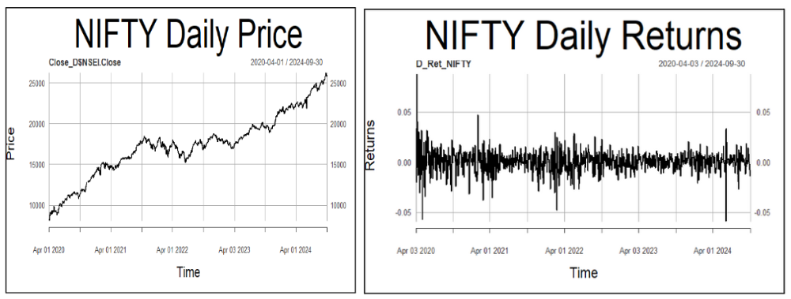

Fig.3.2.1. NIFTY Daily Prices Fig.3.2.2. NIFTY Daily Returns

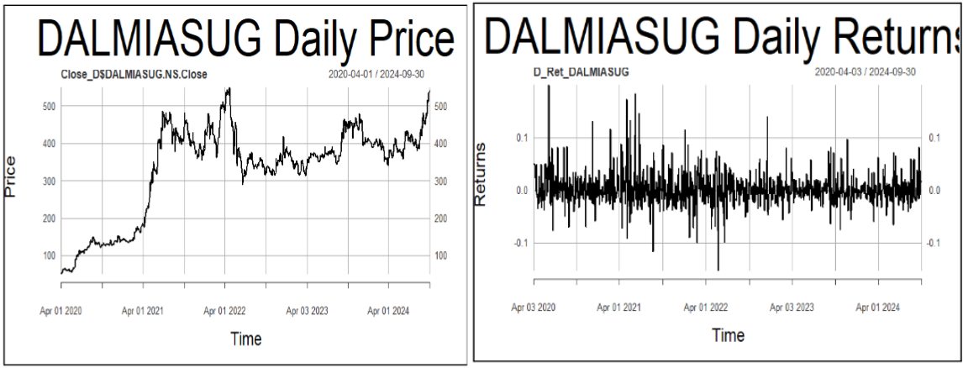

Figure 3.2.3: DALMIASUG Daily price Figure 3.2.4: DALMIASUG Daily returns

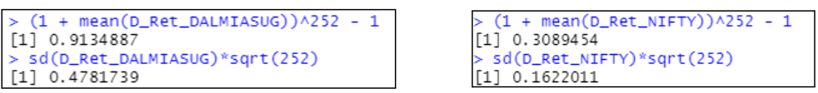

Figure 3.2.5: DALMIASUG and NIFTY Daily returns summary

The analysis period extends from April 1st, 2020 to September 30th, 2024. Daily returns of both NIFTY 50 and DALMIASUG seem to be stationary. Annualized daily return of DALMIASUG for the period considered is 91.35% and that of NIFTY 50 is 30.90%. Annualized daily risk (standard deviation) of DALMIASUG for the period considered is 47.82% and that of NIFTY 50 is 16.22%.

### **3.2.1 Estimating Beta using CAPM**

### The methodology employed is explained in section 1.1.

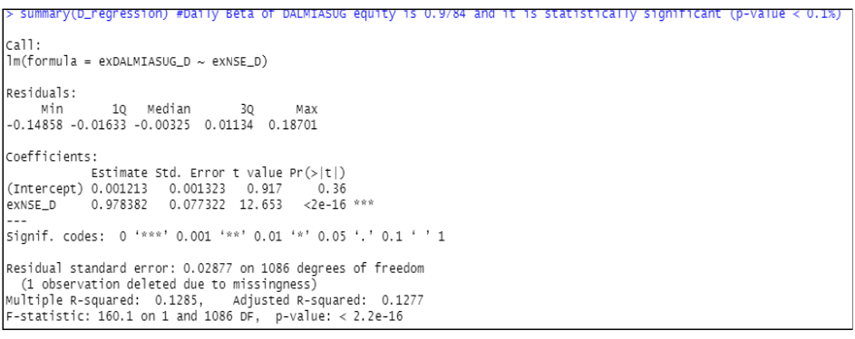

Figure 3.2.6: Regression Summary

After running the regression, from the output we understand that the slope coefficient is 0.978 and its p-value is less than 0.1% implying that it’s statistically significant. Hence, Beta of DALMIASUG at daily time frame is 0.978 and is statistically significant. Economic interpretation of Beta would be that the returns of DALMIASUG are 12.85% more sensitive than that of the market. In other words, if the market premium (market’s excess return) rises by 1%, then the DALMIASUG’s return rises by 0.978%.

### **3.2.2 ARIMA Modelling**

The methodology employed is explained in section *1.2*. From *figure* 3.2.4, the daily returns of DALMIASUG seem to be stationary. To confirm this, Augmented Dickey-Fuller (ADF) test is performed and in the output obtained is:

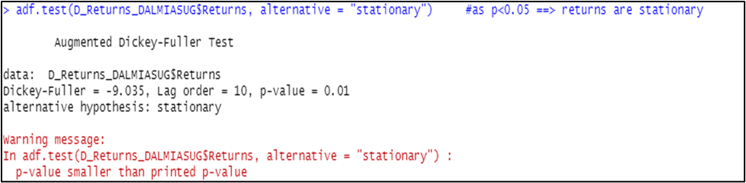

Figure 3.2.7 : ADF Test output

As p < 0.05, we conclude that DALMIASUG’s daily returns are stationary. Now, to find AR and MA coefficients to fit the ARIMA model, we plot ACF and PACF, and use the *auto.arima* function.

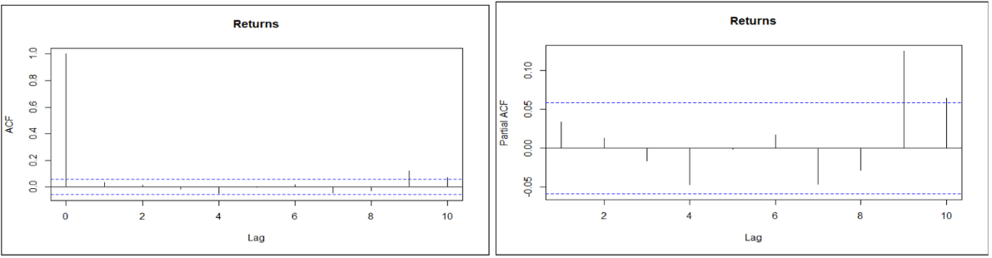

Figure 3.2.8: ACF plot Figure 3.2.9 : PACF plot

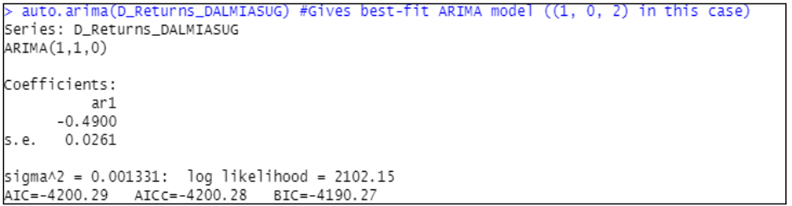

Figure 3.2.10 : *auto.arima* output

From figures 3.2.8, 3.2.9 and 3.2.10; it can be inferred that the best-fit ARIMA model is of order (1,1,0). Now, using the model, forecasting of returns for future periods is done and the following forecasts are obtained.

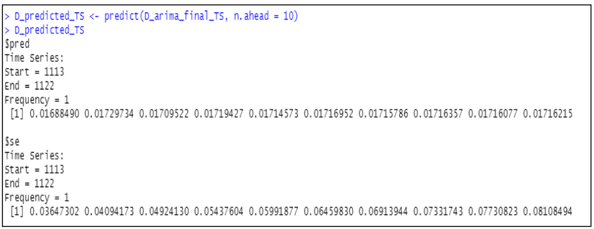

Figure 3.2.11: Return forecasts

Finally, diagnostic tests can be done for the fitted model to check whether it is appropriate. The graphical output obtained using *tsdiag* function is:

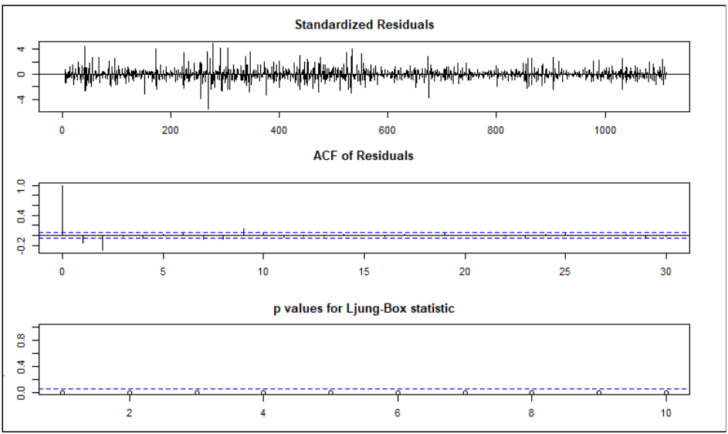

Figure 3.2.12: Diagnostic plots

From graphs 1 and 2 of *figure 3.2.12*, it can be seen that the residuals do not follow any particular pattern, and even the ACF has no peak except lag-0. The Ljung-Box test is used to check whether the residuals have been independently distributed or not from each other. Its null hypothesis says they are independent, whereas the alternative hypothesis says they are not. From Graph 3 of *figure 3.2.12*, it can be seen that all the p-values are above the critical t-statistic. Hence, we cannot reject the null hypothesis and conclude that the residuals are independent.

### 3.2.3 GARCH and EGARCH Modelling

The methodology employed is explained in section *1.3*. GARCH(1,1) and EGARCH(1,1) models are first specified (refer *figure* *1* and *2*). Then, using *rugarch* package and *ugarchfit* function, apt GARCH and EGARCH models are fitted. The output for the same on daily timeframe is as following:

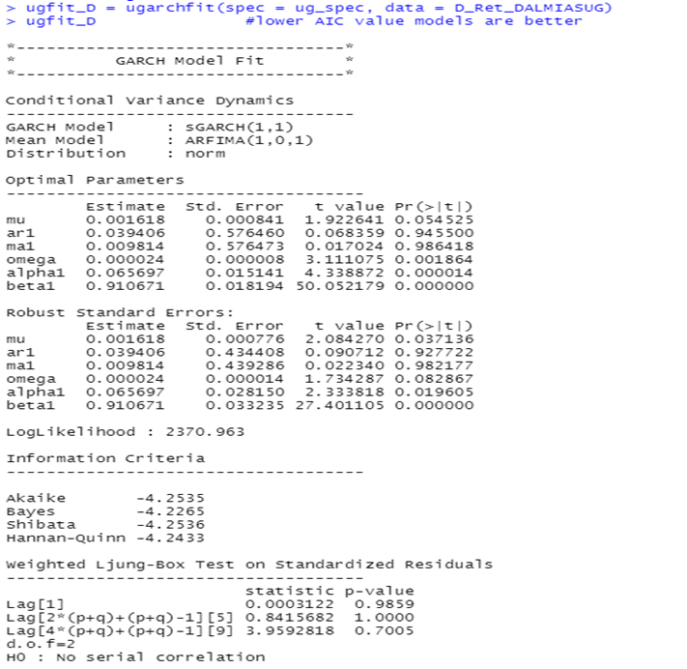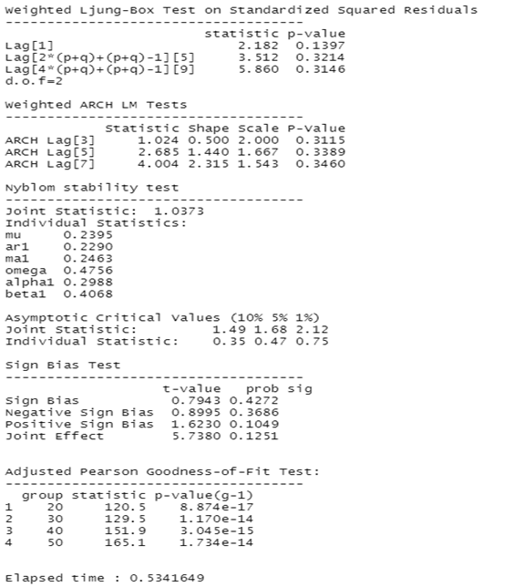

Figure 3.2.13: GARCH(1,1) model

Interpretation of the above GARCH(1,1) model fitting’s result (*figure 3.2.13*) is:

The log-likelihood of the model is 2370.96. GARCH(1,1) and corresponding ARFIMA(1,0,1) are best for DALMIASUG daily returns. Among the optimal parameters, mu, ar1 and ma1 are not statistically significant as their p-values is greater than 0.05. Among the robust standard errors’ parameters, ar1, ma1 and omega are not statistically significant as their p-values are greater than 0.05. In the Ljung-box test result section, since all the p-values for both standardised results and standard squared residuals are much higher than 0.05, the null hypothesis cannot be rejected and hence no serial autocorrelation exists which is a good condition for the model. In the ARCH LM test, as p-values are far greater than 0.05, the null hypothesis that an adequate ARCH process is fitted cannot be rejected. In the Adjusted Pearson goodness-of-fit section, all the p-values are very low, which implies that the null hypothesis cannot be rejected and hence the stated distribution isn’t followed. All-in-all, the fitted GARCH(1,1) is the best-fit model for DALMIASUG daily returns.

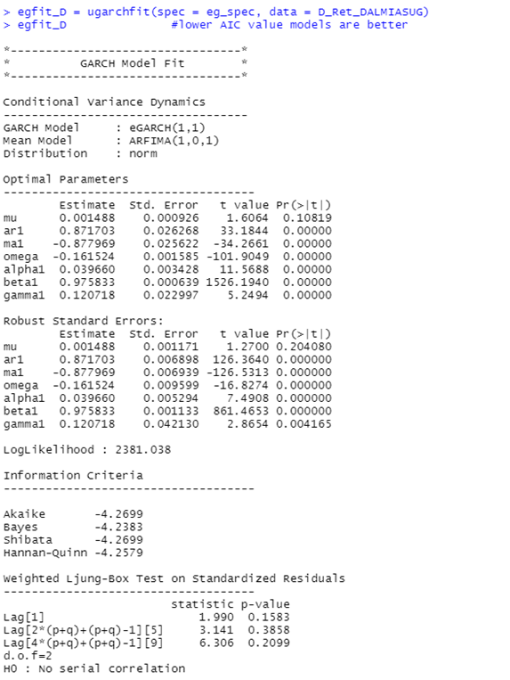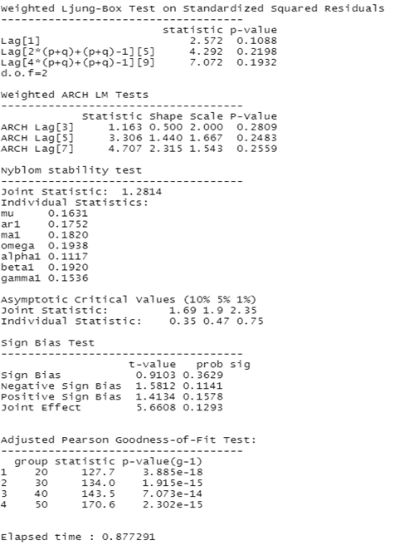

Figure 3.2.14: EGARCH(1,1) model

Interpretation of the above EGARCH(1,1) model fitting’s result (*figure 3.2.14*) is:

The log-likelihood of the model is 2381.038. EGARCH(1,1) and corresponding ARFIMA(1,0,1) are best for DALMIASUG daily returns. All the optimal parameters except mu are statistically significant as their p-values are lower than 0.05. All the robust standard errors’ parameters except mu are statistically significant as their p-values are lower than 0.05. In the Ljung-box test result section, since all the p-values for both standardised results and standard squared residuals are much higher than 0.05, the null hypothesis cannot be rejected and hence no serial autocorrelation exists which is a good condition for the model. In ARCH LM test, as p-values are far greater than 0.05, null hypothesis that adequate ARCH process is fitted cannot be rejected. In the Adjusted Pearson goodness-of-fit section, all the p-values are very low, which implies that the null hypothesis cannot be rejected and hence the stated distribution isn’t followed. All-in-all, EGARCH(1,1) is the best-fit model for DALMIASUG daily returns.

Now, daily volatility forecasts are made for future using the fitted models using the *ugarchforecast* function and the output is as following:

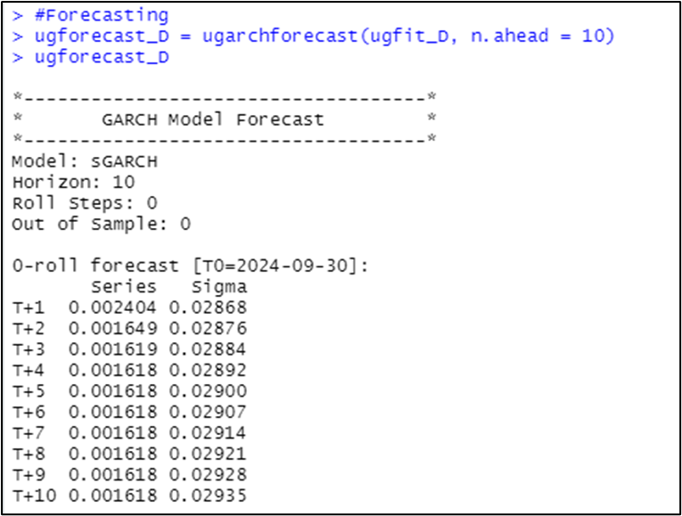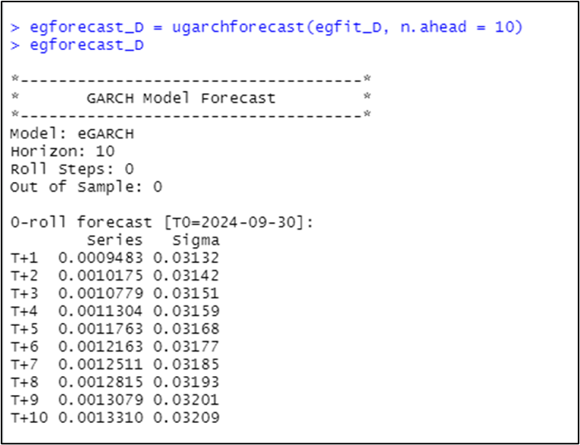

Figure 3.2.15: Volatility forecasts

## 3.3 Frequency: Weekly

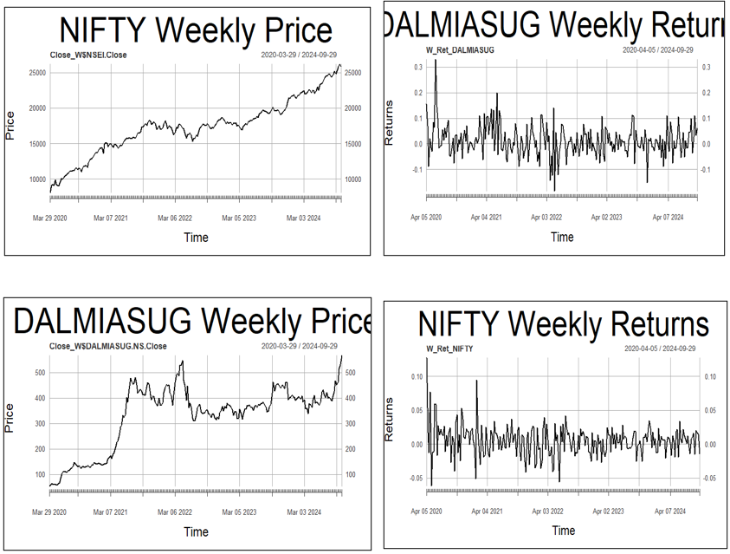

Figure 3.3.3: DALMIASUG weekly prices Figure 3.3.4: DALMIASUG weekly r

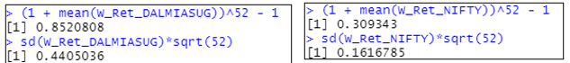

Figure 3.3.5: DALMIASUG & NIFTY weekly results

The analysis period extends from April 1st, 2020 to September 30th, 2024. Weekly returns of both NIFTY 50 and DALMIASUG seem to be stationary. Annualized weekly return of DALMIASUG for the period considered is 85.21% and that of NIFTY 50 is 30.93%. Annualized weekly risk (standard deviation) of DALMIASUG for the period considered is 44.05% and that of NIFTY 50 is 16.17%.

### **3.3.1 Estimating Beta using CAPM**

The methodology employed is explained in section *1.1*. 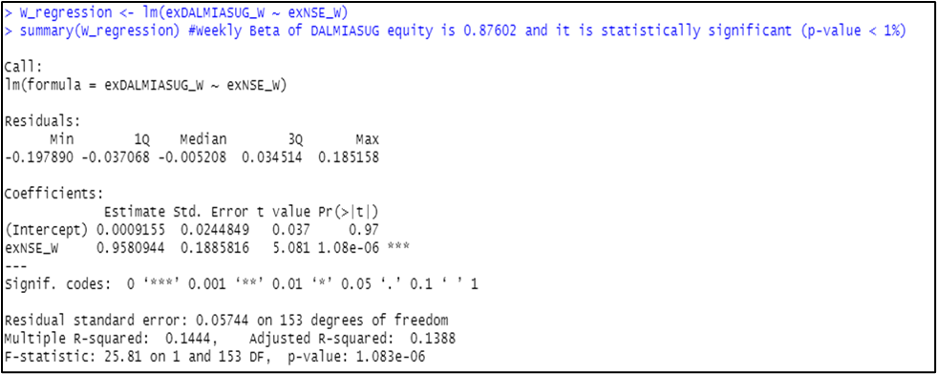

Figure 3.3.6: Regression summary

After running the regression for the weekly time frame, from the output, we understand that the slope coefficient is 0.958 and its p-value is less than 0.1% implying that it’s statistically significant. Hence, Beta of DALMIASUG at weekly time frame is 0.958 and is statistically significant. Economic interpretation of Beta would be that the returns of DALMIASUG are 14.44% more sensitive than that of the market. In other words, if the market premium (market’s excess return) rises by 1%, then the DALMIASUG’s return rises by 0.958%.

### **3.3.2 ARIMA Modelling**

The methodology employed is explained in section *1.2*. The weekly returns of DALMIASUG seem to be stationary. To confirm this, Augmented Dickey-Fuller (ADF) test is performed and the output obtained is:

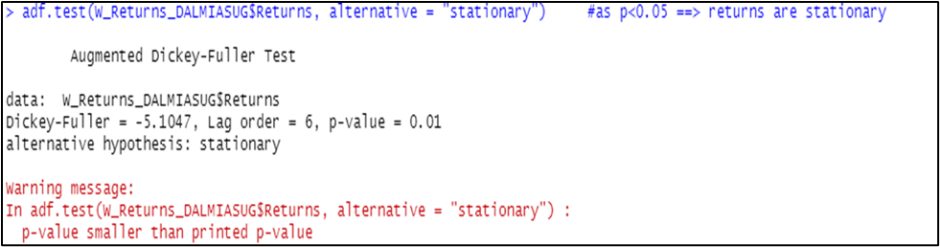

Figure 3.3.7: ADF test output

From *figure 84*, as p < 0.05, we conclude that DALMIASUG’s weekly returns are stationary. Now, to find AR and MA coefficients to fit the ARIMA model, we plot ACF and PACF, and use the *auto.arima* function:

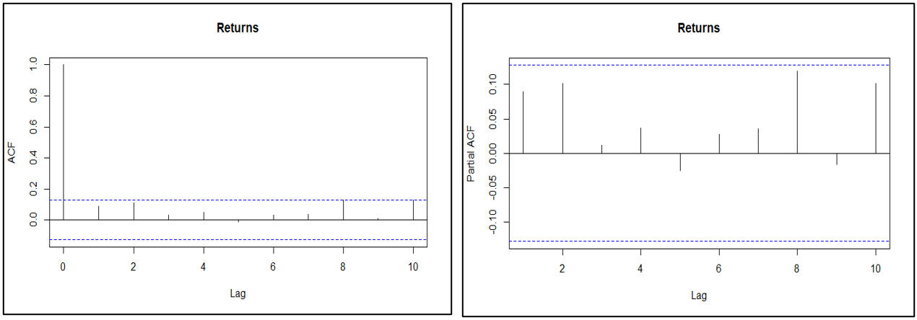

Figure 3.3.8: ACF plot Figure 3.3.9: PACF plot

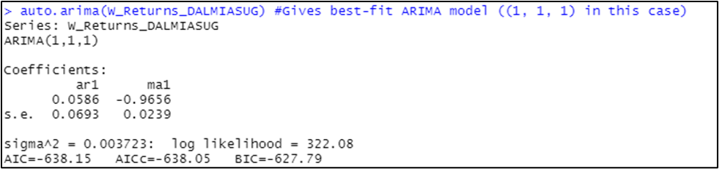

Figure 3.3.10: *auto.arima* output

From figures 85, 86, and 87; it can be inferred that the best-fit ARIMA model is of order (1,1,1). Now, using the model, forecasting of returns for future periods is done and the following forecasts are obtained:

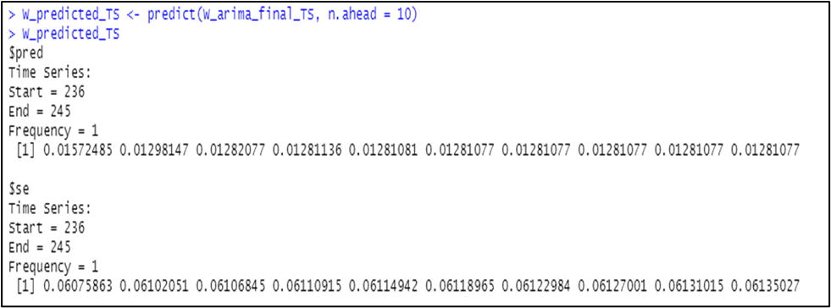

Figure 3.3.11: Return forecasts

Finally, diagnostic test can be done for the fitted model to check whether it is appropriate. The graphical output obtained using *tsdiag* function is:

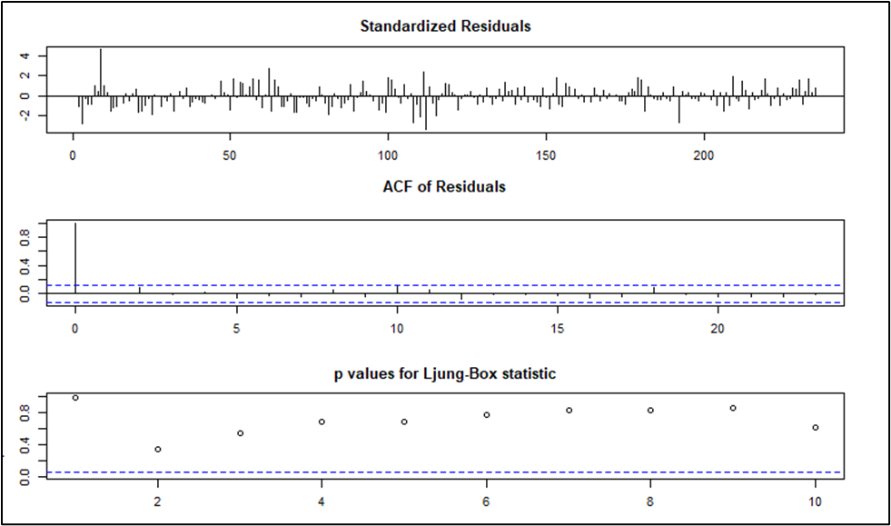

Figure 3.3.12: Diagnostic plots

From graphs 1 and 2 of figure 3.3.12, it can be seen that the residuals do not follow any particular pattern, and even the ACF has no peak except lag-0. The Ljung-Box test is used to check whether the residuals have been independently distributed or not from each other. Its null hypothesis says they are independent, whereas the alternative hypothesis says they are not. From Graph 3 of figure 3.3.12, it can be seen that all the p-values are above the critical t-statistic. Hence, we cannot reject the null hypothesis and conclude that the residuals are independent.

### **3.3.3 GARCH and EGARCH Modelling**

The methodology employed is explained in section *1.3*. GARCH(1,1) and EGARCH(1,1) models are first specified (refer *figure* *1* and *2*). Then, using *rugarch* package and *ugarchfit* function, apt GARCH and EGARCH models are fitted. The output for the same on weekly timeframe is as following:

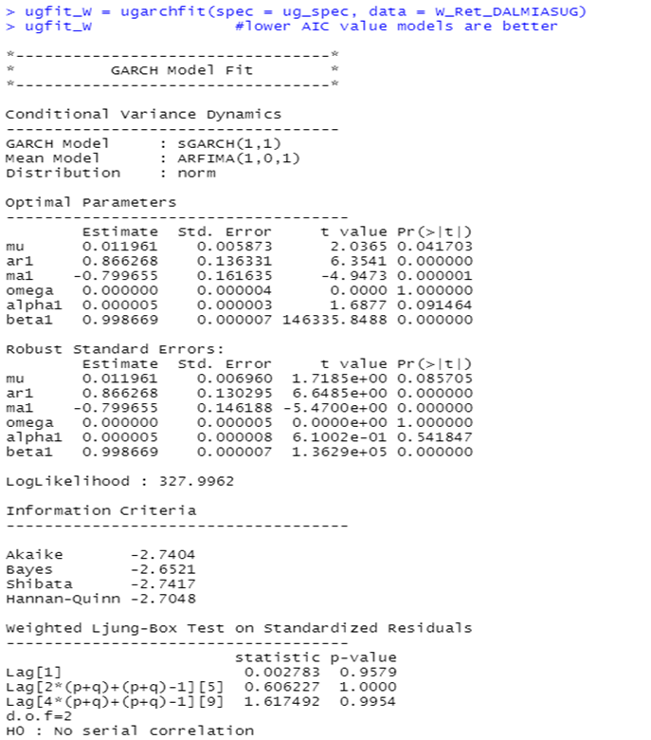 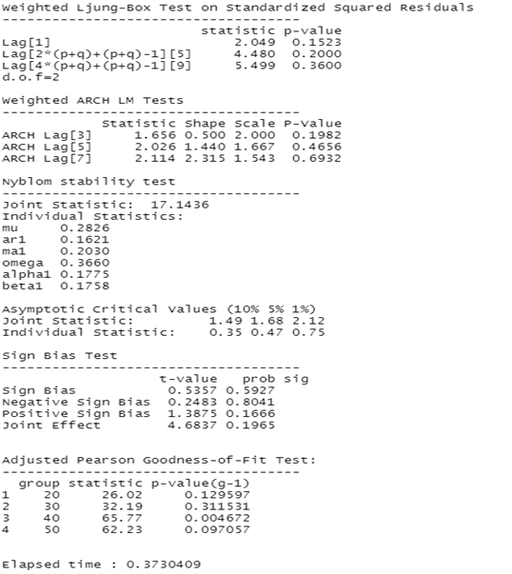

Figure 3.3.13: GARCH(1,1) model

Interpretation of the above GARCH(1,1) model fitting’s result (*figure 90*) is:

The log-likelihood of the model is 327.9962. GARCH(1,1) and corresponding ARFIMA(1,0,1) are best for DALMIASUG weekly returns. Among the optimal parameters, only ar1, ma1, and beta1 are statistically significant as their p-values are lower than 0.05. Among the robust standard errors’ parameters, only ar1, ma1, and beta1 are statistically significant as their p-values are lower than 0.05. In the Ljung-box test result section, since all the p-values for both standardised results and standard squared residuals are much higher than 0.05, the null hypothesis cannot be rejected and hence no serial autocorrelation exists which is a good condition for the model. In ARCH LM test, as p-values are far greater than 0.05, null hypothesis that adequate ARCH process is fitted cannot be rejected. In the Adjusted Pearson goodness-of-fit section, all the p-values are lower than 0.05, which implies that the null hypothesis is rejected and hence the stated distribution isn’t followed. All-in-all, the fitted GARCH(1,1) is the best-fit model for DALMIASUG weekly returns.

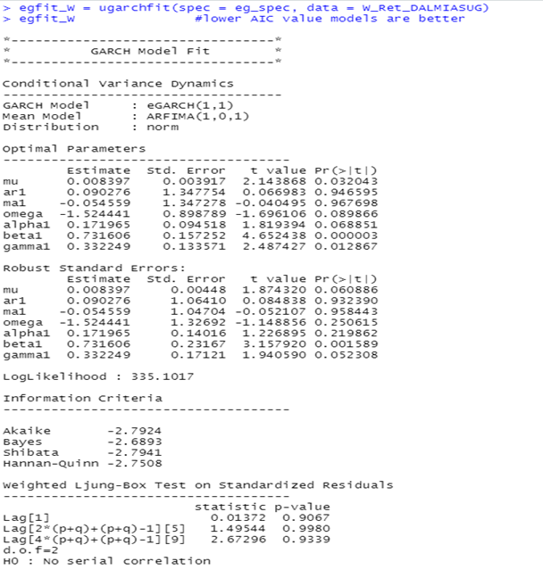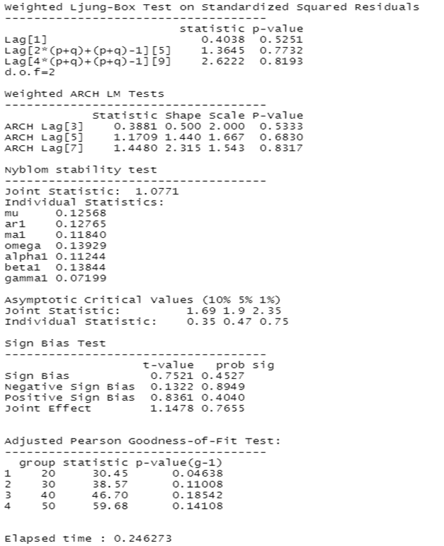

Figure 3.3.14: EGARCH(1,1) model

Interpretation of the above EGARCH(1,1) model fitting’s result (*figure 91*) is:

The log-likelihood of the model is 335.102. EGARCH(1,1) and corresponding ARFIMA(1,0,1) are best for DALMIASUG weekly returns. All the optimal parameters except mu, beta1 and gamma1 are statistically insignificant as their p-values are greater than 0.05. All the robust standard errors’ parameters except beta1 are statistically insignificant as their p-values are greater than 0.05. In the Ljung-box test result section, since all the p-values for standard squared residuals are much higher than 0.05, the null hypothesis cannot be rejected and hence no serial autocorrelation exists which is a good condition for the model. In ARCH LM test, as p-values are far greater than 0.05, null hypothesis that adequate ARCH process is fitted cannot be rejected. In the Adjusted Pearson goodness-of-fit section, all the p-values are greater than 0.05, which implies that the null hypothesis cannot be rejected and hence the stated distribution is followed. All-in-all, the fitted EGARCH(1,1) is the best-fit model for DALMIASUG weekly returns.

Now, weekly volatility forecasts are made for future using the fitted models using the *ugarchforecast* function and the output is as following:

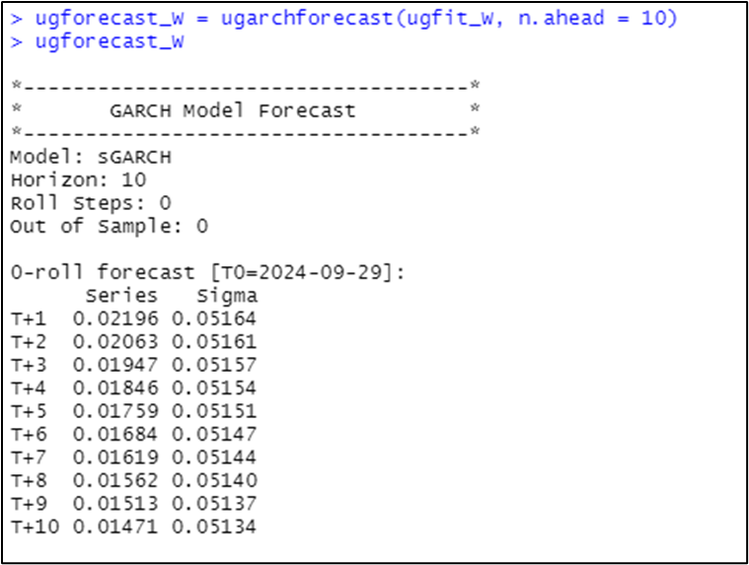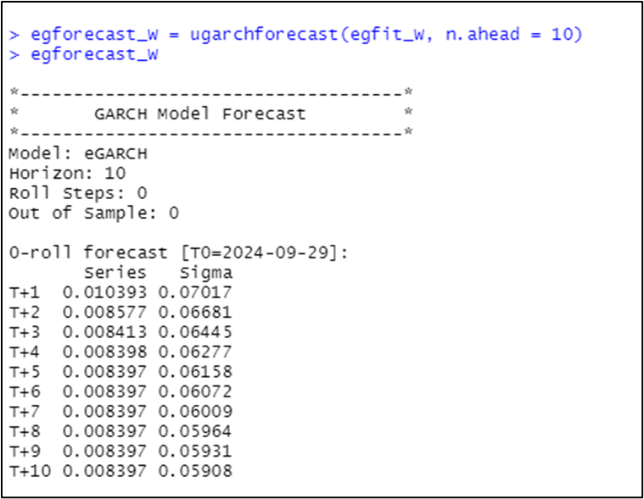

Figure 3.3.15: Volatility forecasts

## 3.4 Frequency: Monthly

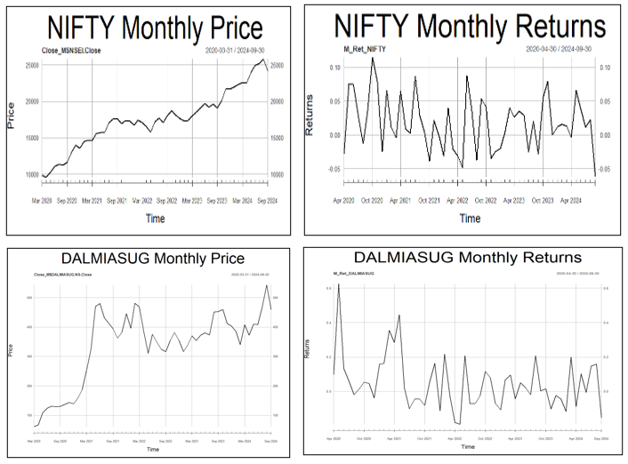

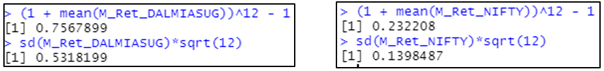

Figure 3.4.5: DALMIASUG and NIFTY monthly summary

The analysis period extends from April 1st, 2020 to September 30th, 2024. Monthly returns of both NIFTY 50 and DALMIASUG seem to be non-stationary. Annualized monthly return of DALMIASUG for the period considered is 75.68% and that of NIFTY 50 is 23.22%. Annualized monthly risk (standard deviation) of DALMIASUG for the period considered is 53.18% and that of NIFTY 50 is 13.98%.

### **3.4.1 Estimating Beta using CAPM**

The methodology employed is explained in section *1.1*.

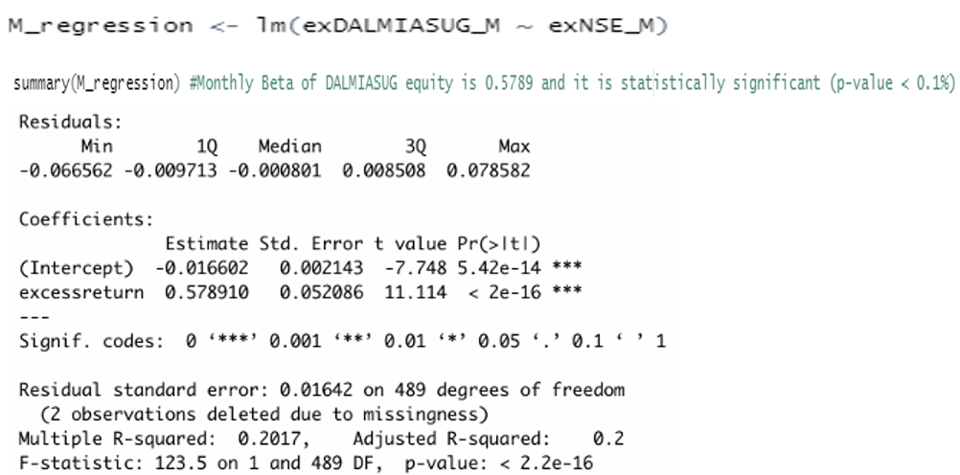

Figure 3.4.6: Regression summary

After running the regression for the monthly time frame, from the output, we understand that the slope coefficient is 0.579 and its p-value is lower than 5% implying that it’s statistically significant. Hence, Beta of DALMIASUG at monthly time frame is 0.579 and is statistically significant. Economic interpretation of Beta would be that the returns of DALMIASUG are 20.17% more sensitive than that of the market. In other words, if the market premium (market’s excess return) rises by 1%, then the DALMIASUG’s return rises by 0.579%.

### 

### **3.4.2 ARIMA Modelling**

The methodology employed is explained in *section 1.2*. The monthly returns of DALMIASUG seem to be non-stationary. To check this, Augmented Dickey-Fuller (ADF) test is performed and the output obtained is:

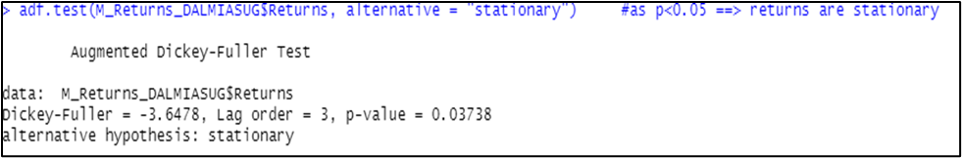

Figure 3.4.7: ADF test output

From *figure 102*, as p < 0.05, we conclude that DALMIASUG monthly returns are stationary. Now, to find AR and MA coefficients to fit the ARIMA model, we plot ACF and PACF, and use the *auto.arima* function.

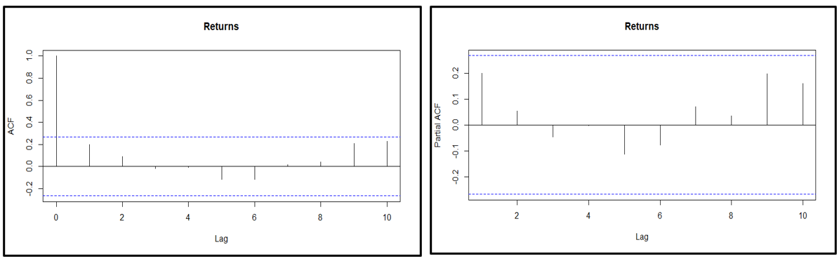

Figure 3.4.8: ACF plot Figure 3.4.9: PACF plot

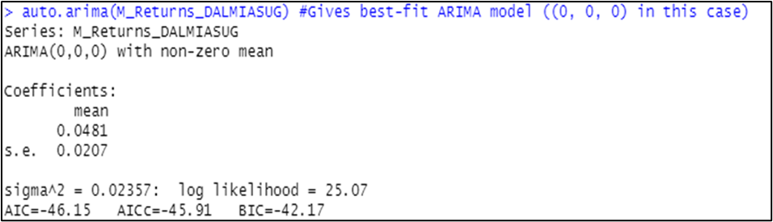

Figure 3.4.10: *auto.arima*  output

From previous discussion and figures 3.4.8, 3.4.9 and 3.4.10; it can be inferred that the best-fit ARIMA model for DALMIASUG monthly returns series is of order (0,0,0). Now, using the model, forecasting of returns for future periods is done and the following forecasts are obtained:

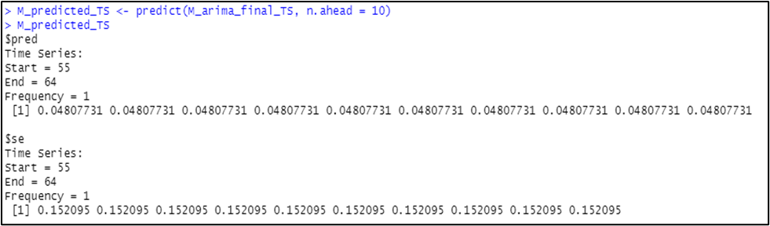

Figure 3.4.11: Return forecasts

Finally, diagnostic test can be done for the fitted model to check whether it is appropriate. The graphical output obtained using *tsdiag* function is:

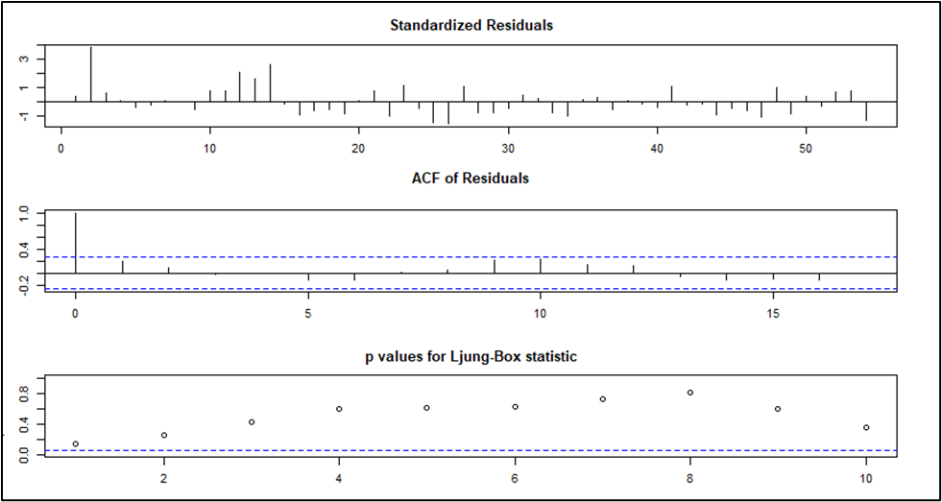

Figure 3.4.12: Diagnostic plots

From graphs 1 and 2 of figure 3.4.12, it can be seen that the residuals do not follow any particular pattern, and even the ACF has no peak except lag-0. The Ljung-Box test is used to check whether the residuals have been independently distributed or not from each other. Its null hypothesis says they are independent, and the alternative hypothesis also says they are independent. From Graph 3 of figure 3.4.12, it can be seen that all the p-values are above the critical t-statistic. Hence, we cannot reject the null hypothesis and conclude that the residuals are independent.

### **3.4.3 GARCH and EGARCH Modelling**

The methodology employed is explained in section *1.3*. GARCH(1,1) and EGARCH(1,1) models are first specified (refer *figure* *1* and *2*). Then, using *rugarch* package and *ugarchfit* function, apt GARCH and EGARCH models are fitted. The output for the same on monthly time frame is as following:

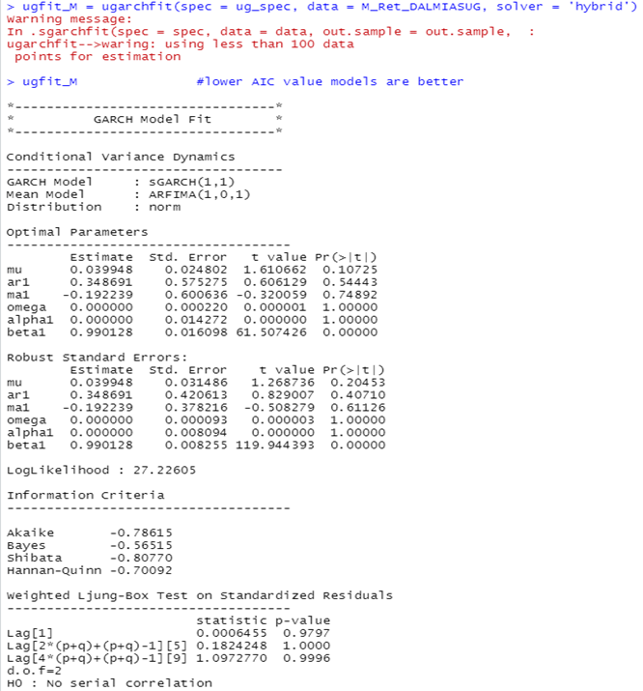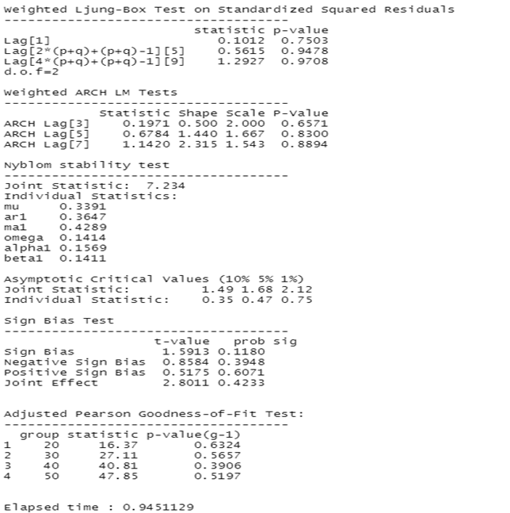

Figure 3.4.13: GARCH(1,1) model

Interpretation of the above GARCH(1,1) model fitting’s result (*figure 108*) is:

The log-likelihood of the model is 27.226. GARCH(1,1) and corresponding ARFIMA(1,0,1) are best for DALMIASUG monthly returns. Among the optimal parameters, except beta1 all are statistically insignificant as their p-values are greater than 0.05. Among the robust standard errors’ parameters, except beta1 all are statistically insignificant as their p-values are greater than 0.05. In the Ljung-box test result section, since all the p-values for both standardised results and standard squared residuals are much higher than 0.05, the null hypothesis cannot be rejected and hence no serial autocorrelation exists which is a good condition for the model. In ARCH LM test, as p-values are far greater than 0.05, null hypothesis that adequate ARCH process is fitted cannot be rejected. In the Adjusted Pearson goodness-of-fit section, all the p-values are greater than 0.05, which implies that the null hypothesis cannot be rejected and hence the stated distribution is followed. All-in-all, the fitted GARCH(1,1) is the best-fit model for DALMIASUG monthly returns.

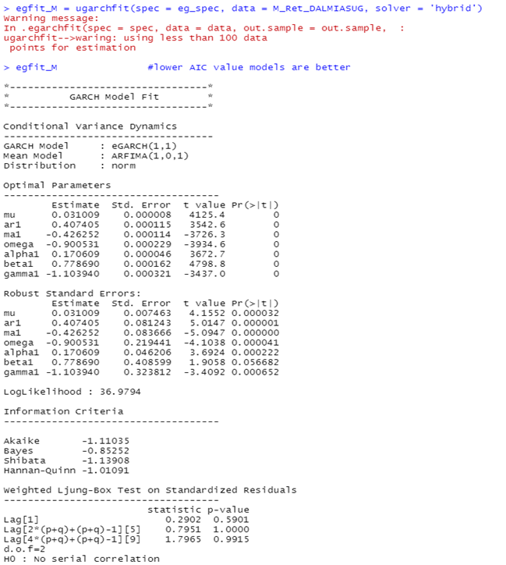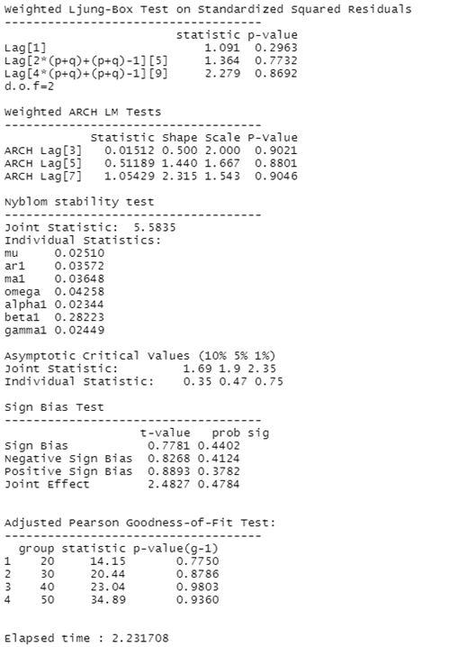

Figure 3.4.14: EGARCH(1,1) model

Interpretation of the above EGARCH(1,1) model fitting’s result (*figure 36*) is:

The log-likelihood of the model is 36.9704. EGARCH(1,1) and corresponding ARFIMA(1,0,1) are best for DALMIASUG monthly returns. All the optimal parameters are statistically significant as their p-values are lower than 0.05. All the robust standard errors’ parameters except beta1 are statistically significant as their p-values are lower than 0.05. In the Ljung-box test result section, since all the p-values for both standardised results and standard squared residuals are much higher than 0.05, the null hypothesis cannot be rejected and hence no serial autocorrelation exists which is a good condition for the model. In ARCH LM test, as p-values are far greater than 0.05, null hypothesis that adequate ARCH process is fitted cannot be rejected. In the Adjusted Pearson goodness-of-fit section, all the p-values are greater than 0.05, which implies that the null hypothesis cannot be rejected and hence the stated distribution is followed. All-in-all, the fitted EGARCH(1,1) is the best-fit model for DALMIASUG monthly returns.

Now, monthly volatility forecasts are made for future using the fitted models using the *ugarchforecast* function and the output is as following:

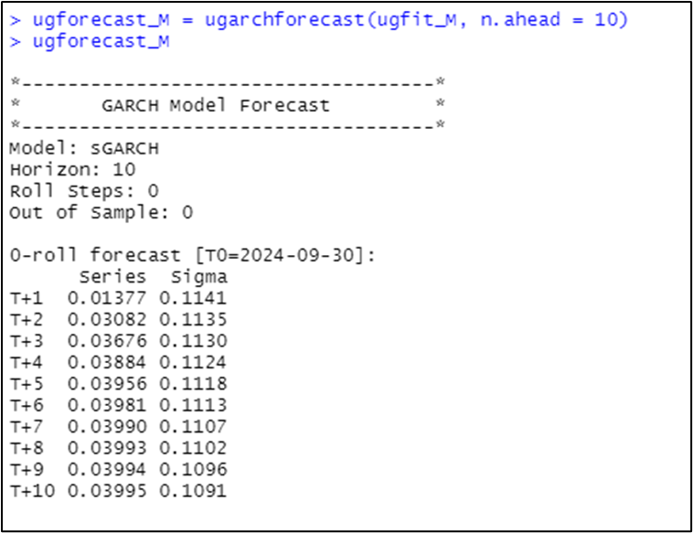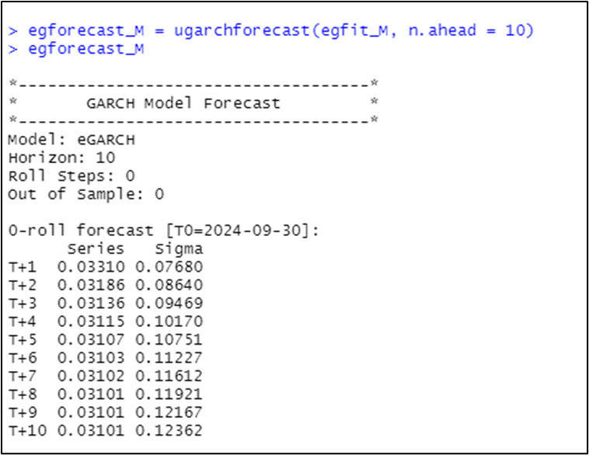

Figure 3.4.15: Volatility forecasts

# 

# 4. Dilip BuildCon (DBL)

## 4.1 Introductionസൗത്ത് ഇന്ത്യൻ ബാങ്ക് - വിക്കിപീഡിയ

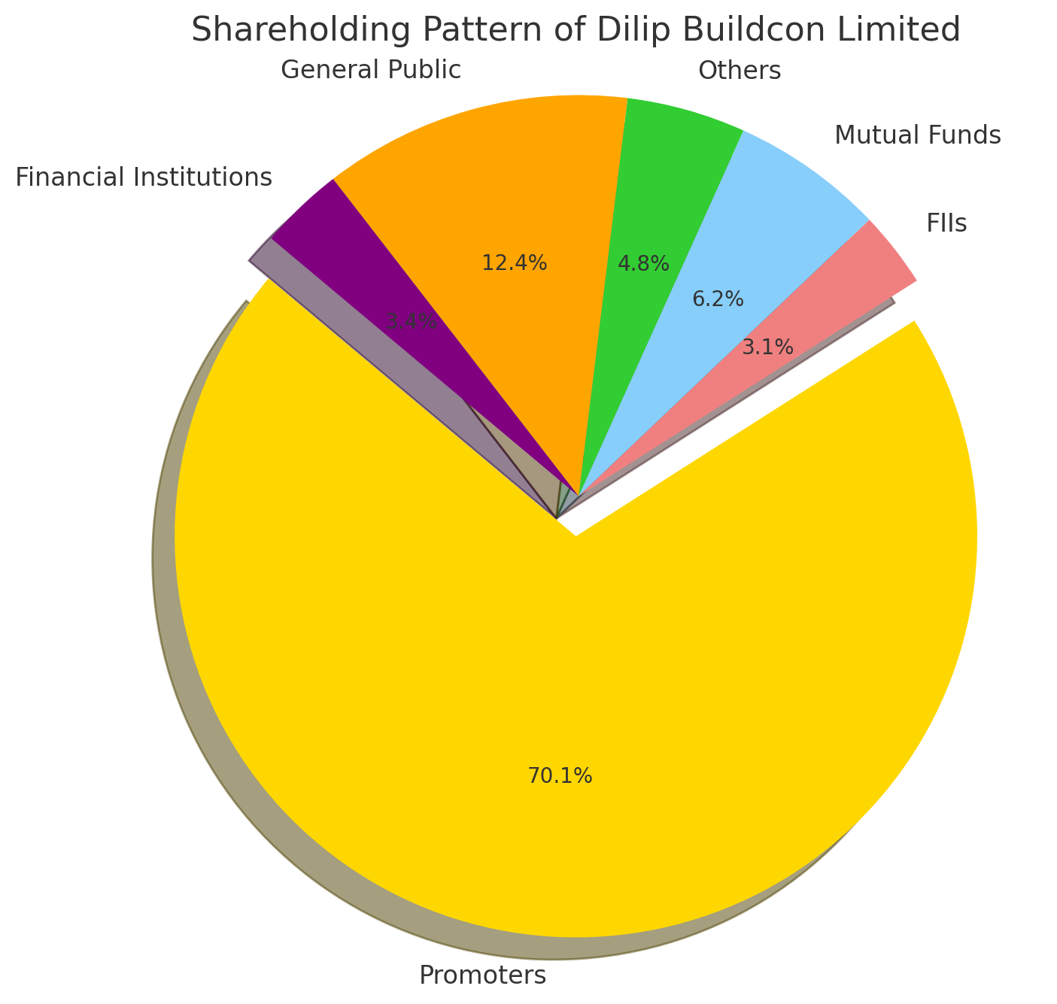  
  
DBL, or **Dilip Buildcon Limited**, operates in the **infrastructure and construction industry**, specializing in **engineering, procurement, and construction (EPC)** projects. The company is known for its expertise in developing roads and highways, bridges, tunnels, irrigation systems, and urban infrastructure in India. Here's a breakdown of the company and its position in the industry:

**Industry Overview:**

* DBL is a key player in India's rapidly growing **infrastructure sector**, which is a cornerstone of the Indian government's development agenda.
* The infrastructure industry in India is vast, with significant investments driven by programs like **Bharatmala Pariyojana** and the **National Infrastructure Pipeline** (NIP), where road and highway construction account for a significant share.
* The government’s focus on PPP (Public-Private Partnership) models boosts opportunities for companies like DBL.

### 4.3.1 Nature of Business

DBL specializes in the development of infrastructure projects across various sectors, including:

* **Highways and Roads**: Construction of national and state highways, expressways, and urban roads.
* **Bridges and Tunnels**: Development of complex bridge structures and tunnels to enhance connectivity.
* **Mining**: Engagement in mining operations, including coal mining, as a Mine Developer and Operator (MDO).
* **Irrigation**: Execution of irrigation projects such as dams and canals to support agricultural activities.
* **Urban Infrastructure**: Participation in metro rail projects and urban development initiatives.

### 4.3.2 Type of Ownership

Dilip Buildcon Limited is a publicly traded company listed on both the Bombay Stock Exchange (BSE) and the National Stock Exchange (NSE) since August 2016.

The shareholding pattern of Dilip Buildcon Limited (DBL) is as follows:

* **Promoters**: 70.15%
* **Foreign Institutional Investors (FIIs)**: 3.07%
* **Mutual Funds**: 6.16%
* **Others**: 4.79%
* **General Public**: 12.43%
* **Financial Institutions**: 3.41%

This distribution reflects the ownership structure of DBL, indicating a significant majority stake held by promoters, with the remaining shares distributed among institutional investors, mutual funds, and the general public.

### 4.3.3 Commencement of Business

Dilip Buildcon Limited (DBL) commenced its journey in 1987 as a proprietorship named Dilip Builders, founded by Mr. Dilip Suryavanshi in Bhopal, Madhya Pradesh. Initially, the firm concentrated on residential and commercial building projects within the state.

In 2006, the company was incorporated as Dilip Buildcon Private Limited, marking its transition to a private limited company. This incorporation facilitated the expansion of its operations beyond Madhya Pradesh, allowing DBL to undertake larger and more diverse infrastructure projects.

By 2010, DBL converted into a public limited company, adopting the name Dilip Buildcon Limited. This change enabled the company to access capital markets, attract investments, and further broaden its project portfolio across India.

Over the years, DBL has diversified its services to include highways, bridges, tunnels, mining, irrigation, and urban infrastructure projects, establishing itself as a significant player in India's infrastructure development sector.

### 4.3.4 Overall Greatness of the Company

DBL's growth trajectory is marked by several key achievements:

* **Extensive Project Portfolio**: Completion of numerous high-value projects, including sections of the Bangalore–Chennai Expressway, Bundelkhand Expressway, and Delhi–Mumbai Expressway.
* **Technological Integration**: Adoption of advanced technologies such as drone monitoring and GPS tracking to enhance project efficiency and safety.
* **Awards and Recognition**: Recipient of the Silver Award for Excellence in Construction Management in 2018, presented by Nitin Gadkari, acknowledging DBL's commitment to quality and innovation.
* **Financial Performance**: Demonstrated robust financial growth with significant revenue and profit margins, reflecting operational efficiency and strategic project selection.

DBL's dedication to timely project delivery, quality construction, and innovation has solidified its reputation as a leader in India's infrastructure sector.

## 4.2 Frequency: Daily

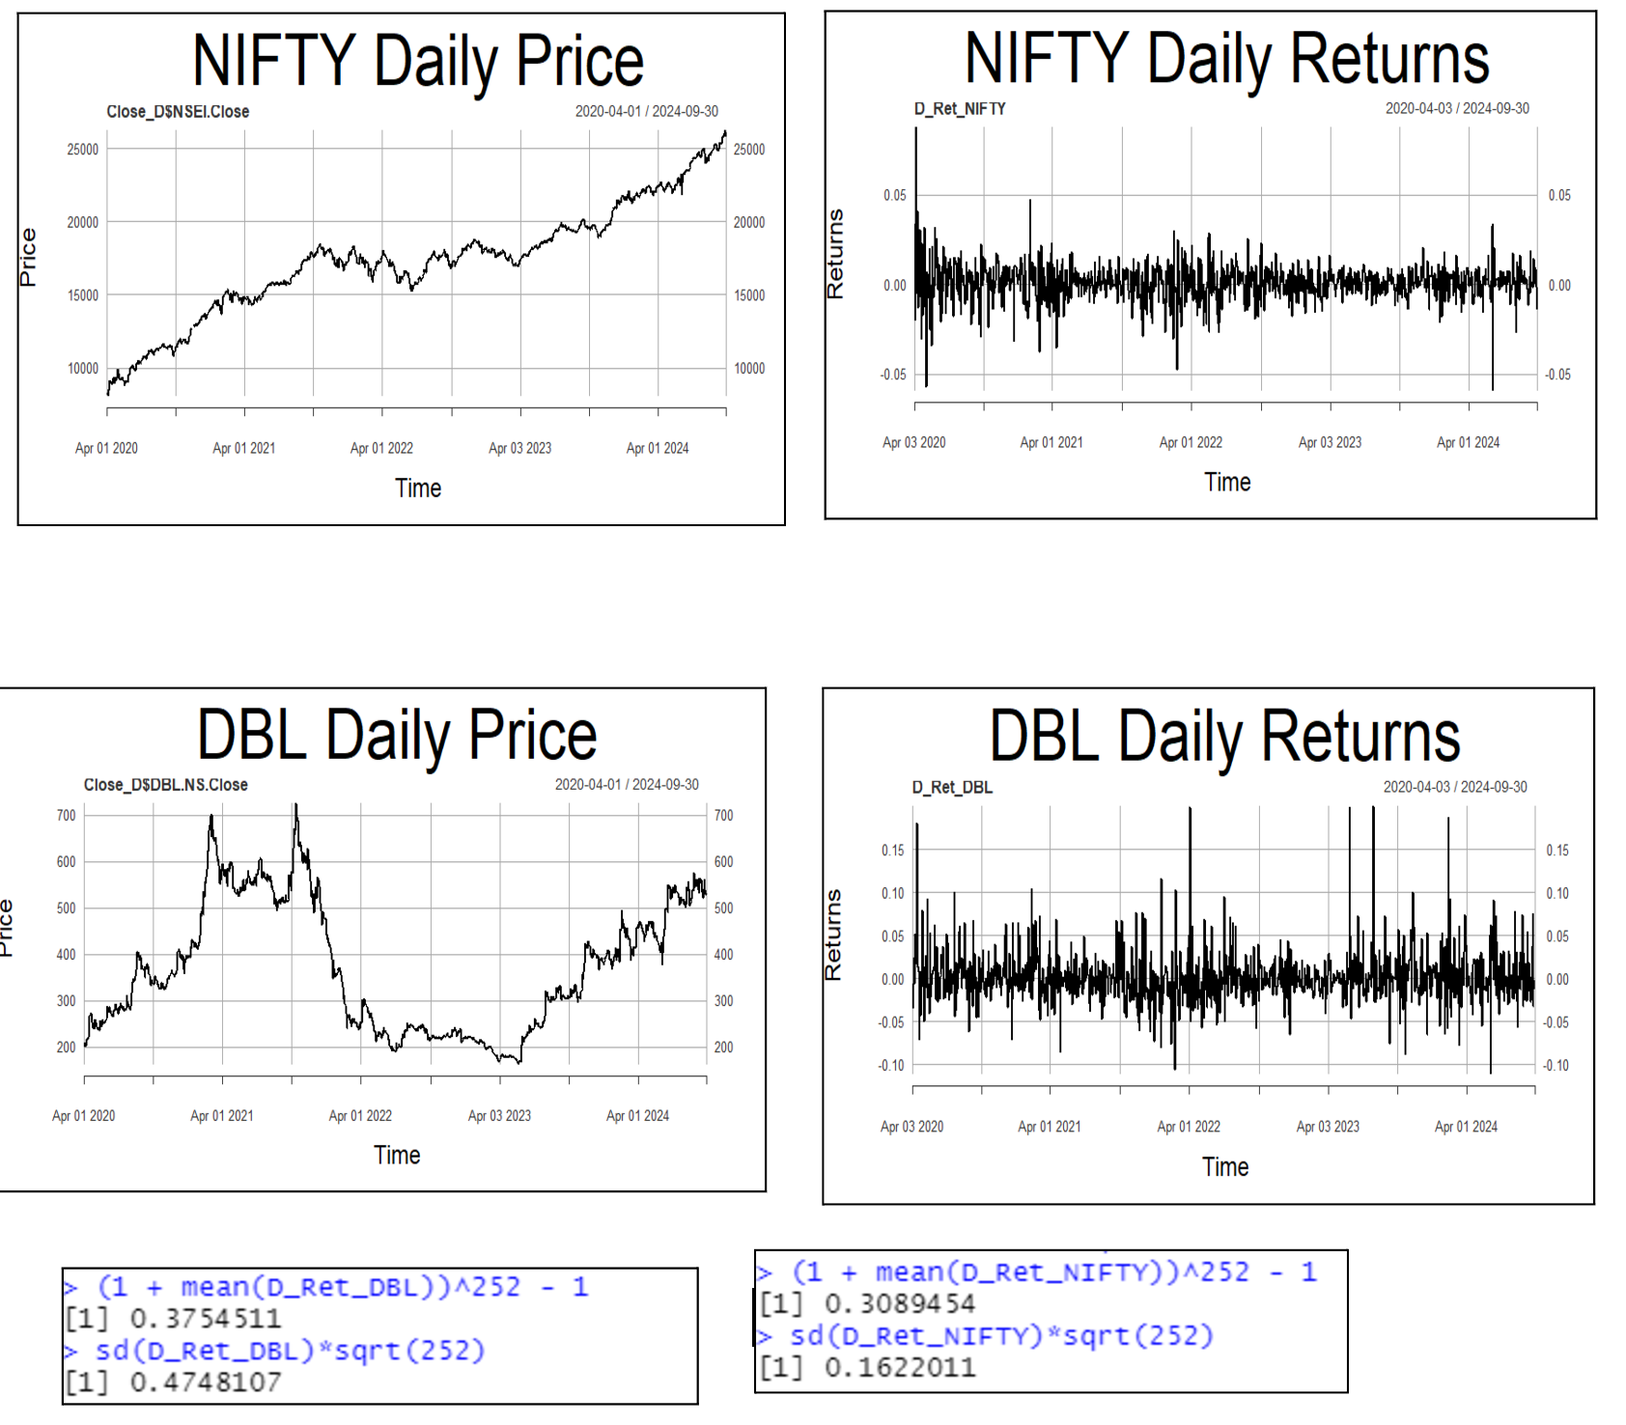

The analysis period extends from April 1st, 2020, to September 30th, 2024.

Daily returns of both NIFTY 50 and DBL appear to be volitile.

The annualised daily return of DBL for the period considered is 37.54%, while that of NIFTY 50 stands at 30.89%.

The annualised daily risk (standard deviation) of DBL for this period is 47.48%, compared to 16.22% for NIFTY 50.

### 3.2.1 Estimating Beta using CAPM

The methodology employed is explained in the *section 1.1*.

After running the regression, the output for the (daily timefreame) is: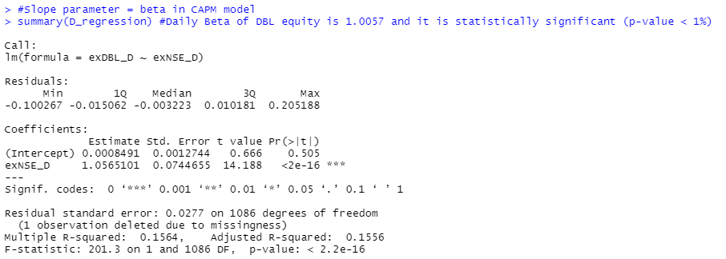

From the output on the left, we understnd that the slope coeficient is 1.0057, and its p-value is less than 1%, implying that it’s statistically signifcant.  
Hence, the Beta of DBL at the daily timeframe is 1.0057 and is statistically signifiant.

The economic interprtation of Beta is that the returns of DBL are 0.57% more senstive than those of the market. In other words, if the market premuim (market’s excess return) rises by 1%, then DBL’s return increases by 1.0057%.

### 3.2.2 ARIMA Modelling

The methodology employed is explained in the *section 1.2*.

From *figure 117*, the daily returns of DBL seem to be stationary. To confirm this, Augmented Dicky-Fuller (ADF) test is performed and the output obtained is:

From the above *figure*, as p < 0.05, we conclude that DBL daily returns are stationary.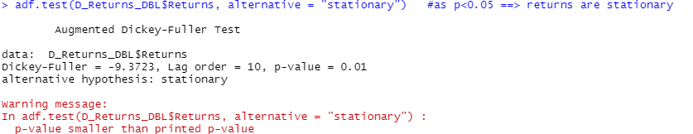

Now, to find AR and MA coefficients to fit the ARIMA model, we plot acf and pacf, and use the *auto.arima* function.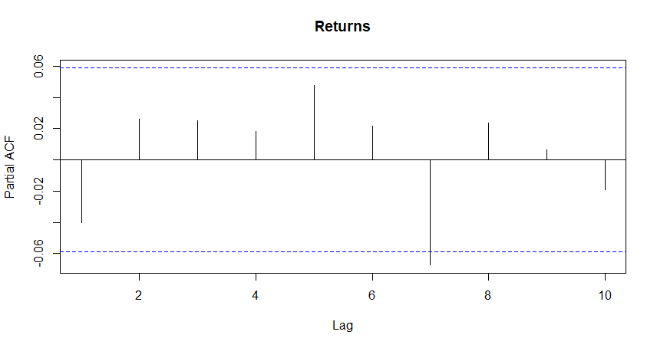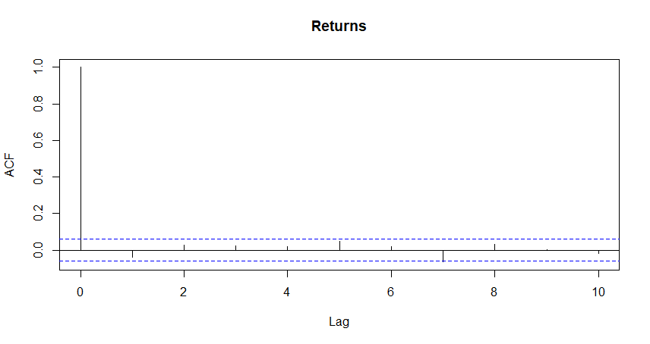

From figures above; it can be inferred that best-fit ARIMA model is of order (2,0,2).

Now, using the model, forecasting of returns for future periods is done and the following forecasts are obtained:  
  
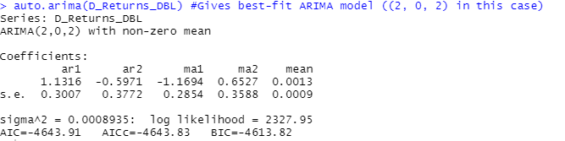

Finally, diagnostic test can be done for the fitted model to check whether it is appropriate. The graphical output obtained using *tsdiag* function is:  
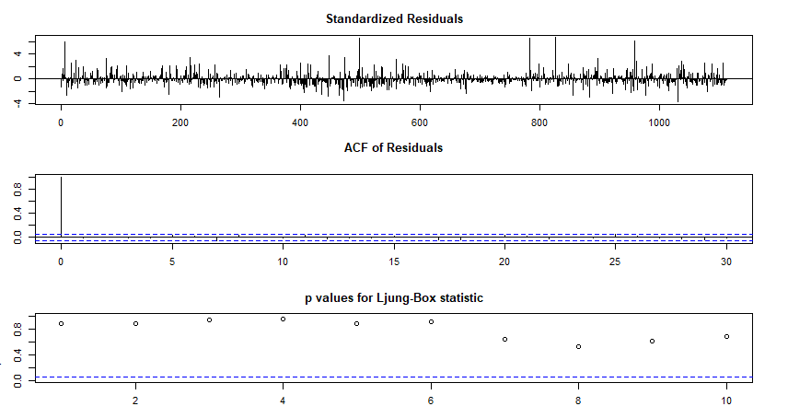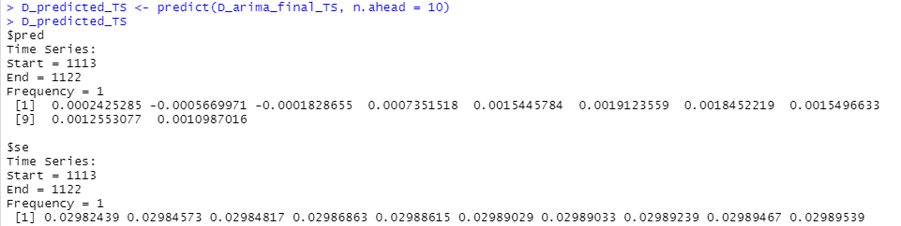

From graphs 1 and 2 of *figure 126*, it can be seen that the residuals do not follow any particular pattern, and even the ACF has no peak except lag-0.

The Ljung-Box test is used to check whether the residuals have been independently distributed or not from each other. Its null hypothesis says they are independent, whereas the alternative hypothesis says they are not. From Graph 3 of *figure 126*, it can be seen that all the p-values are above the critical t-statistic. Hence, we cannot reject the null hypothesis and conclude that the residuals are independent.

### 3.2.3 GARCH and EGARCH Modelling

The methodology employed is explained in the *section 1.3*.

GARCH(1,1) and EGARCH(1,1) models are first specified (refer *figure* *1* and *2*). Then, using *rugarch* package and *ugarchfit* function, apt GARCH and EGARCH models are fitted. The output for the same on daily timeframe is as following:

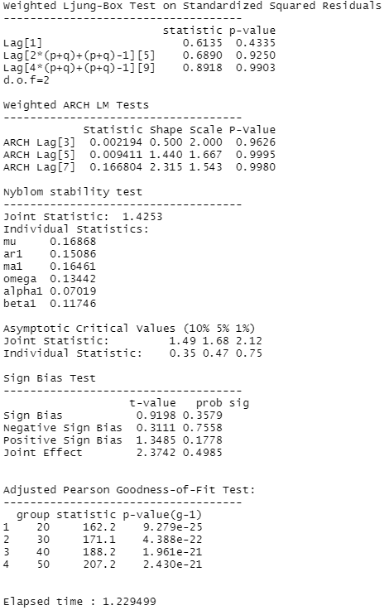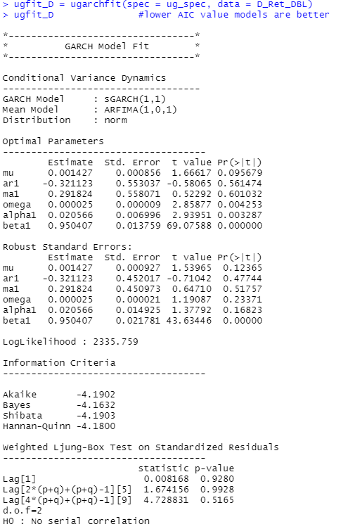

Interpretation of the above GARCH(1,1) model fitting’s result (*figure 127*) is:

* The log-likelihod of the model is 2335.76.  
  GARCH(1,1) and corresonding ARFIMA(1,0,1) are best for DBL daily returns.  
  Among the optimal parametres, only omega, alpha1, and beta1 are statistically signifcant as their p-values are lower than 0.05.  
  Among the robust standard erors’ parametres, ar1, omega, alpha1, and beta1 are statistically signifcant as their p-values are lower than 0.05.  
  In the Ljung-box test reslt section, since all the p-values for both standarised results and standrd squared residuals are much higher than 0.05, the null hypothesis cannot be rejected, and hence no serial autocorelation exists, which is a good condition for the model.  
  In ARCH LM test, as p-values are far greater than 0.05, the null hypothesis that an adequate ARCH process is fitted cannot be rejected.  
  In the Adjusted Pearson goodness-of-fit secton, all the p-values are very low, which implies that the null hypothesis cannot be rejected and hence the stated distrbution isn’t followed.  
  All-in-all, the fitted GARCH(1,1) is the best-fit model for DBL daily returns.
* Interpretaton of the above EGARCH(1,1) model fitting’s result (figure 128) is:  
  The log-likelihod of the model is 2335.76.  
  EGARCH(1,1) and corresonding ARFIMA(1,0,1) are best for DBL daily returns.  
  All the optimal parametres are statistically signifcant as their p-values are lower than 0.05.  
  All the robust standard erors’ parametres are statistically signifcant as their p-values are lower than 0.05.

All-in-all, EGARCH(1,1) is the best-fit model for DBL daily returns.

Now, daily volatility forecasts are made for future using the fitted models using the *ugarchforecast* function and the output is as following:   
  
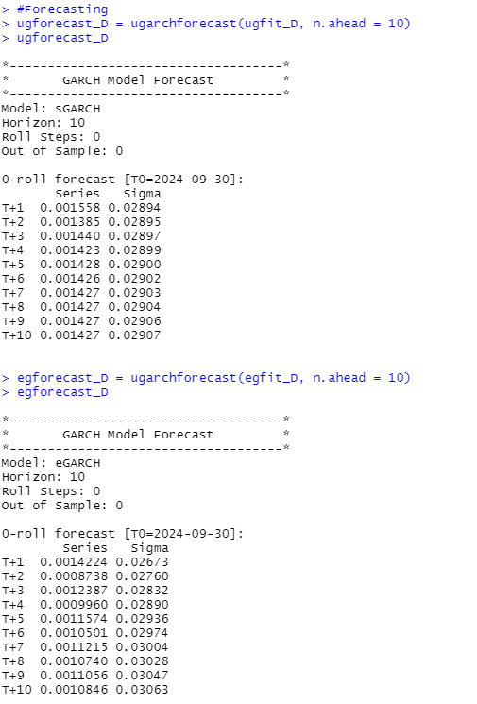

## 4.3 Frequency: Weekly

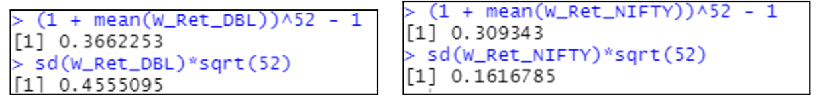  
The period of anlysis is from March 29th 2020 to Septembr 29th 2024.  
Weekly returns of DBL seem to be volitile compred to NIFTY 50.

Anualized weekly return of DBL for the period considered is 36.62% and that of NIFTY 50 is 30.94%.  
Anualized weekly risk (standrd deviation) of DBL for the period considered is 45.55% and that of NIFTY 50 is 16.17%.

### 4.3.1 Estimating Beta using CAPM

The methodology employed is explained in the *section 1.1*.

After running the regression, the output for (weekly timeframe) we get is:

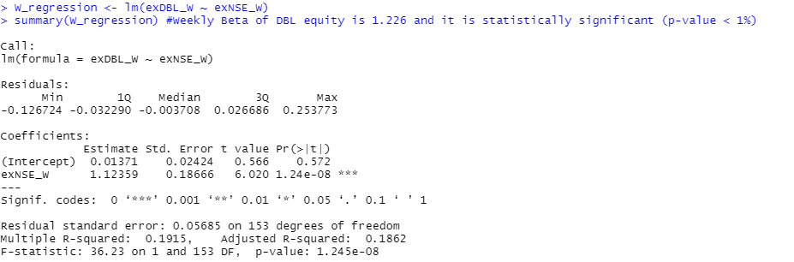

From the output on the left, we undrstand that the slope coefficent is 1.226 and its p-value is less than 1% implying that it’s statistically signficant.  
Hence, Beta of DBL at weekly timefram is 1.226 and is statistically signficant.

Economic interprtation of Beta would be that the returns of DBL are 22.6% more sensitve than that of the market. In other words, if the market premuim (market’s excess return) rises by 1%, then the DBL return rises by 1.226%.

### 4.3.2 ARIMA Modelling

The methodology employed is explained in the *section 1.2*.

From *figure 134*, the weekly returns of DBL seem to be stationary. To confirm this, Augmented Dicky-Fuller (ADF) test is performed and the output obtained is:

From *figure 138*, as p < 0.05, we conclude that DBL weekly returns are stationary.

Now, to find AR and MA coefficients to fit the ARIMA model, we plot acf and pacf, and use the *auto.arima* function:

From figures 139, 140, and 141; it can be inferred that best-fit ARIMA model is of order (2,0,1).

Now, using the model, forecasting of returns for future periods is done and the following forecasts are obtained:  
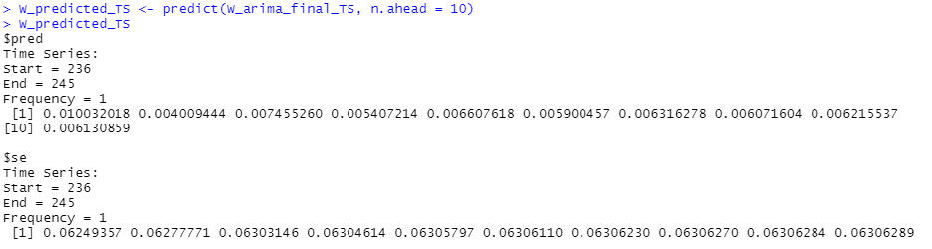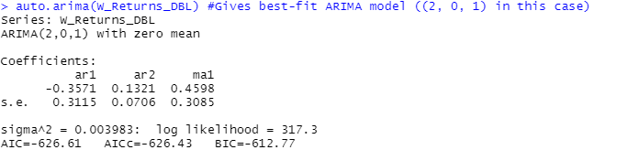

Finally, diagnostic test can be done for the fitted model to check whether it is appropriate. The graphical output obtained using *tsdiag* function is:

From graphs 1 and 2 of *figure 143*, it can be seen that the residuals do not follow any particular pattern, and even the ACF has no peak except lag-0.

The Ljung-Box test is used to check whether the residuals have been independently distributed or not from each other. Its null hypothesis says they are independent, whereas the alternative hypothesis says they are not. From Graph 3 of *figure 143*, it can be seen that all the p-values are above the critical t-statistic. Hence, we cannot reject the null hypothesis and conclude that the residuals are independent.

### 4.3.3 GARCH and EGARCH Modelling

The methodology employed is explained in the *section 1.3*.

GARCH(1,1) and EGARCH(1,1) models are first specified (refer *figure* *1* and *2*). Then, using *rugarch* package and *ugarchfit* function, apt GARCH and EGARCH models are fitted. The output for the same on weekly timeframe is as following:



Interpretation of the above GARCH(1,1) model fitting’s result (*figure 90*) is:

* The log-likelihood of the model is 216.245.  
  GARCH(1,1) and the corresponding ARFIMA(1,0,1) are the best for DBL weekly returns.  
  Among the optimal parameters, only **ar1**, **ma1**, **alpha1**, and **beta1** are statistically significant, as their p-values are lower than 0.05.  
  Among the robust standard errors’ parameters, only **ma1**, **alpha1**, and **beta1** are statistically significant, as their p-values are lower than 0.05.
* In the Ljung-box test result section, since all the p-values for standardized residuals are much higher than 0.05, the null hypothesis cannot be rejected, and hence no serial autocorrelation exists, which is a good condition for the model.  
  In the ARCH LM test, as the p-values are far greater than 0.05, the null hypothesis that an adequate ARCH process is fitted cannot be rejected.  
  In the Adjusted Pearson goodness-of-fit section, all the p-values are lower than 0.05, which implies that the null hypothesis is rejected, and hence the stated distribution isn’t followed.
* All-in-all, the fitted GARCH(1,1) is the best-fit model for DBL weekly returns.
* Interpretation of the EGARCH(1,1) model fitting result (Figure 91) is:  
  The log-likelihood of the model is 224.76.  
  EGARCH(1,1) and the corresponding ARFIMA(1,0,1) are the best for DBL weekly returns.  
  All the optimal parameters are statistically significant, as their p-values are lower than 0.05.  
  All the robust standard errors’ parameters are statistically significant, as their p-values are lower than 0.05.
* In the Ljung-box test result section, since all the p-values for standardized residuals are much higher than 0.05, the null hypothesis cannot be rejected, and hence no serial autocorrelation exists, which is a good condition for the model.  
  In the ARCH LM test, as the p-values are far greater than 0.05, the null hypothesis that an adequate ARCH process is fitted cannot be rejected.  
  In the Adjusted Pearson goodness-of-fit section, all the p-values are greater than 0.05, which implies that the null hypothesis cannot be rejected, and hence the stated distribution is followed.

All-in-all, the fitted EGARCH(1,1) is the best-fit model for DBL weekly returns.

Now, weekly volatility forecasts are made for future using the fitted models using the *ugarchforecast* function and the output is as following:



## 4.4 Frequency: Monthly

The period of analysis is from **30th April, 2020 to 30th September, 2024**.  
Monthly returns of both **NIFTY 50** and **DBL** seem to be non-stationary.

* Annualized monthly return of DBL for the period considered is **30.19%**, while that of NIFTY 50 is **23.22%**.
* Annualized monthly risk (standard deviation) of DBL for the period considered is **51.95%**, while that of NIFTY 50 is **13.98%**.

### 4.4.1 Estimating Beta using CAPM

The methodology employed is explained in the *section 1.1*.

After running the regression, the output for (monthly timeframe) we get is:

### From the output on the left, we understand that the slope coefficient is **0.834** and its p-value is lower than **0.1%**, implying that it’s **statistically significant**. Hence, **Beta of DBL at the monthly timeframe is 0.834** and is **statistically significant**.

### The returns of DBL are **14.6% less sensitive** than those of the market. In other words, if the market premium (market’s excess return) rises by **1%**, then the **DBL return rises by 0.834%**.

### 

### 4.4.2 ARIMA Modelling

The methodology employed is explained in the *section 1.2*.

From *figure 151*, the monthly returns of DBL seem to be non-stationary. To check this, Augmented Dicky-Fuller (ADF) test is performed and the output obtained is:

From *figure 155*, as p > 0.05, we conclude that DBL monthly returns are non-stationary. Hence, differencing should be done using the *diff* function. The adf test output for first-differenced monthly returns is:  


From *figure 156*, as p > 0.05, we conclude that DBL first-differenced monthly returns are non-stationary. Hence, differencing should be done once again. The adf test output for second-differenced monthly returns is:



As p < 0.05, we conclude that third-differenced DBL monthly returns are stationary. Hence, the coefficient *d* (degree of differencing) is found to be 3.

Now, to find AR and MA coefficients to fit the ARIMA model, we plot acf and pacf, and use the *auto.arima* function.

From previous discussion and *figures*; it can be inferred that best-fit ARIMA model for DBL monthly returns series is of order (0,0,0). Hence, best-fit ARIMA model for third-differenced DBL monthly returns series is of order (0,0,0).

Now, using the model, forecasting of returns for future periods is done and the following forecasts are obtained:

Finally, diagnostic test can be done for the fitted model to check whether it is appropriate. The graphical output obtained using *tsdiag* function is:

From graphs 1 and 2 of figure 161, it can be seen that the residuals do not follow any particular pattern, and even the ACF has no peak except at lag-0.

The Ljung-Box test is used to check whether the residuals are independently distrubuted or not. Its null hypothesis states that the residuals are independant, while the alternative hypothesis suggests they are not. From graph 3 of figure 161, it is observed that all the p-values are above the critical t-statistic. Therefore, we cannot reject the null hypothesis and conclude that the residuals are independant.

### 4.4.3 GARCH and EGARCH Modelling

The methodology employed is explained in the *section 1.3*.

GARCH(1,1) and EGARCH(1,1) models are first specified (refer *figure* *1* and *2*). Then, using *rugarch* package and *ugarchfit* function, apt GARCH and EGARCH models are fitted. The output for the same on monthly timeframe is as following:



Interpretation of the above GARCH(1,1) model fitting’s result (*figure 164*) is:

* The log-likelihood of the model is 26.736.
* GARCH(1,1) and corresponding ARFIMA(1,0,1) are best for DBL monthly returns.
* Among the optimal parameters, only beta1 is statistically signifficant as its p-value is lower than 0.05.
* Among the robust standard errors' parameters, only beta1 is statistically signifficant as its p-value is lower than 0.05.
* In the Ljung-box test result section, since all the p-values for both standardised results and standard squared residuals are much higher than 0.05, the null hypothesis cannot be rejected and hence no serial autocorrelation exists, which is a good condition for the model.
* In ARCH LM test, as p-values are far greater than 0.05, the null hypothesis that an adequate ARCH process is fitted cannot be rejected.
* In the Adjusted Pearson goodness-of-fit section, all the p-values are greater than 0.05, which implies that the null hypothesis cannot be rejected and hence the stated distribution is followed.
* All-in-all, the fitted GARCH(1,1) is the best-fit model for DBL monthly returns.

Interpretation of the above EGARCH(1,1) model fitting’s result (*figure 163*) is:

* The log-likelihood of the model is 36.535.
* EGARCH(1,1) and corresponding ARFIMA(1,0,1) are best for DBL monthly returns.
* All the optimal parameters are statistically signifficant as their p-values are lower than 0.05.
* All the robust standard errors' parameters are statistically insignificant as their p-values are greater than 0.05.
* In the Ljung-box test result section, since all the p-values for both standardised results and standard squared residuals are much higher than 0.05, the null hypothesis cannot be rejected and hence no serial autocorrelation exists, which is a good condition for the model.
* In ARCH LM test, as p-values are far greater than 0.05, the null hypothesis that an adequate ARCH process is fitted cannot be rejected.
* In the Adjusted Pearson goodness-of-fit section, all the p-values are greater than 0.05, which implies that the null hypothesis cannot be rejected and hence the stated distribution is followed.

All-in-all, the fitted EGARCH(1,1) is the best-fit model for DBLmonthly returns.

Now, monthly volatility forecasts are made for future using the fitted models using the *ugarchforecast* function and the output is as following:

# 

# 8. VaR Simulation

VaR, or Value at Risk, is a statistical methodology used to estimate the loss that an investment might incur in a specific time frame with a defined level of confidence. It reports useful information on the maximum possible loss that the chosen set of securities can incur during a specified time frame and with a specified level of confidence. Being a financial model for risk management, VaR takes several factors into consideration while calculating and estimating the risk, some of these factors are correlation between the assets, historical data analysis and market volatility. One of the most crucial assumptions that we make while doing the VAR calculation is that the future returns will be similar and will resemble the return the portfolio gave in the past. There are many ways to compute the VAR but most frequently applied approaches are:

1. Variance-Covariance Method
2. Monte Carlo Simulation
3. Sensitivity Analysis

In this report, Variance-Covariance Method is used to calculate VAR for the portfolio that consists of CUB, DALMIASUG, CREST, and DBL. We constructed a portfolio of stocks that consist of CUB, DALMIASUG, CREST, and DBL. The Composition of portfolio is as follows:

1. CREST : 175 Shares
2. CUB : 100 Shares
3. DALMIASUG : 150 Shares
4. DBL: 250 shares

The Following code snippet is used to calculate the VAR of our portfolio of stocks.

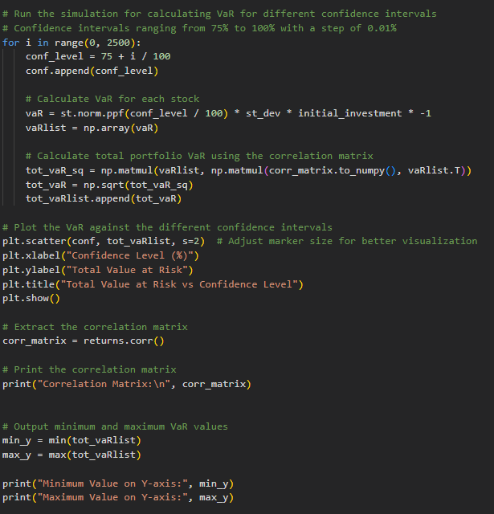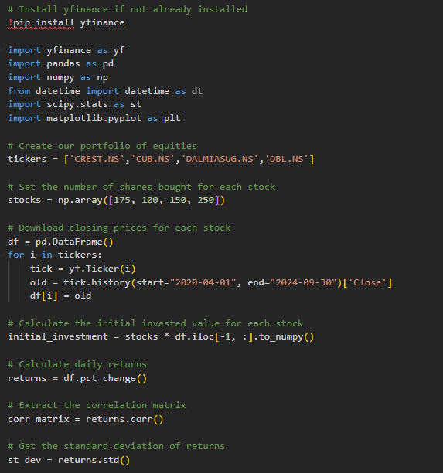

This code runs a VaR analysis for a portfolio of equities. The following is executed sequentially for the task.

1. Portfolio Creation:

A portfolio of stocks has been created with the following tckrs: 'CREST.NS', 'CUB.NS', 'DALMIASUG.NS', and 'DBL.NS'. The number of shares purchased on each is also specified.

1. Data Import:

This code downloads historical closing prices for these stocks from the date "2020-04-01" until today, using Yahoo Finance (yfinance) and stores them in a DataFrame.

1. Investment at Beginning:

Calculates the amount invested at the beginning by multiplying the number of shares bought for each stock by their respective current prices.

1. Returns Calculation:

Calculation of the daily returns of each stock based on the imported closing prices.

1. Correlation Matrix:

The program calculates the correlation matrix of the returns of the stocks portfolio. This matrix condenses how the different stocks' returns correlate with each other.

1. Standard Deviation:

Calculating the standard deviation of the returns for each stock, which is a measure of their respective volatility (risk).

1. Value-at-Risk (VaR) Calculation:

The core piece of the code is a simulation in order to compute VaR at different confidence intervals. The loop was run for 2500 iterations where the confidence level was changed step by step from 75 to 100 by a step of 0.01 .

Minimum Value of Var Being : 4541.9563

Maximum Value of Var Being : 25043.5389

For each iteration, it calculates VaR for the entire portfolio by the formula:

**VaR = z * σ * P**

Then it calculates the Total VaR accounting for the correlations between stocks using the formula:

**Total VaR = sqrt(P' * Σ * P)**

1. Plotting:

Lastly, the code plots a scatter plot to illustrate how the Total VaR depends on different levels of confidence. The x-variable is the confidence levels while the y-variable is the Total VaR.

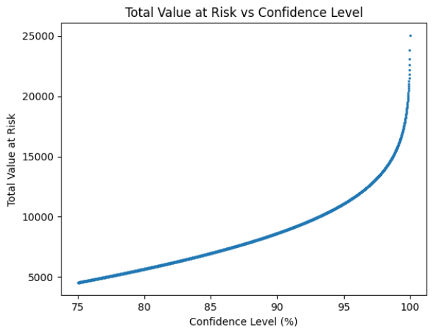

Interpreting the VaR plot:

1. In order to interpret the result of a VAR, there are two major aspects that need to be taken into consideration namely the confidence level and secondly the horizon under consideration. For instance, let a 1-day VAR with the confidence level of 99% for a portfolio is $ 100,000. With a 99% confidence level, an expectation goes along with the notion that in a single day, the value of the portfolio will not decline by more than $ 100,000.
2. As we go along to greater confidence levels (for example, from 75 percent to 100 percent), the cumulative VaR increases (from 7540.59 to 41577.47 in our study). This should be intuitive because at higher levels of confidence, we are speaking more extreme cases where the portfolio has a likelihood of experiencing large losses; consequently, its value at risk will be higher.
3. It reflects the exposure of the portfolio at other confidence levels. A higher Total VaR reflects the potential potential loss in the portfolio in case extreme market conditions arise.
4. Risk managers and investors apply VaR to measure and manage potential downside risk. Therefore, VaR enables the risk manager/investor to have information on the amount he would lose under specified confidence levels. This is critical in formulating investment decisions and recommending control strategies for risk management.

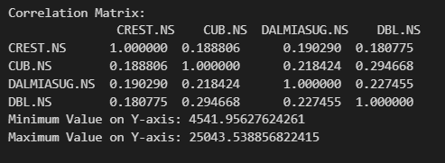

# 

# 9. Conclusion

The detailed analysis of the allotted companies on daily, weekly and monthly returns frequencies yielded the following results:

1. The beta, calculated through the regression simulations of stock’s excess returns and market’s excess returns (using CAPM) across given frequencies, has produced the following consolidated results:

| **Frequency**  **Company** | **Daily** | **Weekly** | **Monthly** |
| --- | --- | --- | --- |
| **CREST** | 0.8208 | 0.8760 | 0.8507 |
| **CUB** | 0.9806 | 0.3114 | 0.9675 |
| **DALMIASUG** | 0.9783 | 0.9580 | 0.5789 |
| **DBL** | 1.056 | 1.123 | 0.8326 |

2. Following are the orders of best-fit ARIMA models (having least AIC and BIC values) obtained for each of the companies’ returns across different frequencies following which the respective returns are forecasted:

| **Frequency**  **Company** | **Daily** | **Weekly** | **Monthly** |
| --- | --- | --- | --- |
| **CREST** | (1, 0, 2) | (1, 0, 0) | (1, 0, 0) |
| **CUB** | (4, 0, 0) | (3, 0, 1) | (0, 0, 0) |
| **DALMIASUG** | (1, 0, 2) | (1, 1, 1) | (0, 0, 0) |
| **DBL** | (2, 0, 2) | (2, 0, 1) | (0, 0, 0) |

3. GARCH(1,1) and EGARCH(1,1) models are fitted for each of the companies’ returns across different frequencies and the volatility forecasts are hence obtained.

Finally, VaR simulation is carried out. Historical prices are imported through the code for the portfolio's stocks, and the initial value is calculated. VaR is then obtained by making use of the Variance-Covariance Method. The code runs 2500 rounds of simulations, at different confidence levels, and thus produces the scatter plot showing that as confidence levels increase from 75% to 100%, the VaR fluctuates from 4541.9567 to 25043.5388. Total VaR value increases with an increase in the confidence level.

# 10. References

1. Crest Ventures Limited: <https://www.crest.co.in/>
2. City Union Bank:[*https://www.cityunionbank.com/*](https://www.cityunionbank.com/)
3. Dalmia Bharat Sugar and Industries Limited: <https://www.dalmiasugar.com/>
4. Dilip Buildcon Limited: <https://dilipbuildcon.com/>
5. *Screener* : <https://www.screener.in/>
6. *Trendlyne.* (n.d.): <https://trendlyne.com/features/>
7. *YahooFinance*. (n.d.): <https://finance.yahoo.com/>
8. *MoneyControl.* (n.d.): <https://www.moneycontrol.com/>
9. *R: What is R?*(n.d.): [https://www.r-project.org/about.htm](https://www.r-project.org/about.html)l
10. GeeksforGeeks. (2020, July 8). *Time Series Analysis using ARIMA model in R Programming*. <https://www.geeksforgeeks.org/time-series-analysis-using-arima-model-in-r-programming/>
11. Tsafack, I. (2021, December 6). GARCH models with R programming : a practical example with TESLA stock. *Idrisstsafack.* <https://www.idrisstsafack.com/post/garch-models-with-r-programming-a-practical-example-with-tesla-stock>